Josh Apps 2026 - Numbered for Reference

- Josh Hub - https://josh-hub-two.vercel.app/dashboard
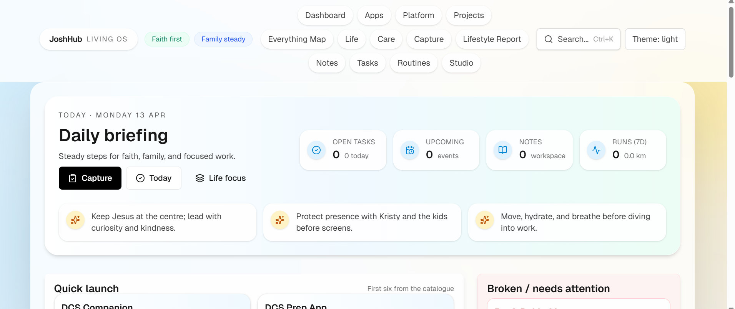
(All in One - Josh App)

Dubbo / DCS Apps / Games

- DCS Companion - https://joshuaparris-max.github.io/DCSCompanion
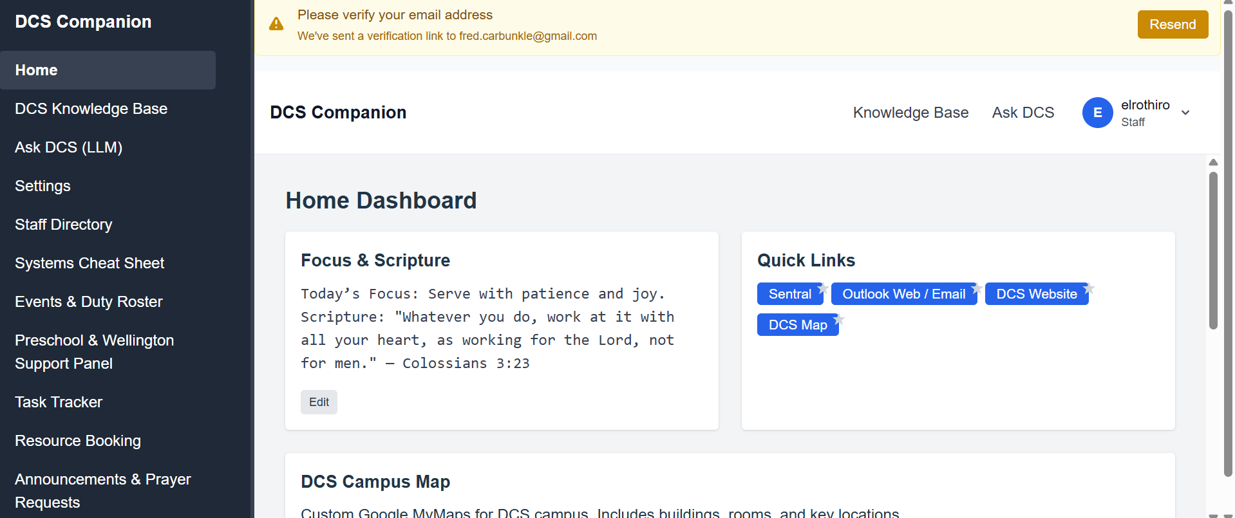

- DCS Prep App - https://dcs-prep.vercel.app/
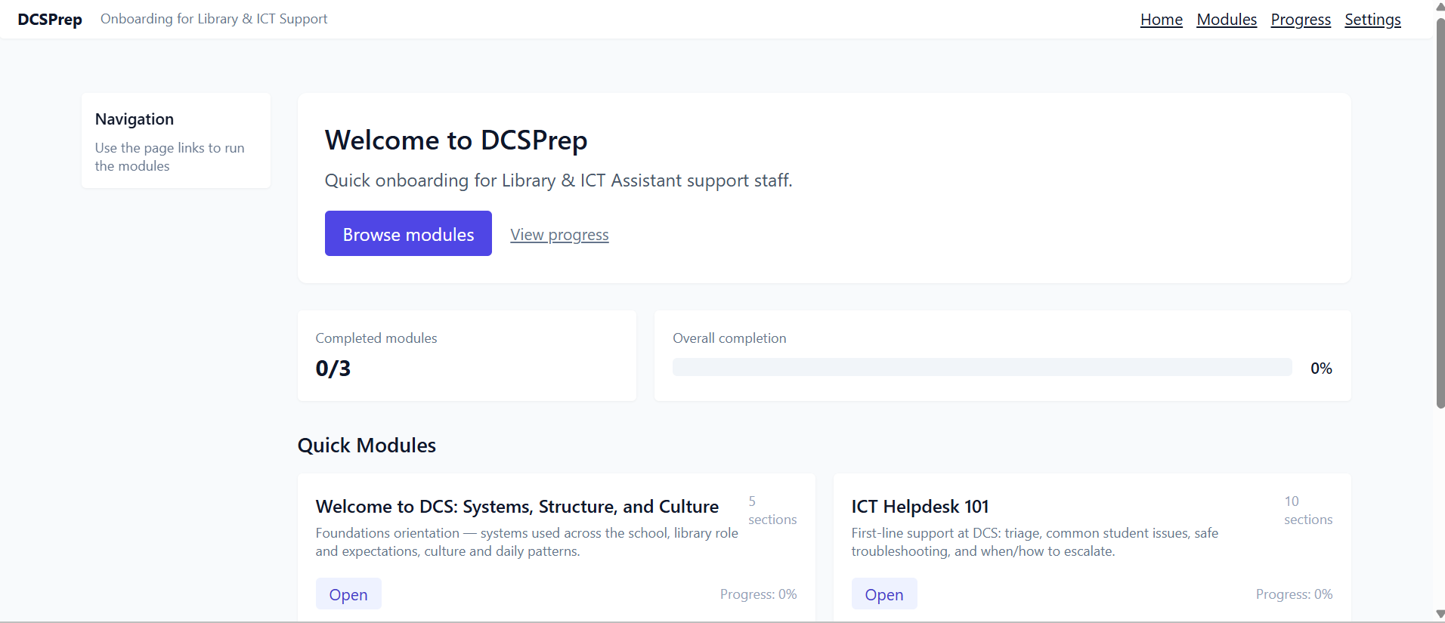
- ParrisDubboMover - https://parris-dubbo-mover-app-main-client.vercel.app/
(Note API / Backend Server is not working for this one)
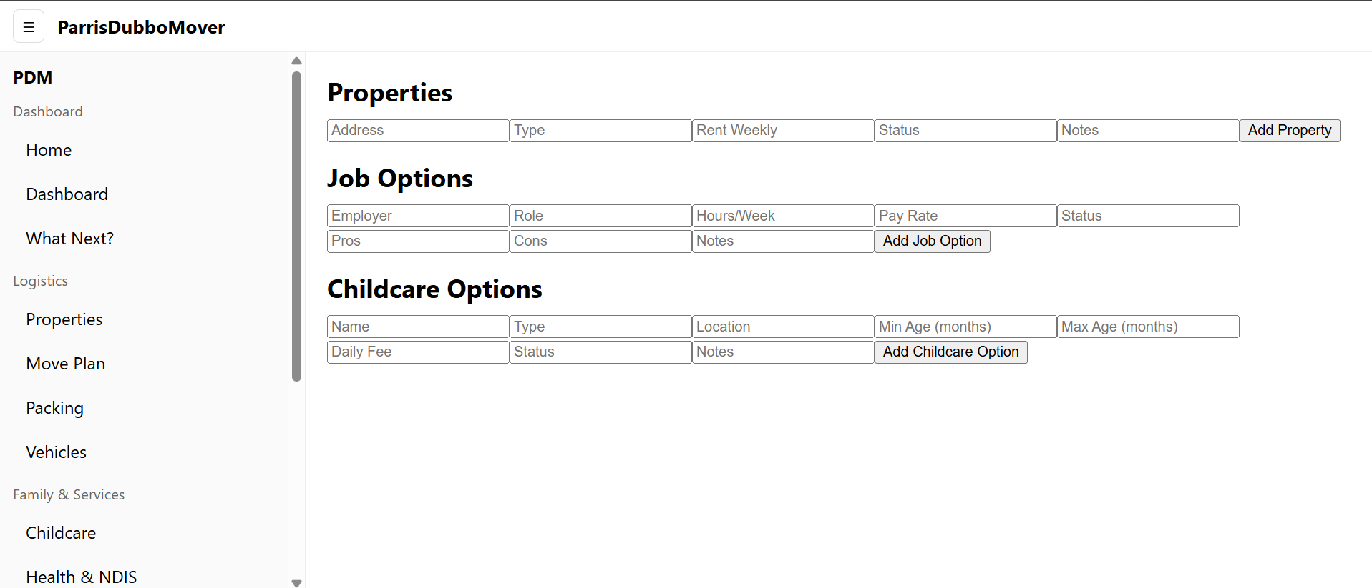

- Campaign Copilot - https://joshuaparrisdadlan-stack.github.io/campaign-copilot/
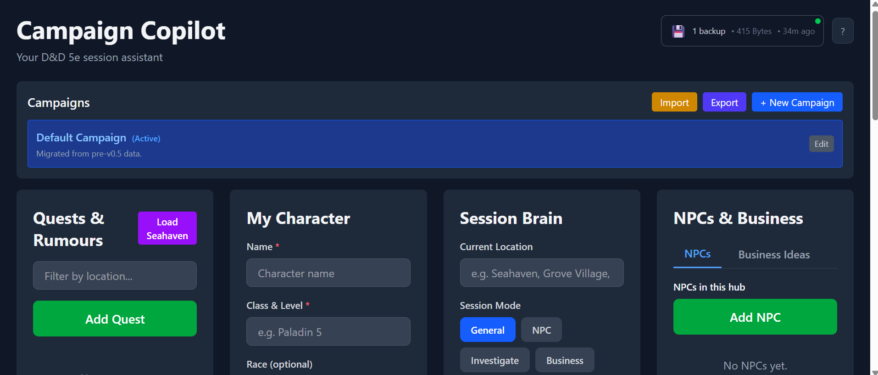

Games
- Whispering Wilds - 3 Versions
https://joshuaparris-max.github.io/WhirringWilderness/
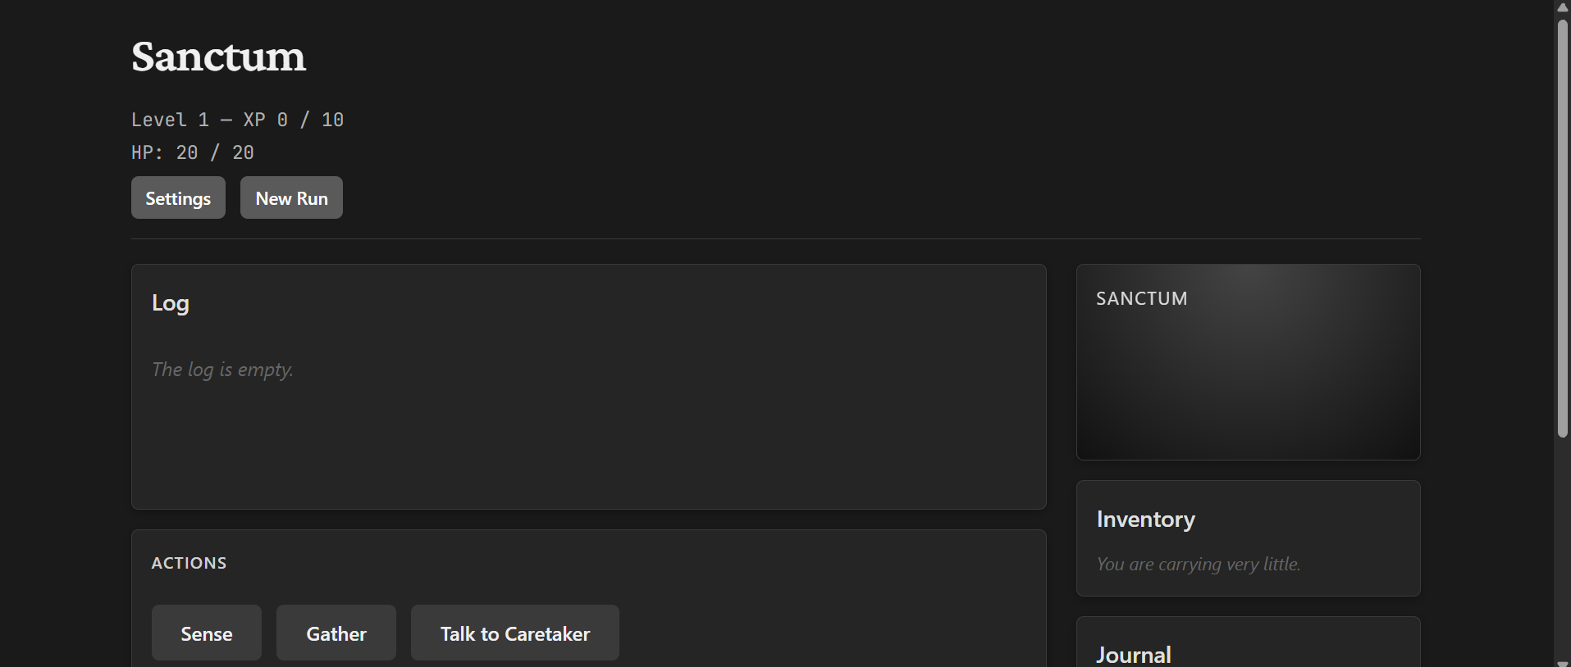
6. https://joshuaparrisdadlan-stack.github.io/whispering-wilds/
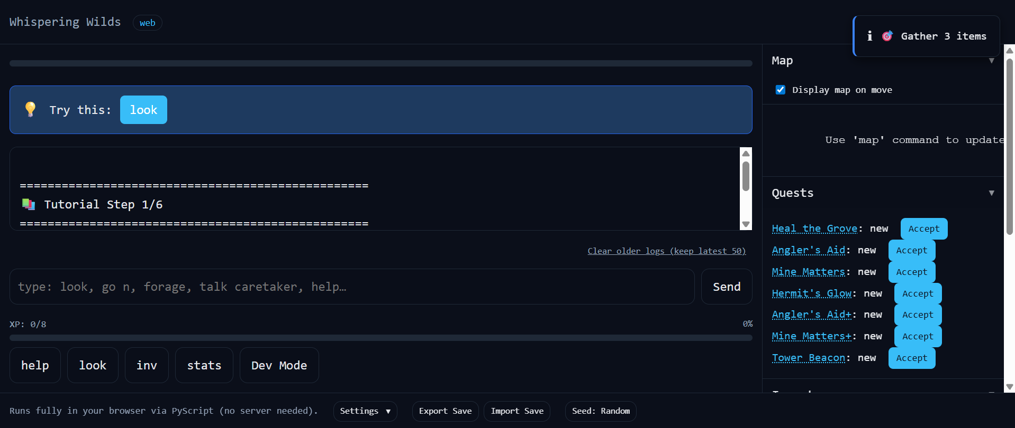
6. WhisperingWilds by joshualparris
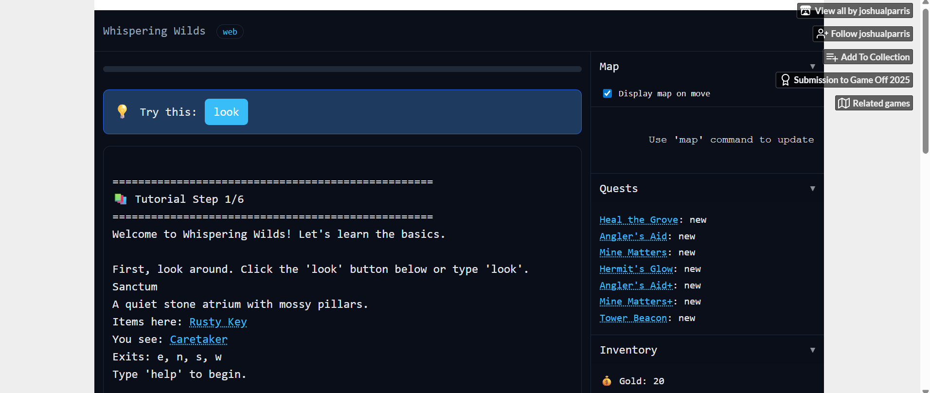
- King Killer Chronicle Adventure - KingKiller Chronicle - Patrick Rothfuss
https://joshualparris.github.io/kkc-adventure/
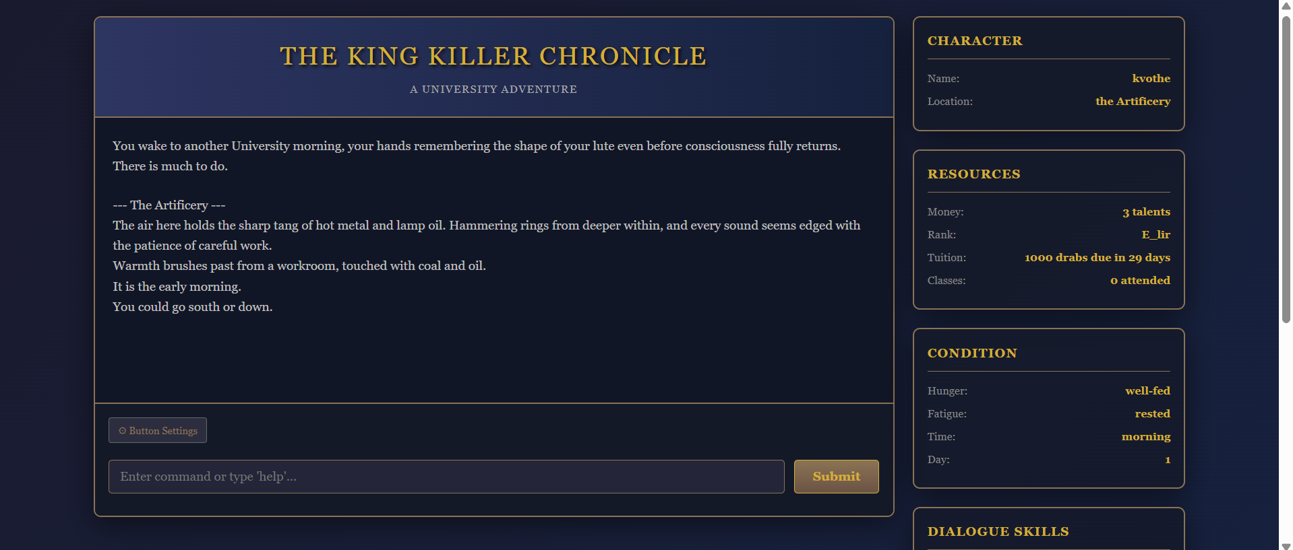
https://rothfuss-kkc-adventure-production.up.railway.app/ - No longer live here
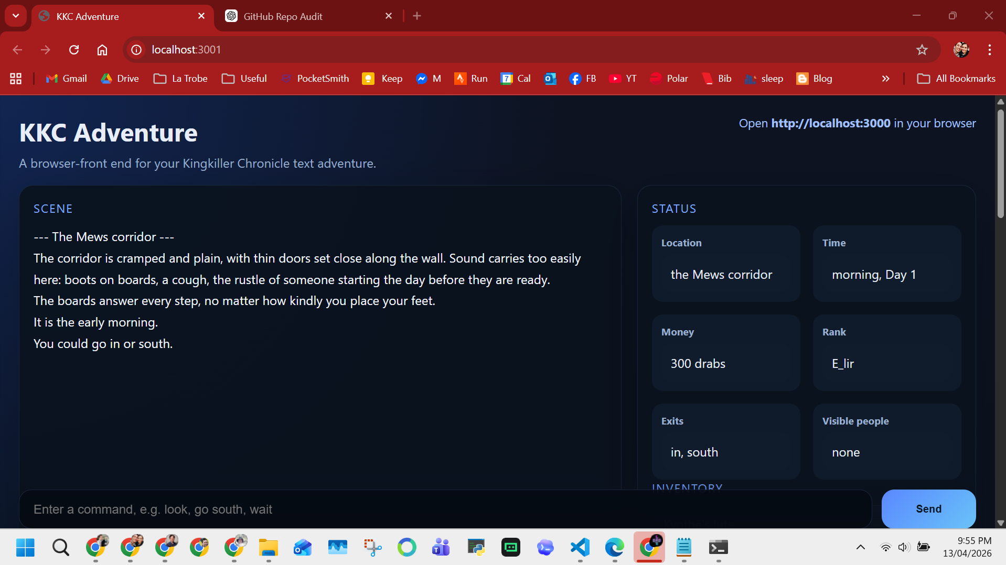
- Aetheria - https://skill-deploy-fs1ircxjkn.vercel.app/
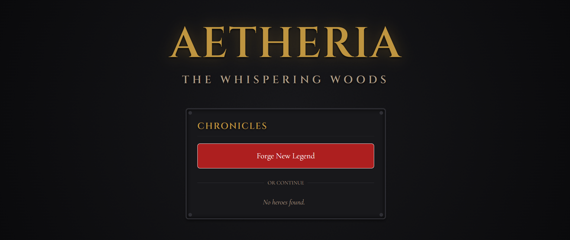
- Neverwinter RPG - https://skill-deploy-dwxq7kw5pa.vercel.app/
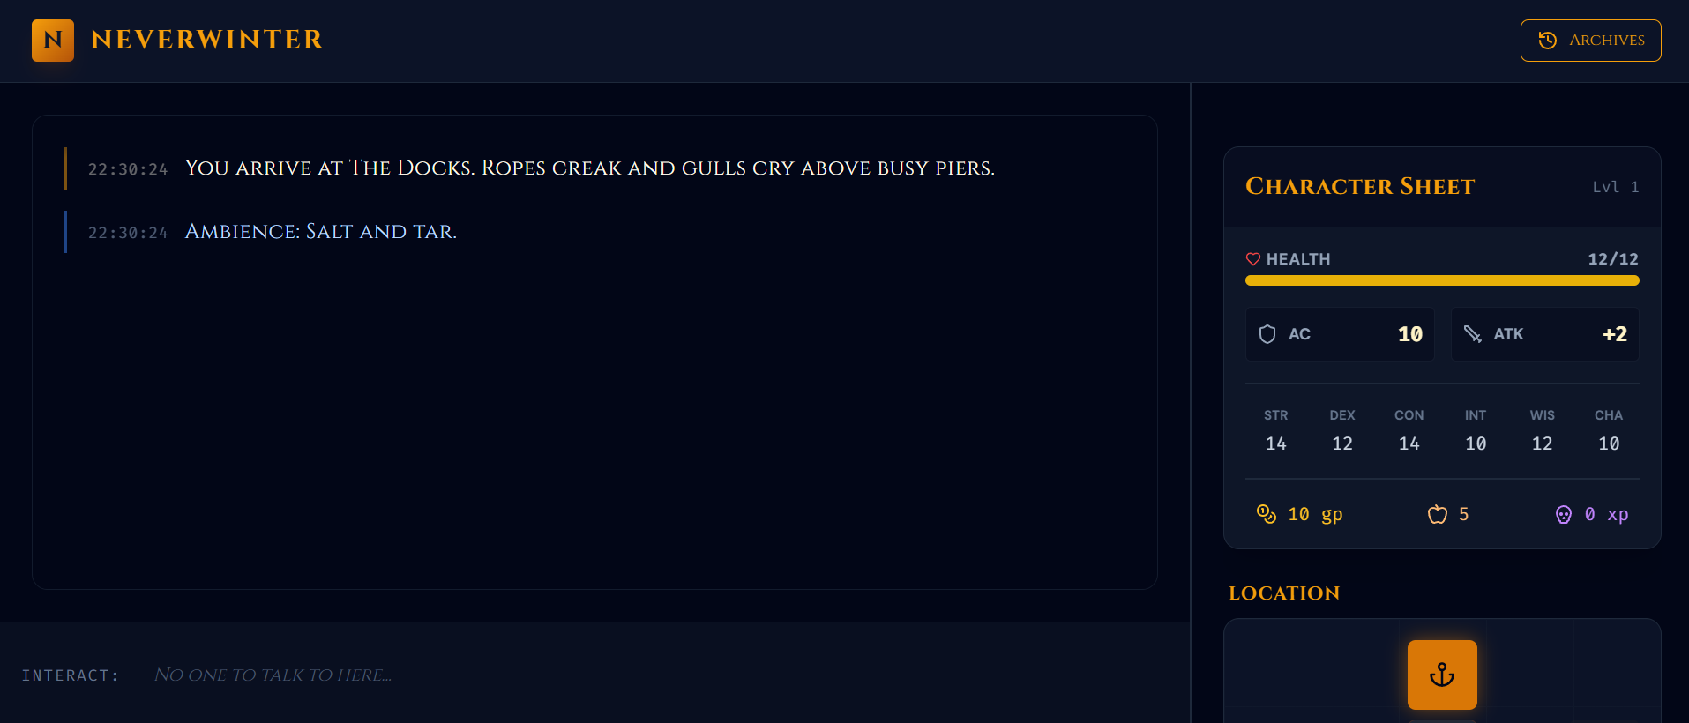
https://skill-deploy-wbzruert4j-codex-agent-deploys.vercel.app
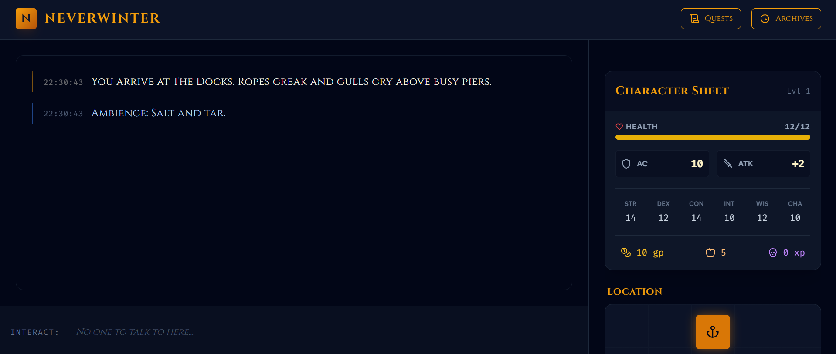
- Forbidden Lands Lite - https://skill-deploy-7tfaq44eli-codex-agent-deploys.vercel.app
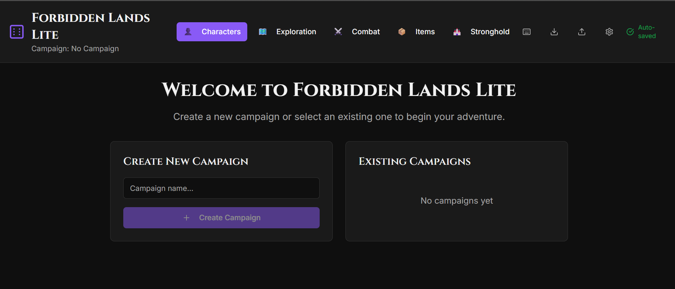

- Serenity - Firefly RPG - http://skill-deploy-ubokv1ax71.vercel.app/
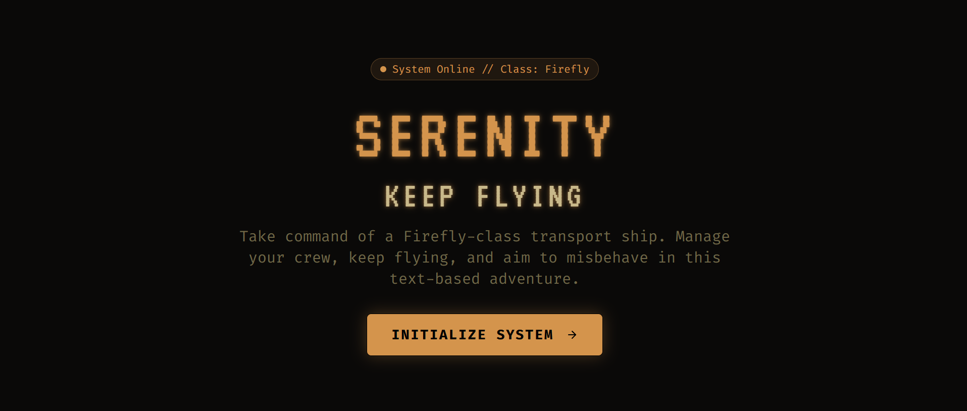

- Mystery Depths - https://joshualparris.itch.io/mysterydepths
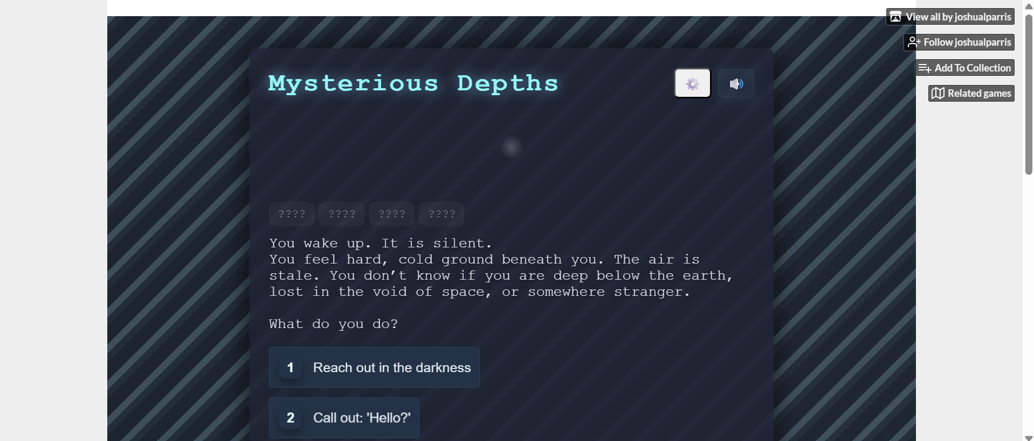
12. https://joshuaparrisdadlan-stack.github.io/MysteriousDepths/
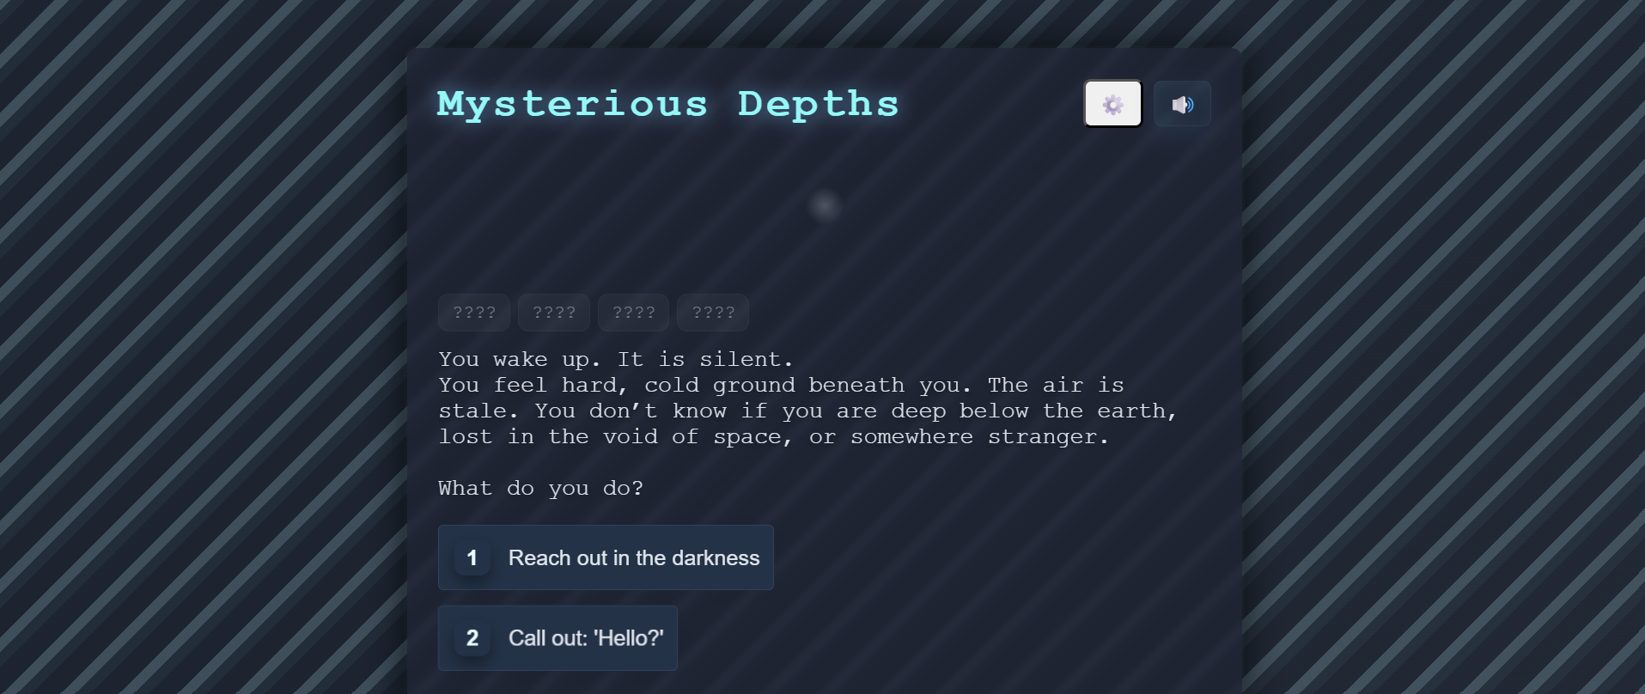
- Simple RPG - SimpleRPG by joshualparris
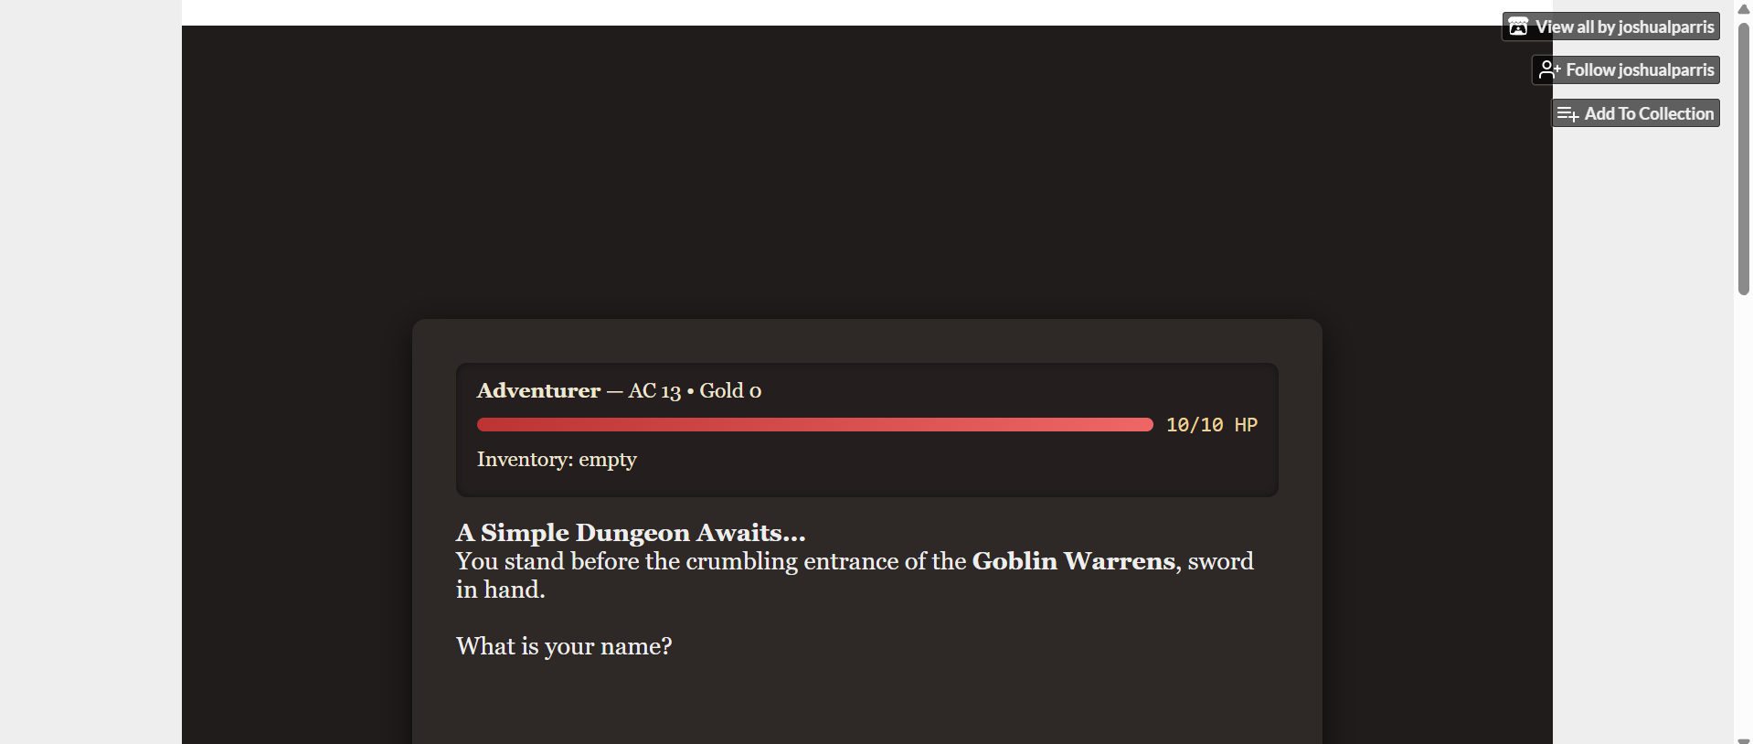
13. https://joshuaparrisdadlan-stack.github.io/LetsPlayDnd/
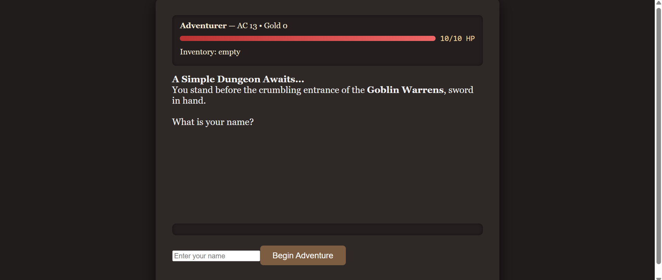

- Infinite Office - InfiniteOffice by joshualparris
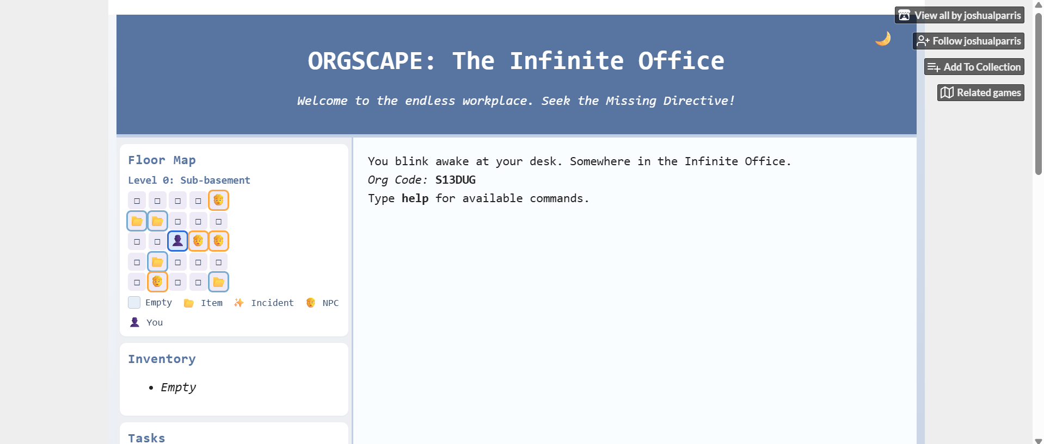
https://joshuaparrisdadlan-stack.github.io/OrgScape/
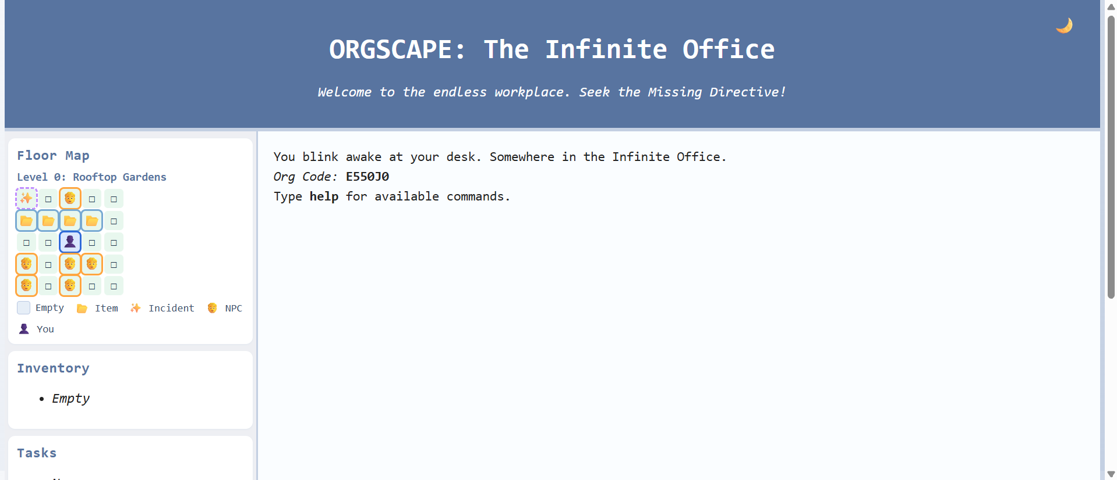

- Null - https://joshualparris.itch.io/null-html-game
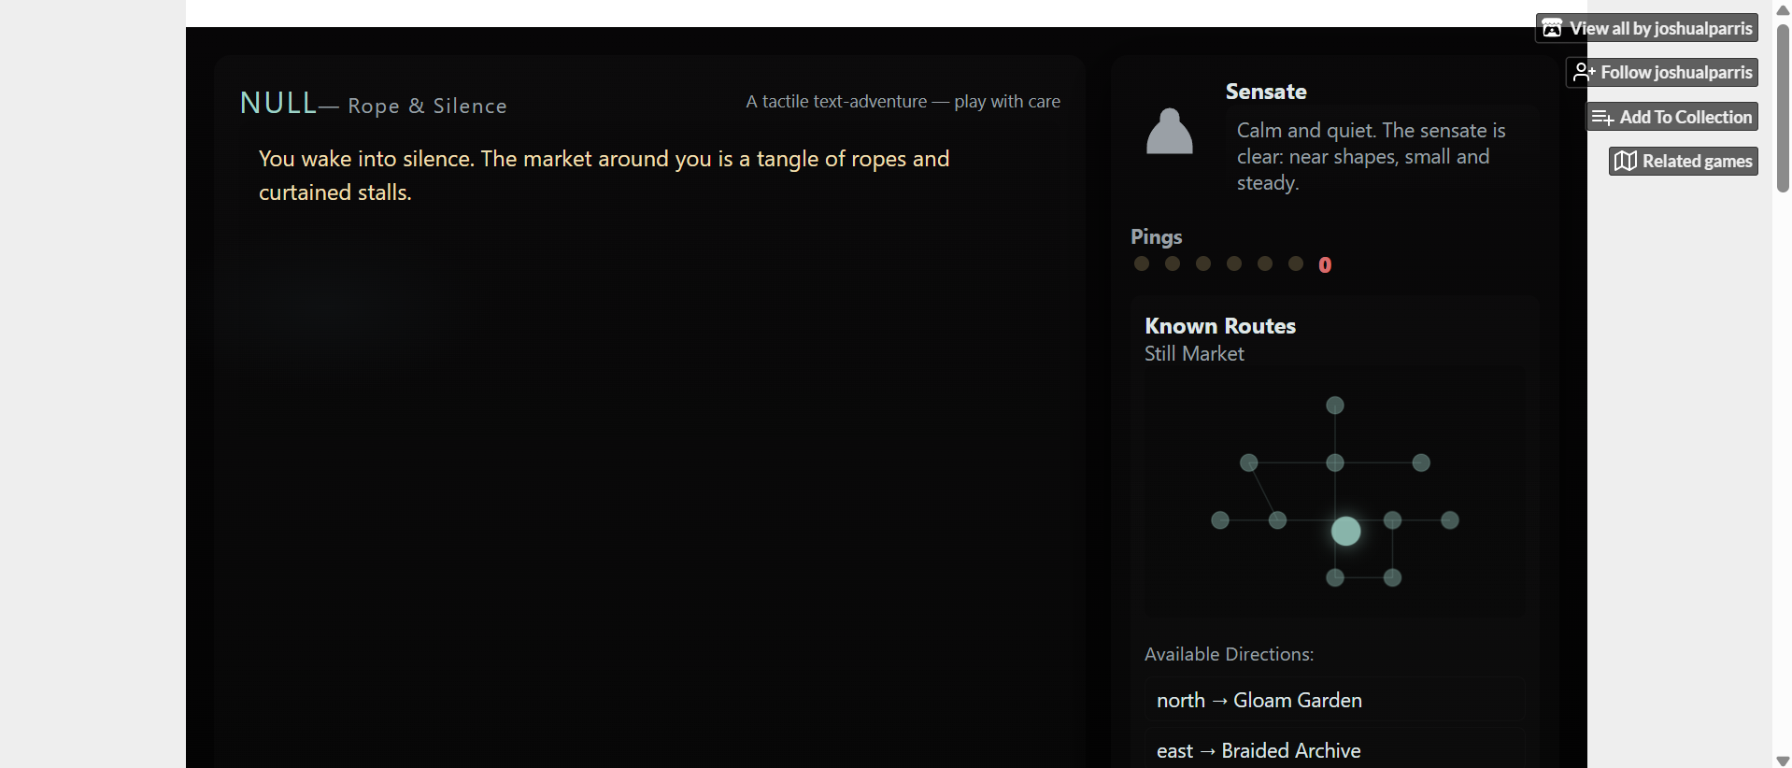
https://joshuaparrisdadlan-stack.github.io/Null/
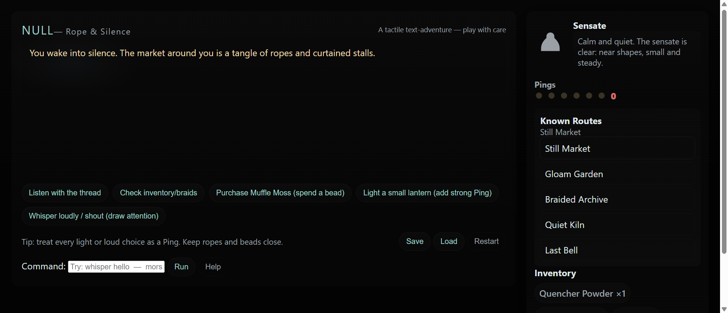
Vercel apps
- Takeaway tonight - https://skill-deploy-gzaqtty7hb-codex-agent-deploys.vercel.app
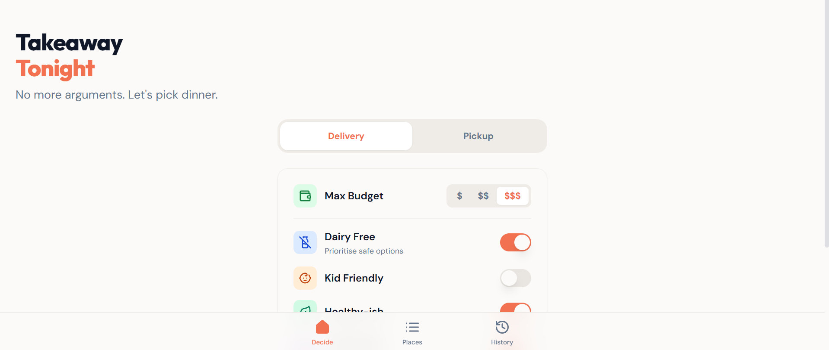

- JoshSim - Life Simulator - https://skill-deploy-wn74y0trpc-codex-agent-deploys.vercel.app
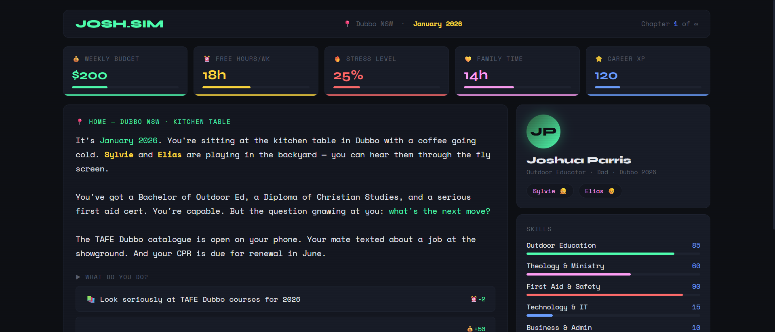
- Parris Budget App - https://parris-budget-app.vercel.app/
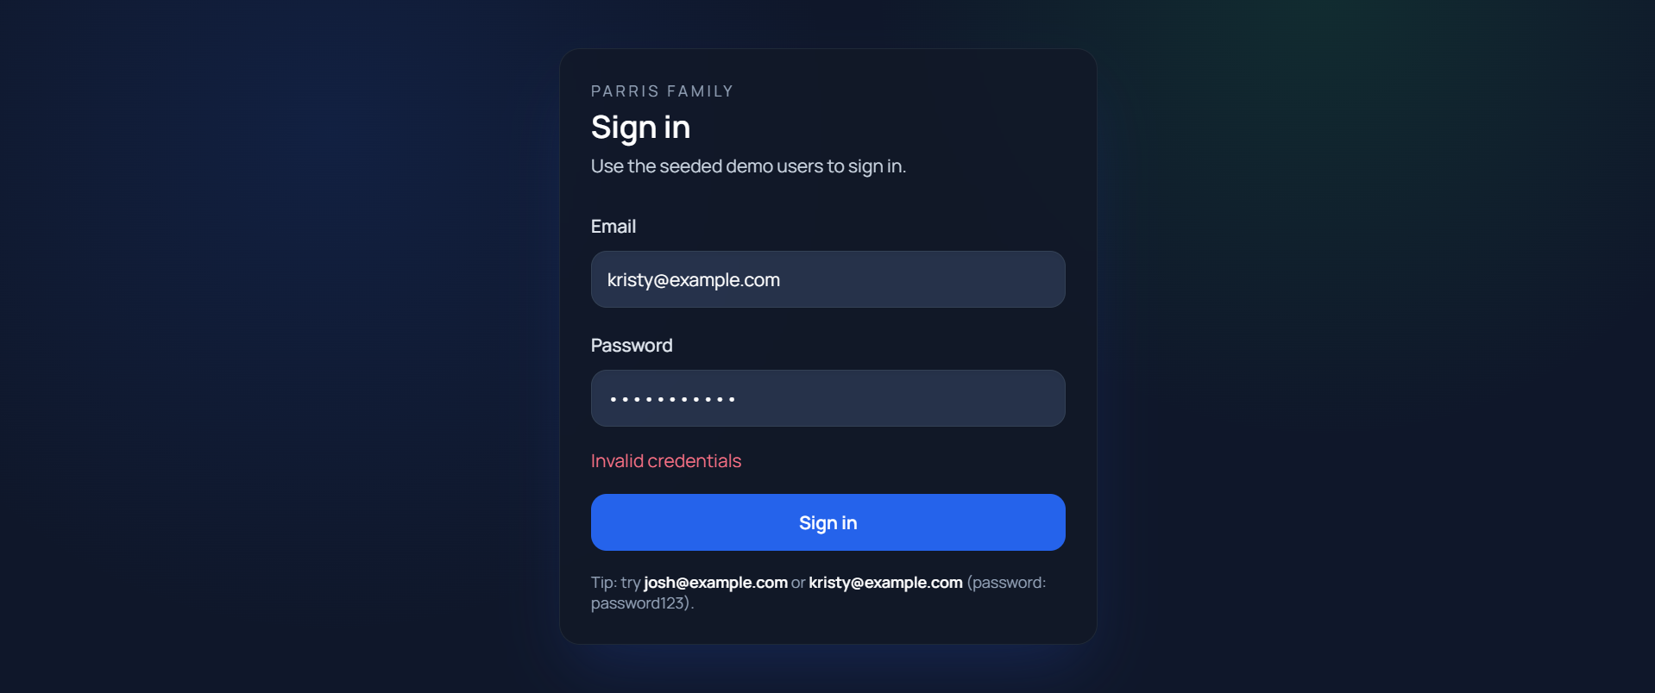
- JoshHealthHub - https://skill-deploy-ibq7zs9hn6-codex-agent-deploys.vercel.app
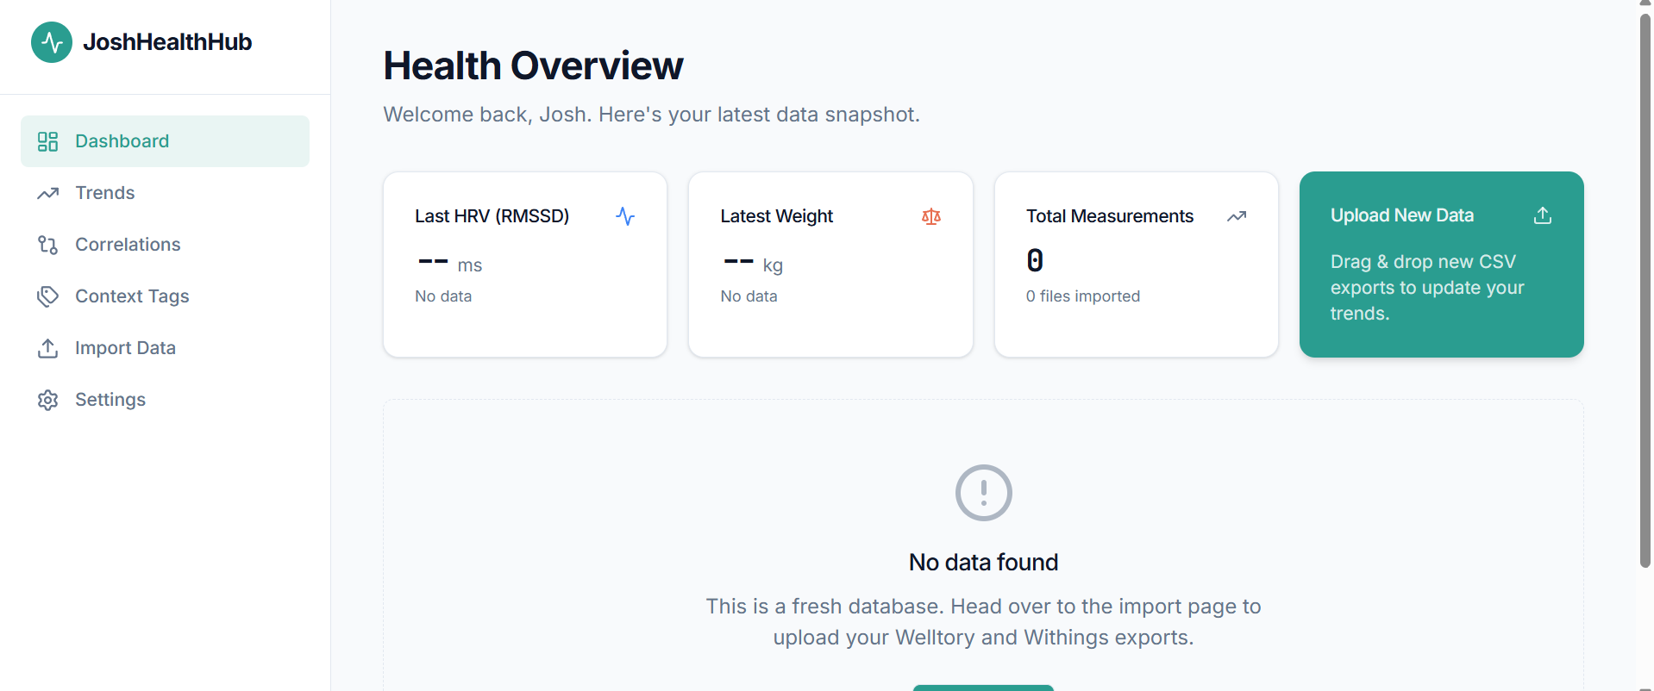

- DrunkJoshGuardian - https://skill-deploy-oww33mfjrh-codex-agent-deploys.vercel.app
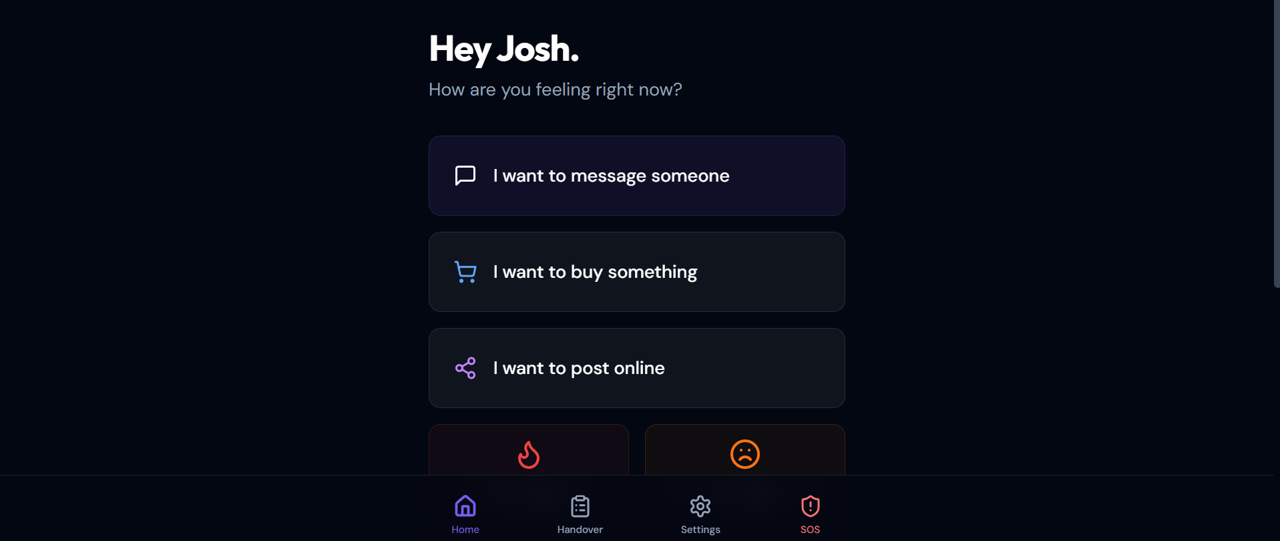

- JoshHub Apps - https://josh-hub-96no.vercel.app/apps
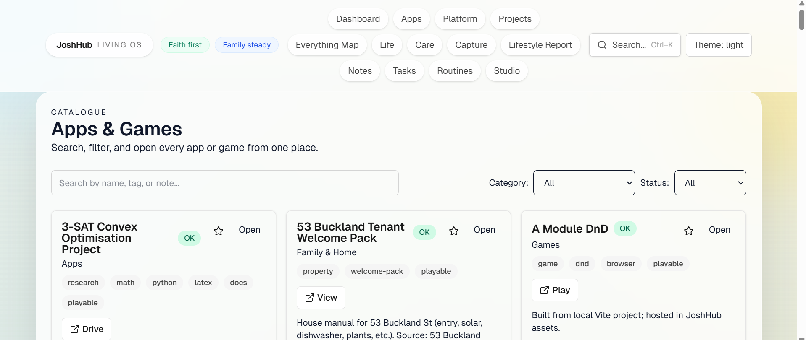
- Hug Coach
https://hug-coach.vercel.app/
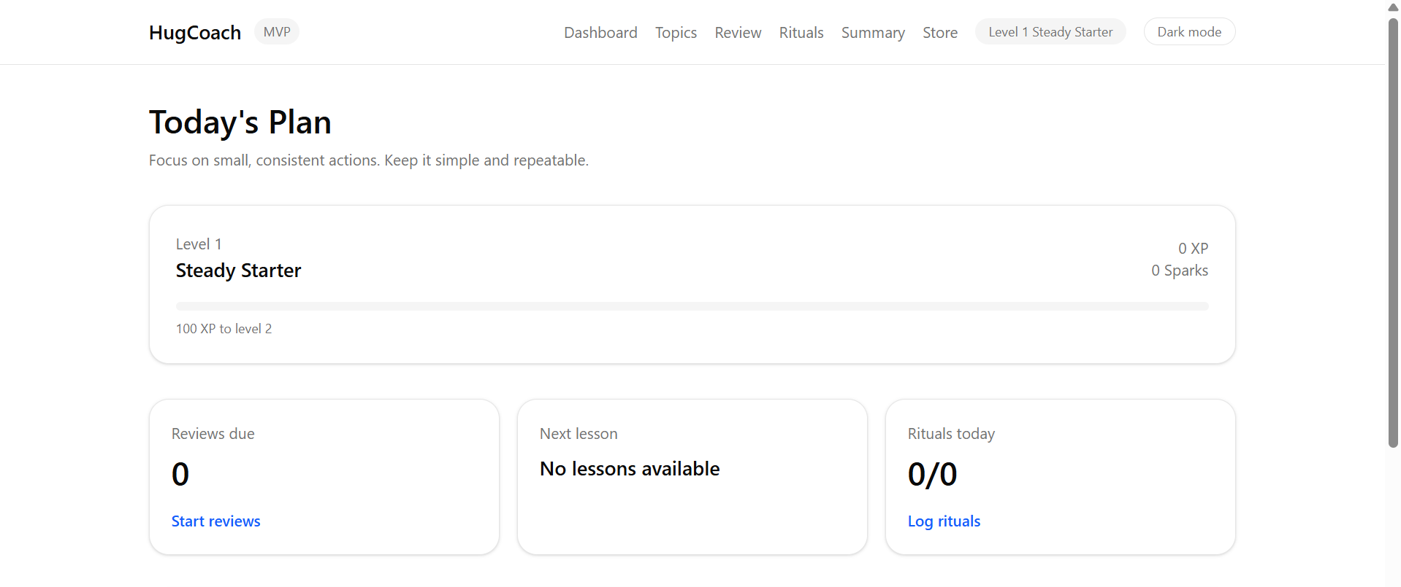

- Clearcore -https://clearcore.vercel.app/
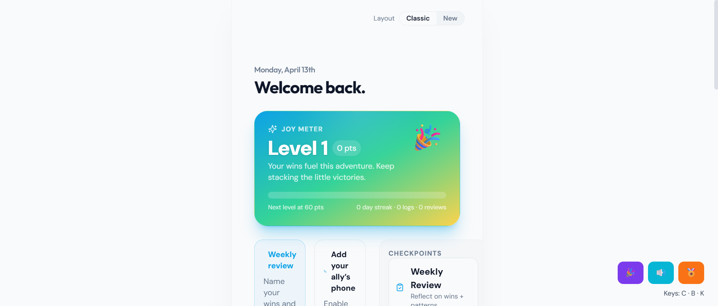
- Lifehub Dashboard - https://lifehubdashboard.vercel.app/
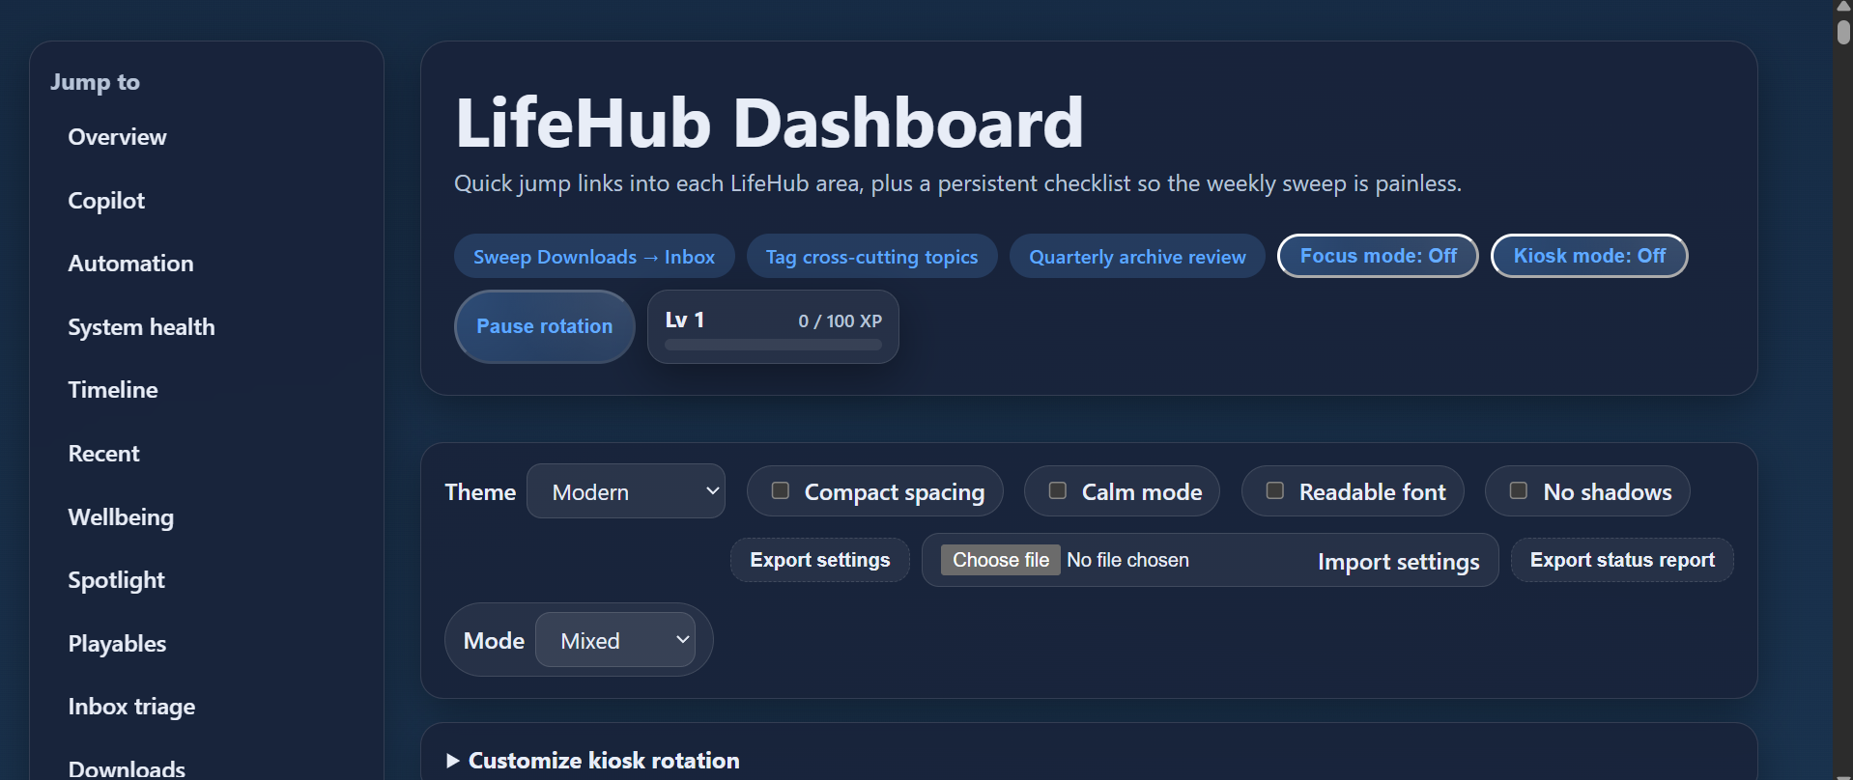
- Parris Piano App
https://parris-piano.vercel.app/
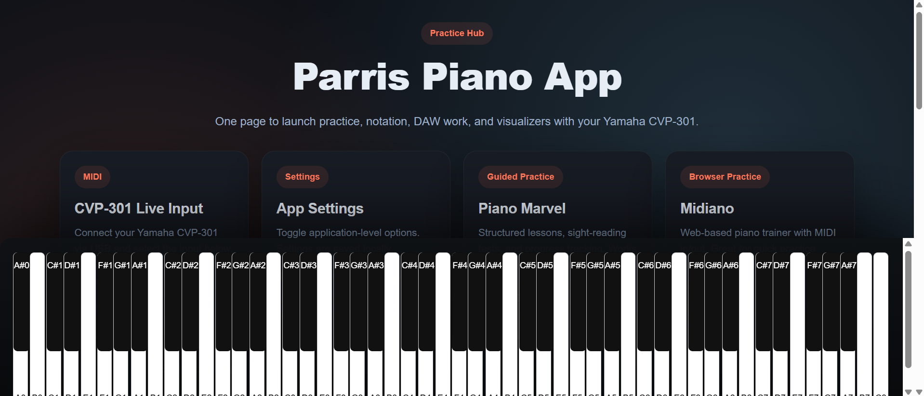

- Parris Tech App - https://parris-tech-app.vercel.app/ (mac one)
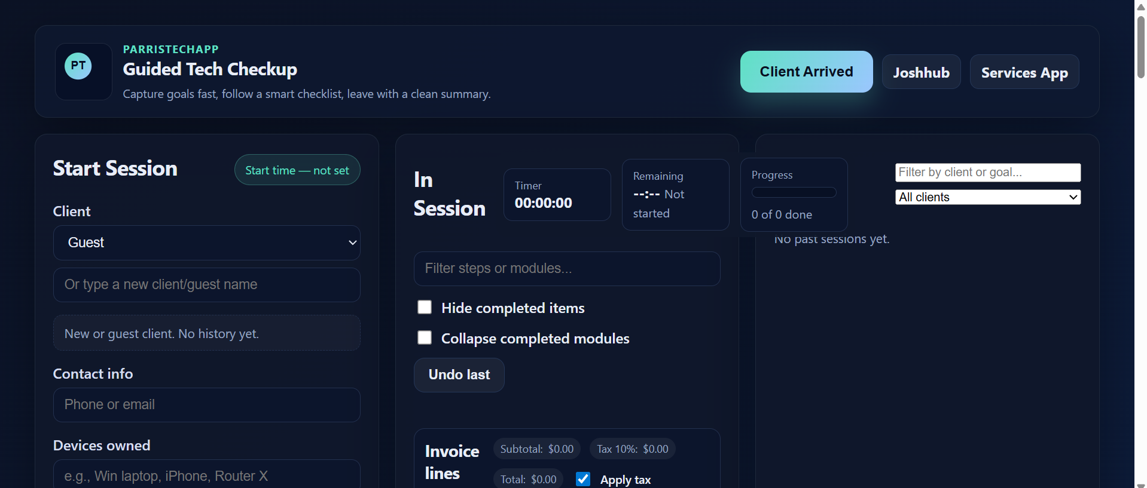
- Parris Tech Services App - https://parris-tech-services-app.vercel.app/ (windows one)
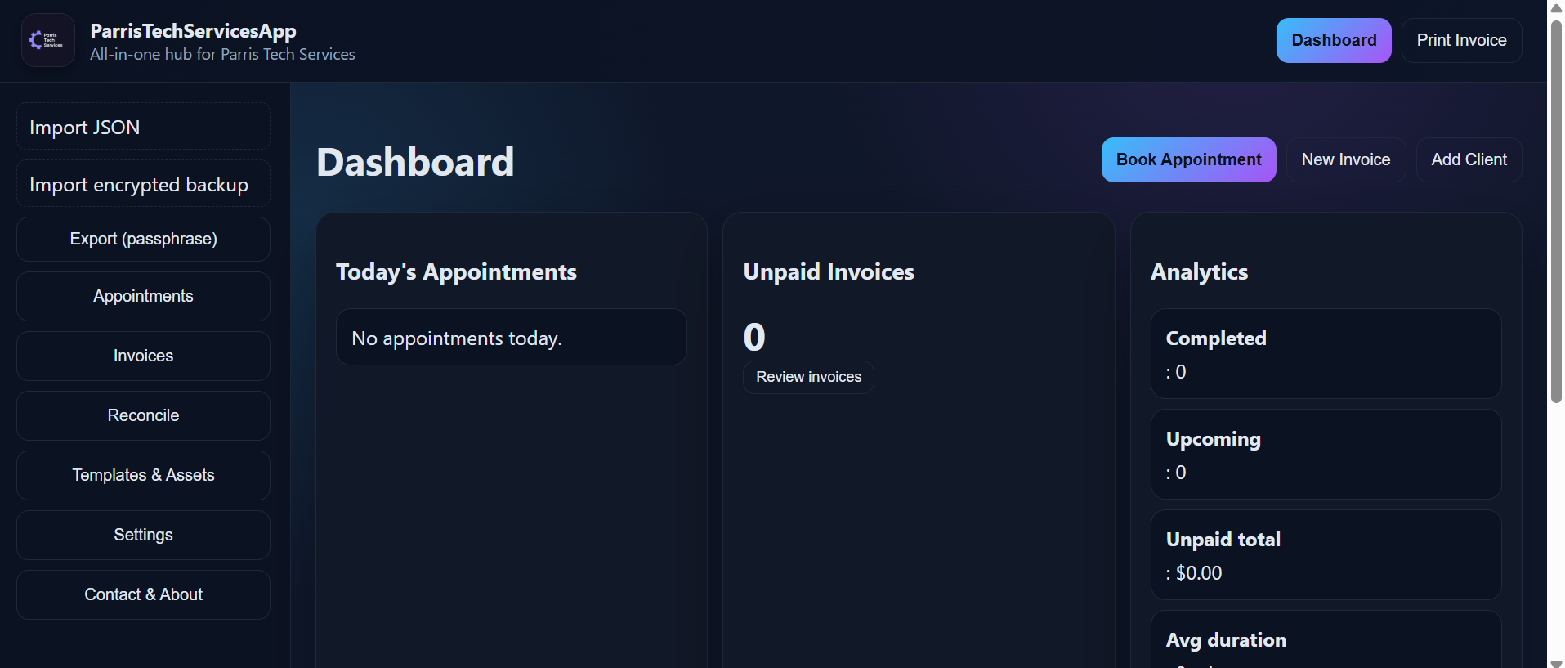
6. https://joshuaparrisdadlan-stack.github.io/whispering-wilds/
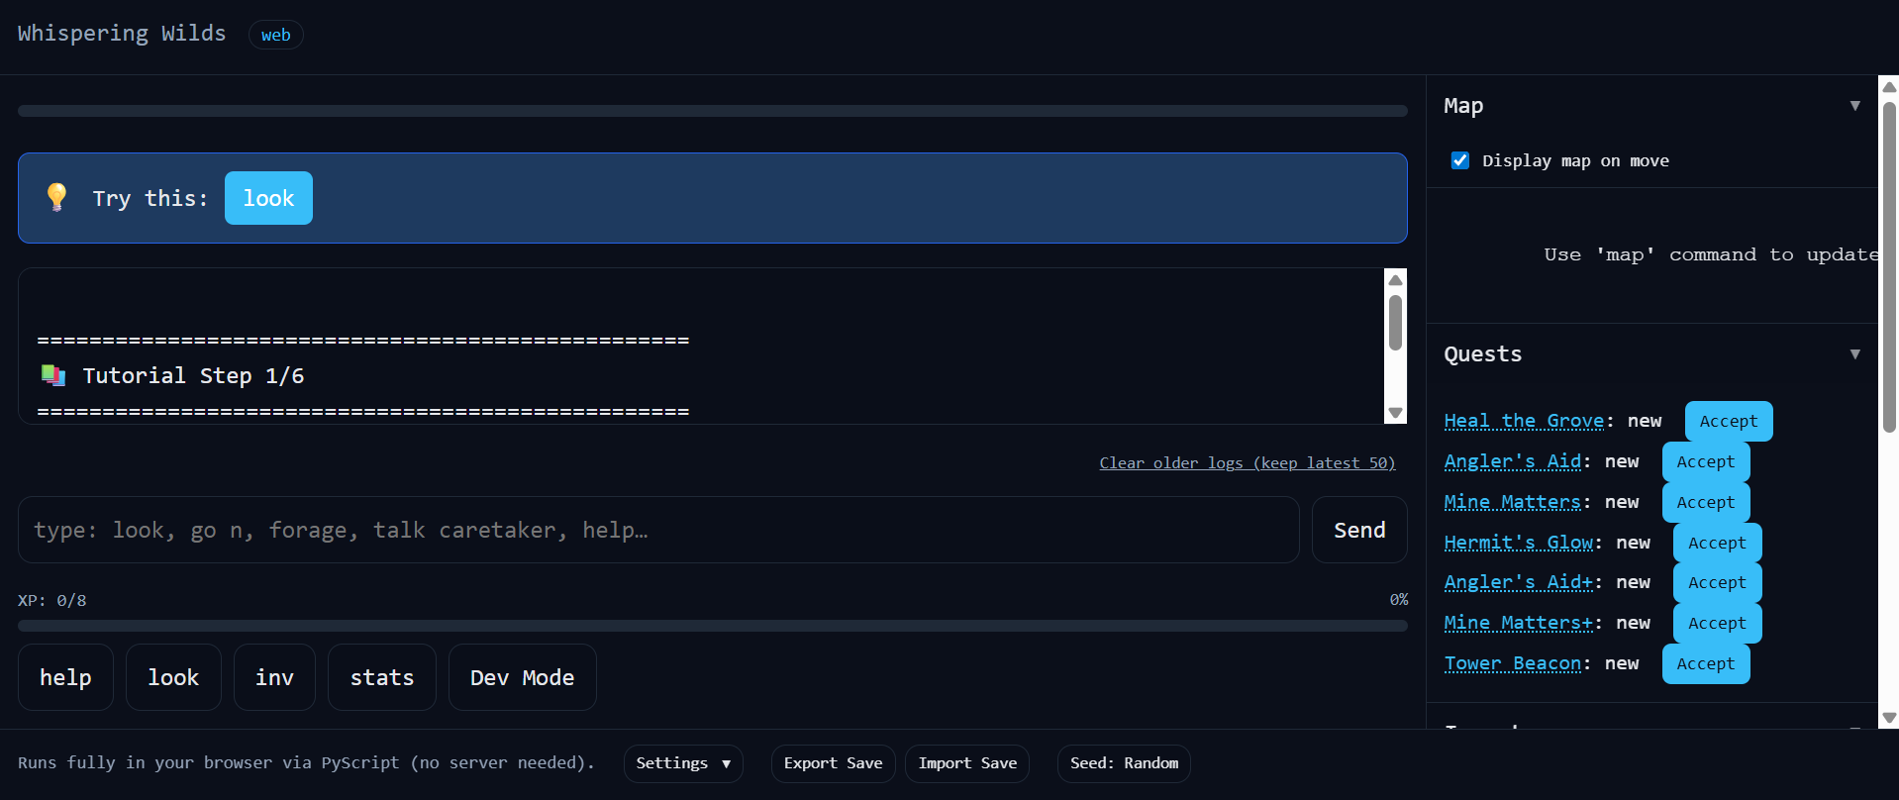

13. https://josh-hub-96no.vercel.app/games/classic-dnd-text/index.html
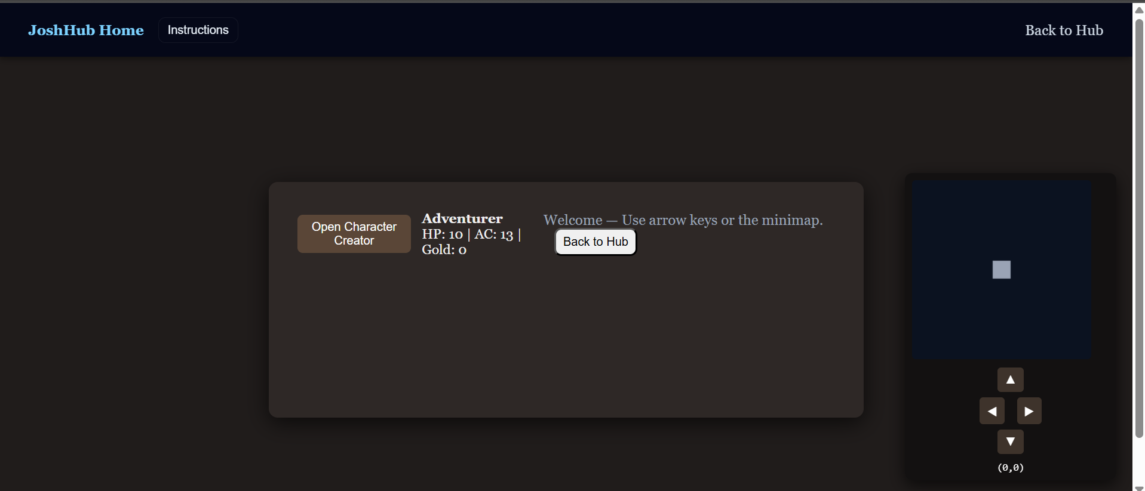
- https://josh-hub-96no.vercel.app/games/dnd-rpg-dungeon/index.html
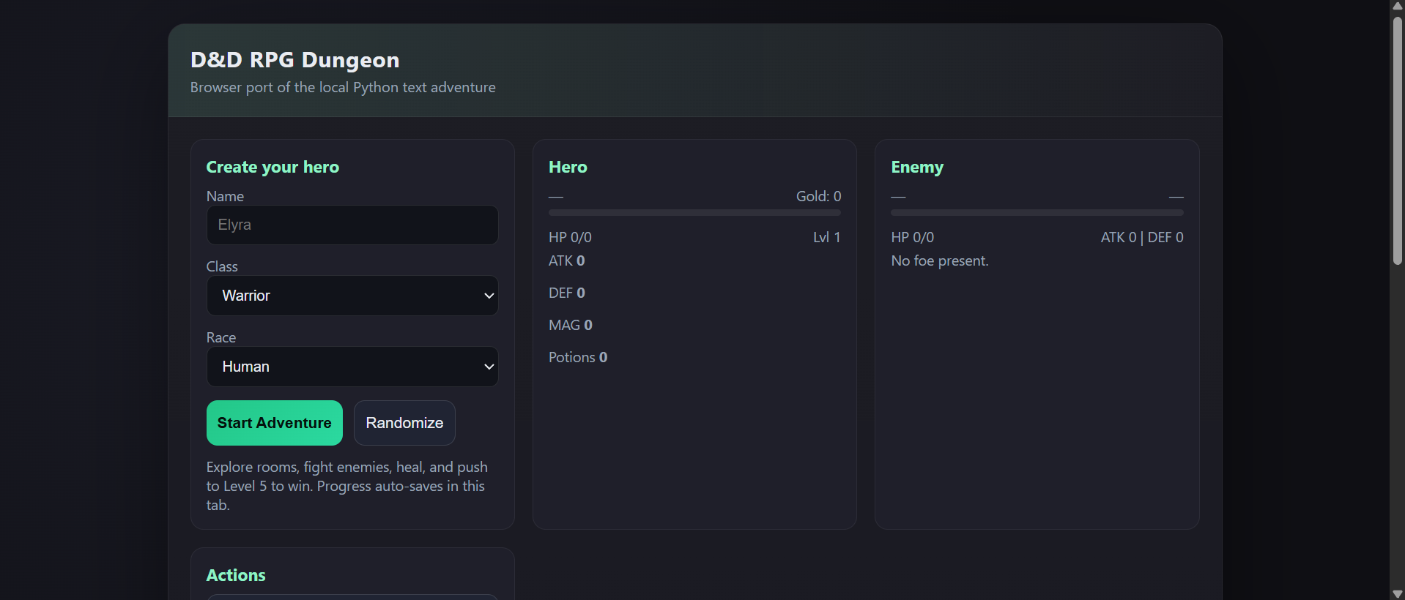
10. https://josh-hub-96no.vercel.app/games/forbidden-quests/index.html
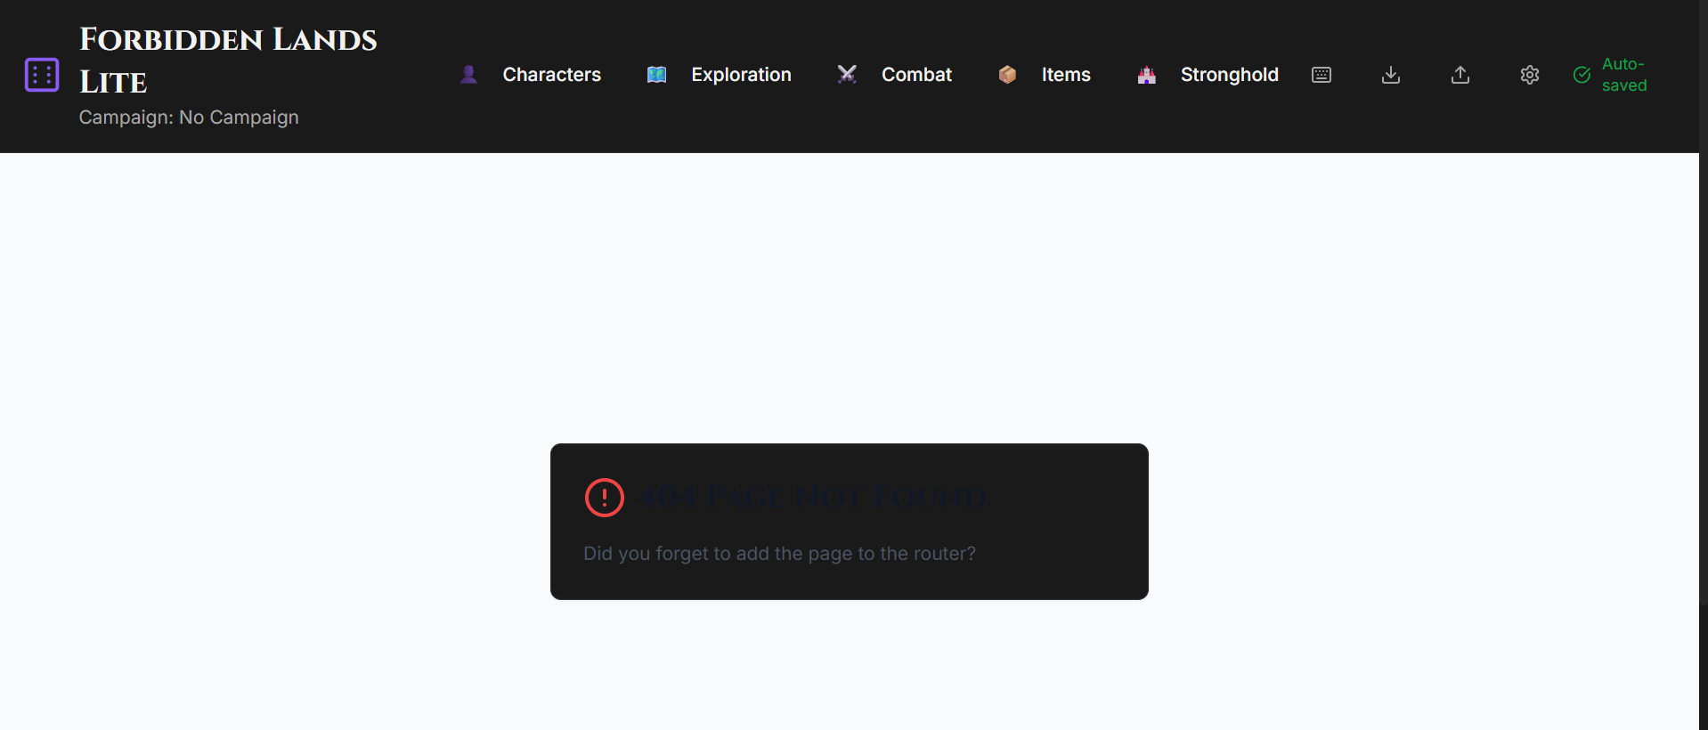

14. Infinite Office / Orgscape - https://josh-hub-96no.vercel.app/games/infinite-office/index.html
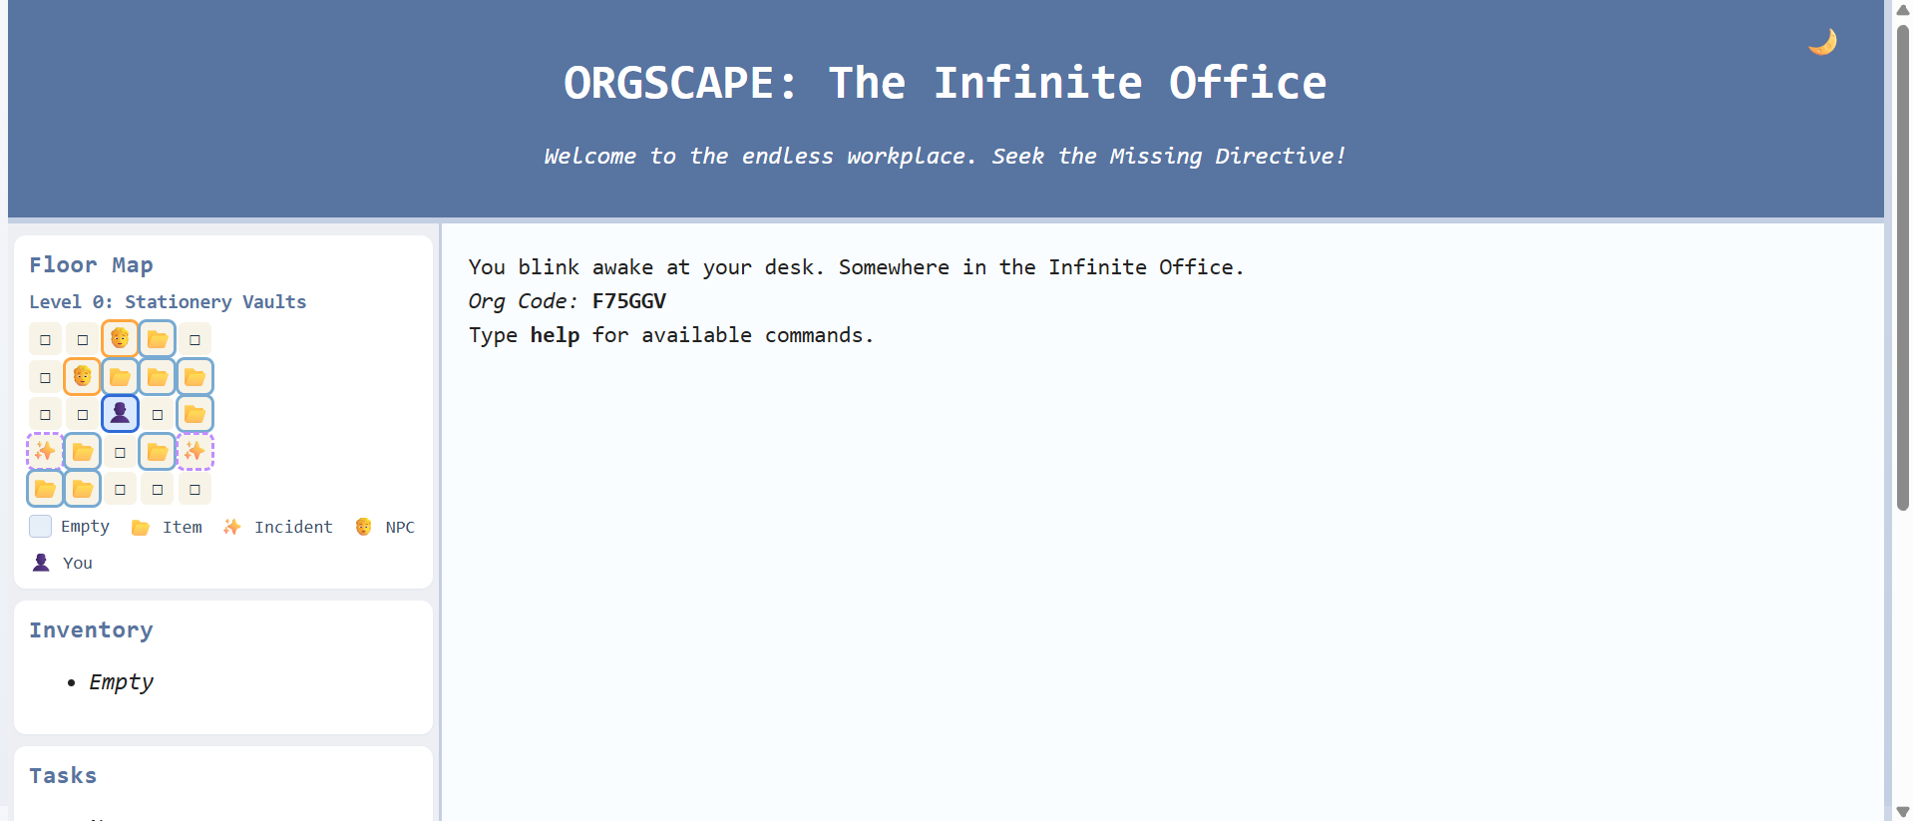
- Max Starhaven - https://josh-hub-96no.vercel.app/games/max/index.html
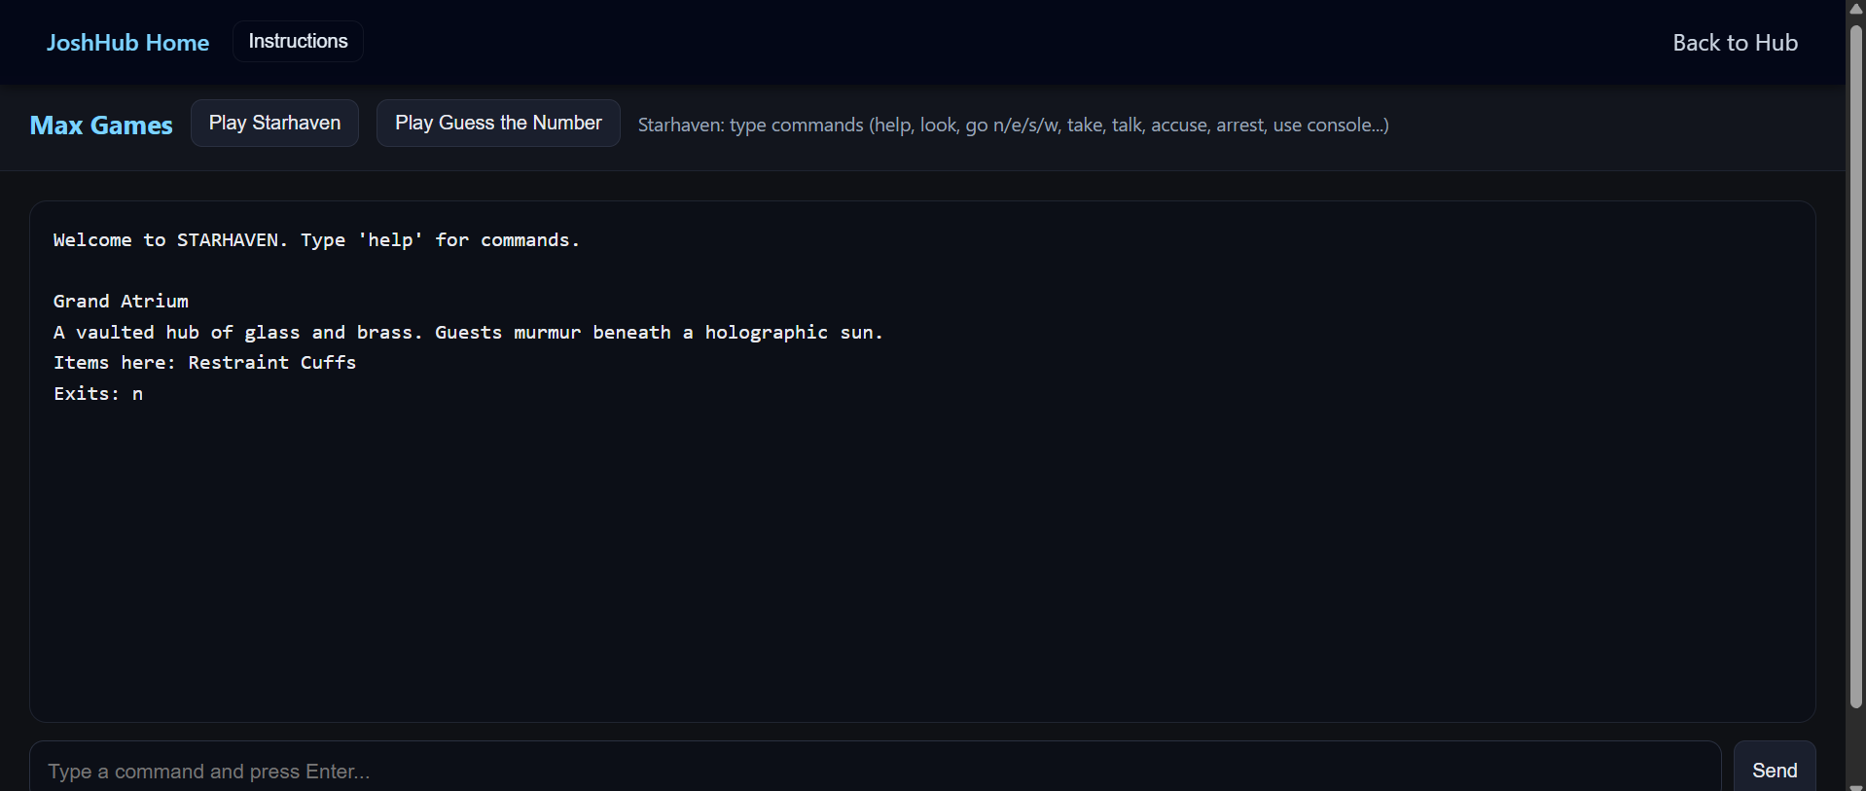
- Midnight Line - https://josh-hub-96no.vercel.app/games/midnight-line/index.html
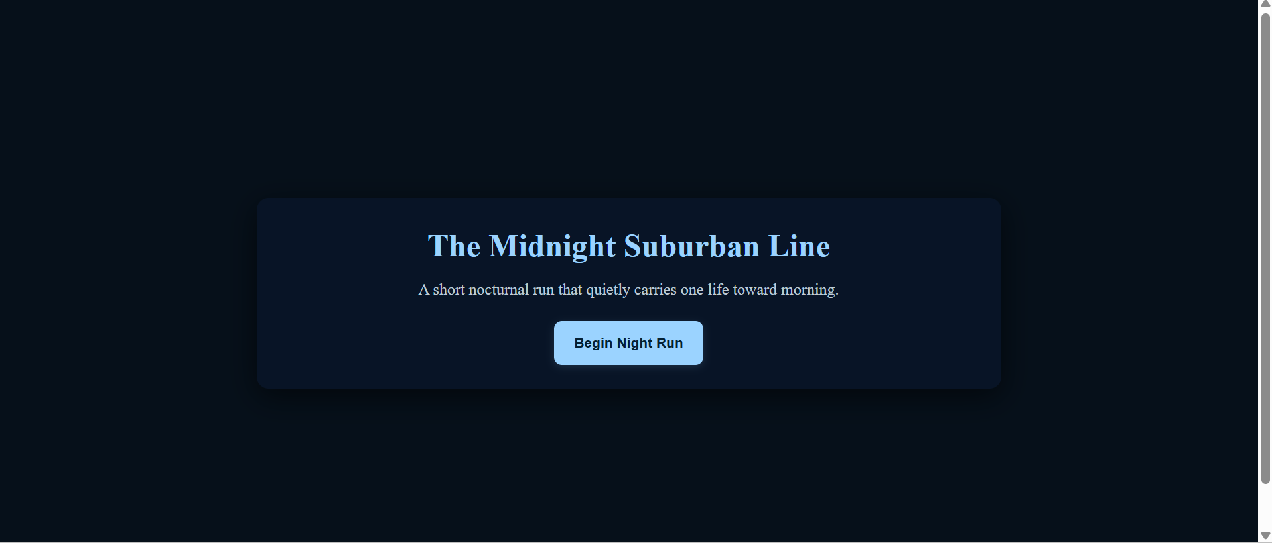
12. https://joshuaparrisdadlan-stack.github.io/MysteriousDepths/
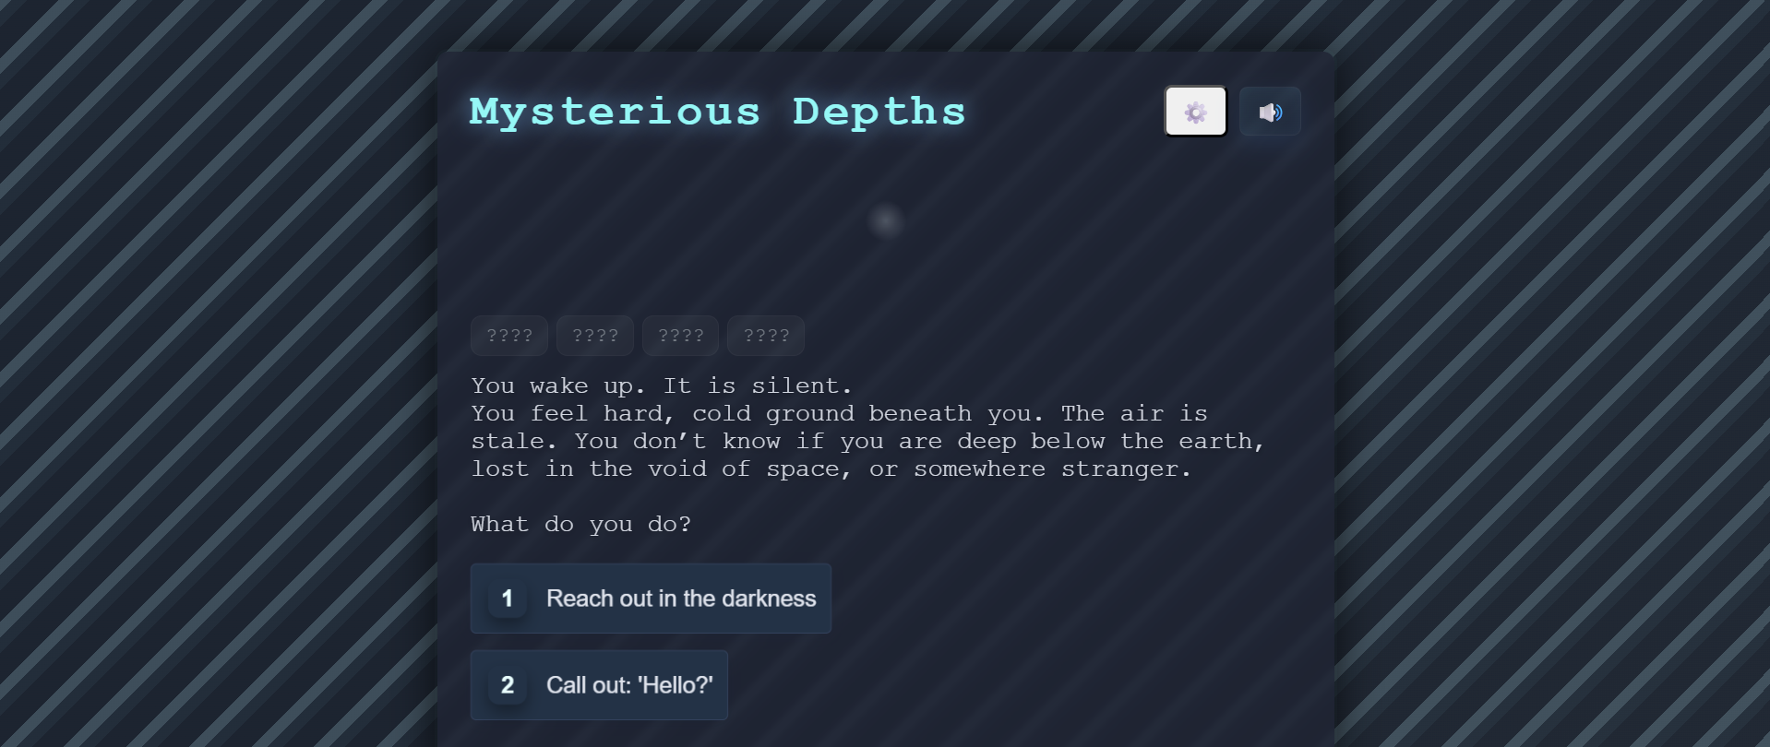
- Dark Realms - https://josh-hub-96no.vercel.app/games/newgame/index.html
https://htmlpreview.github.io/?https://raw.githubusercontent.com/joshualparris/JoshHub/d7521ab/public/games/newgame/index.html
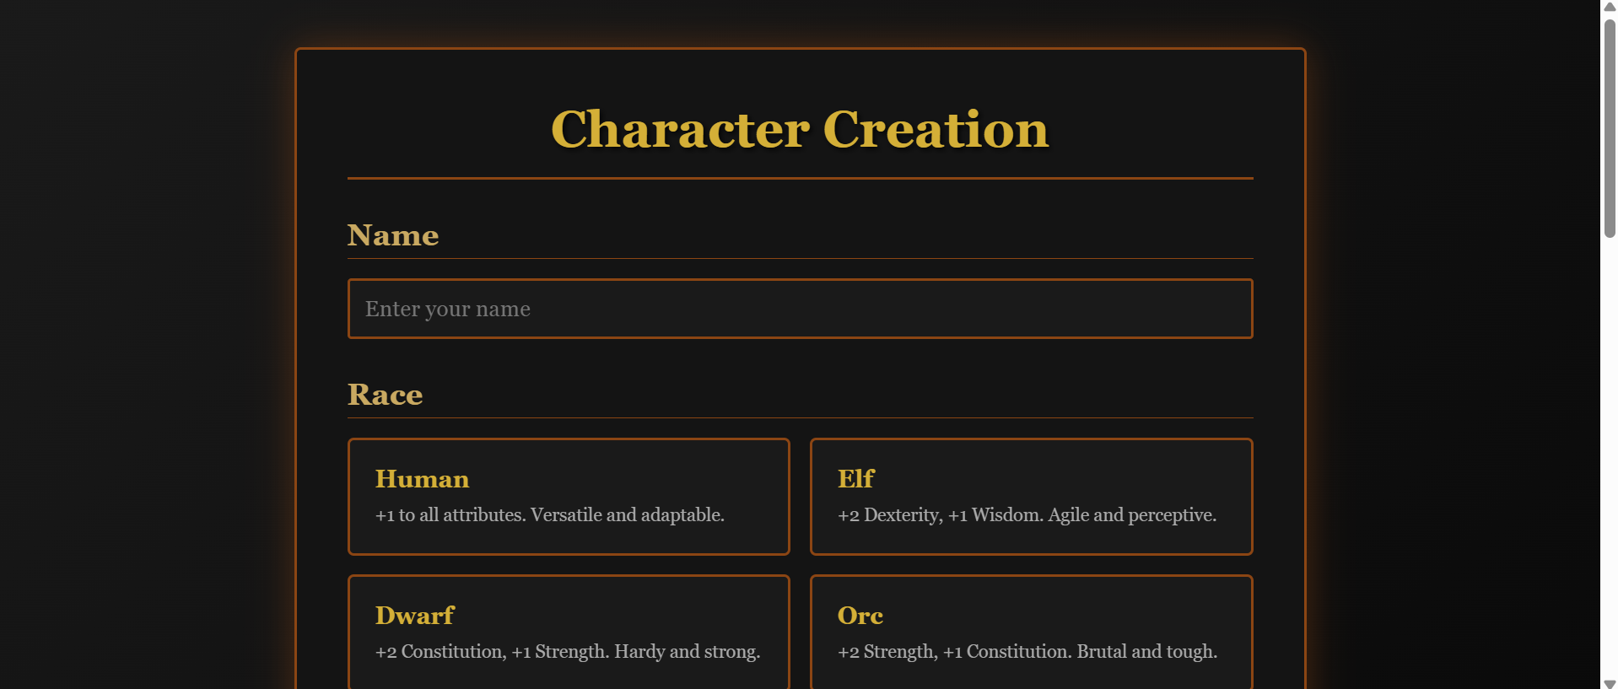
15. https://joshuaparrisdadlan-stack.github.io/Null/
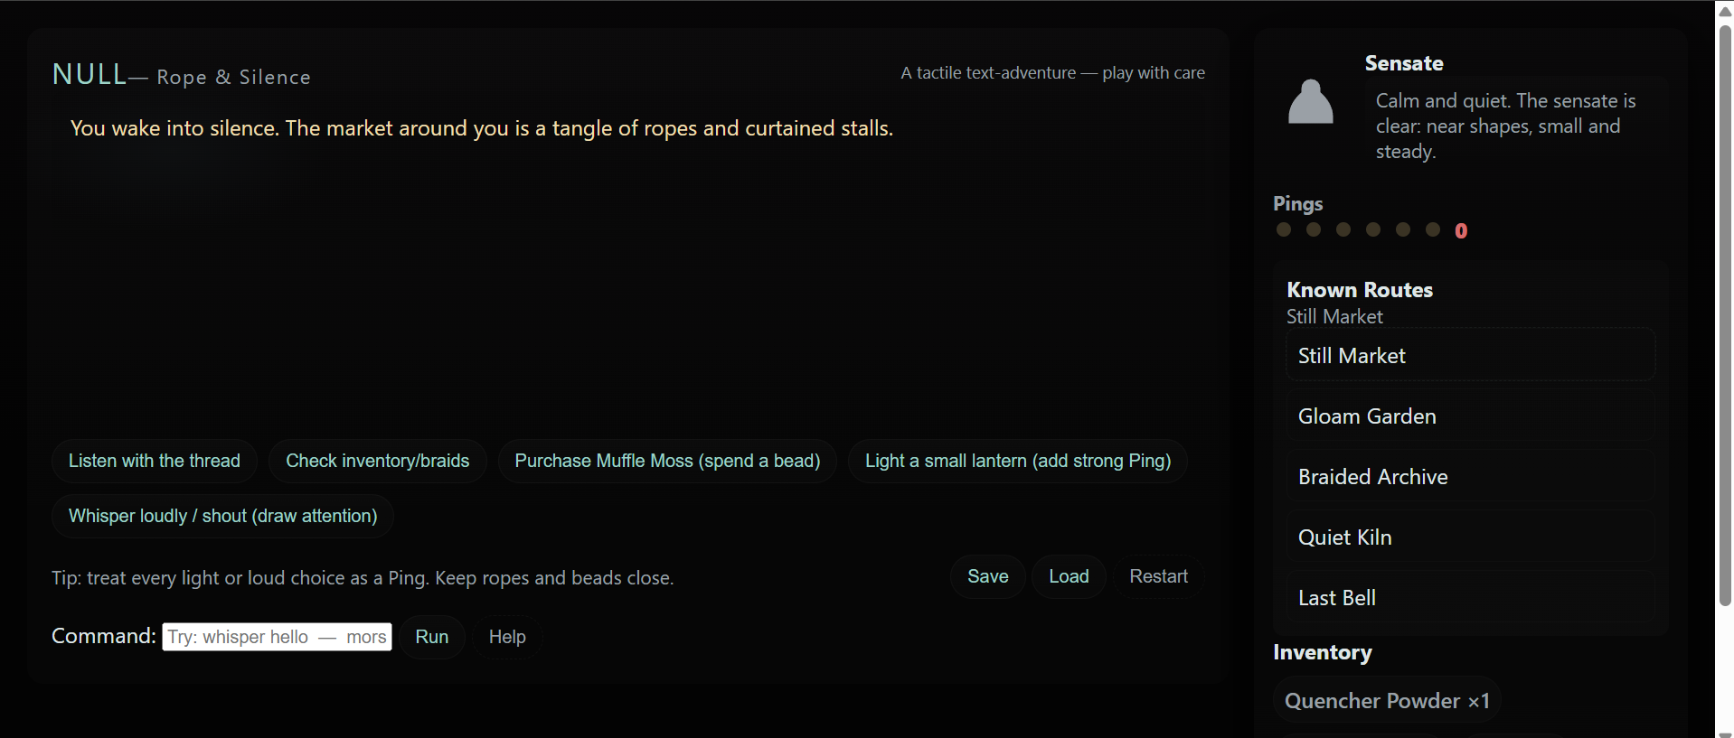

14. https://josh-hub-96no.vercel.app/games/orgscape/index.html
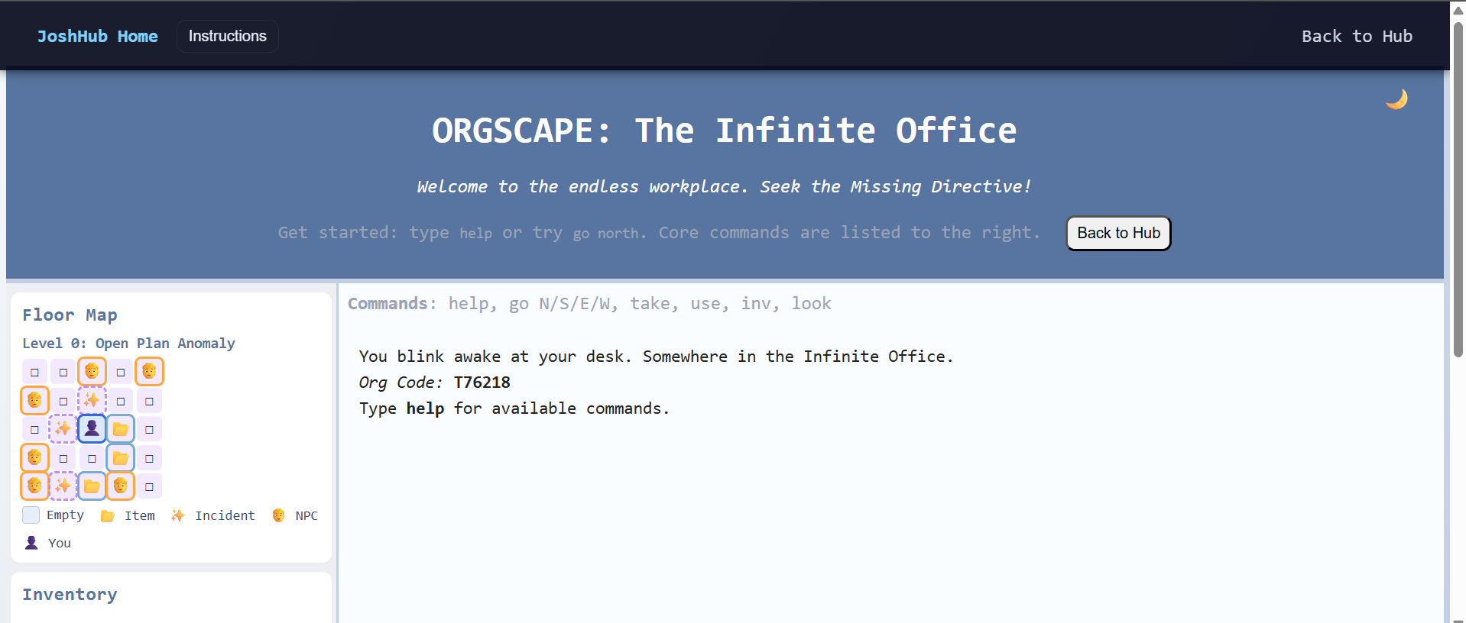

14. https://joshuaparrisdadlan-stack.github.io/OrgScape/
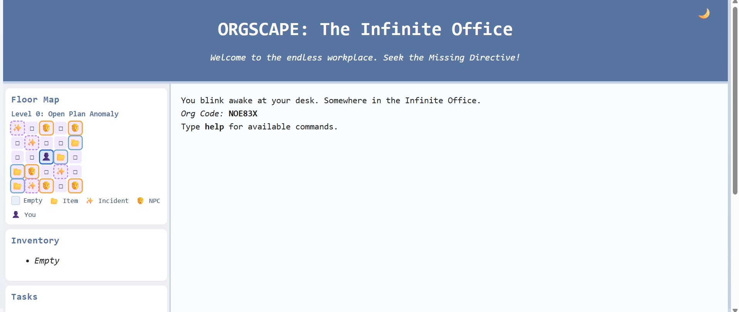

13. https://joshuaparrisdadlan-stack.github.io/LetsPlayDnd/
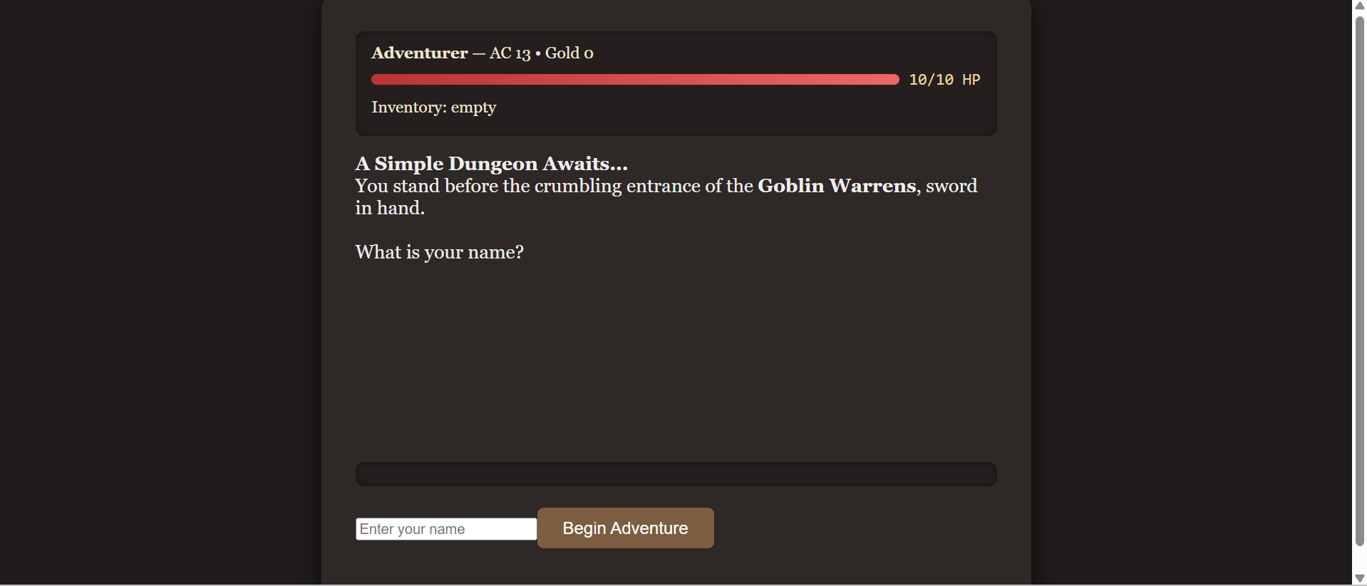
- https://josh-hub-96no.vercel.app/
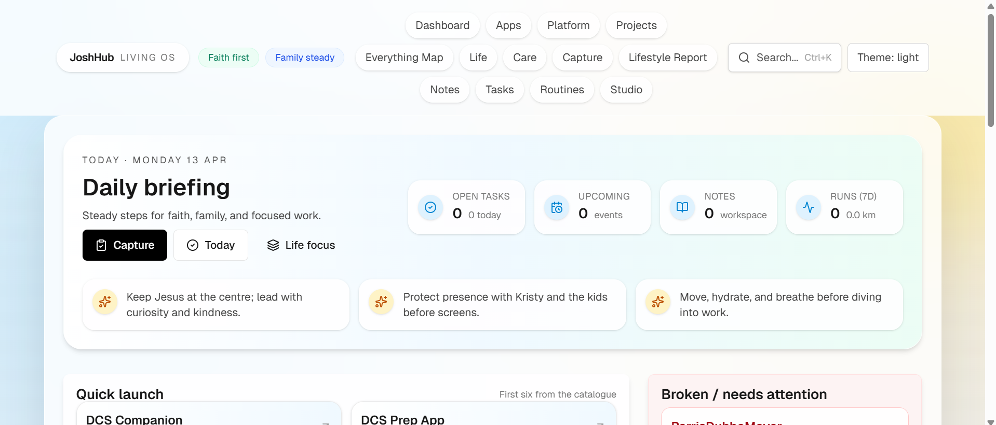

29. https://josh-hub-96no.vercel.app/games/max/index.html
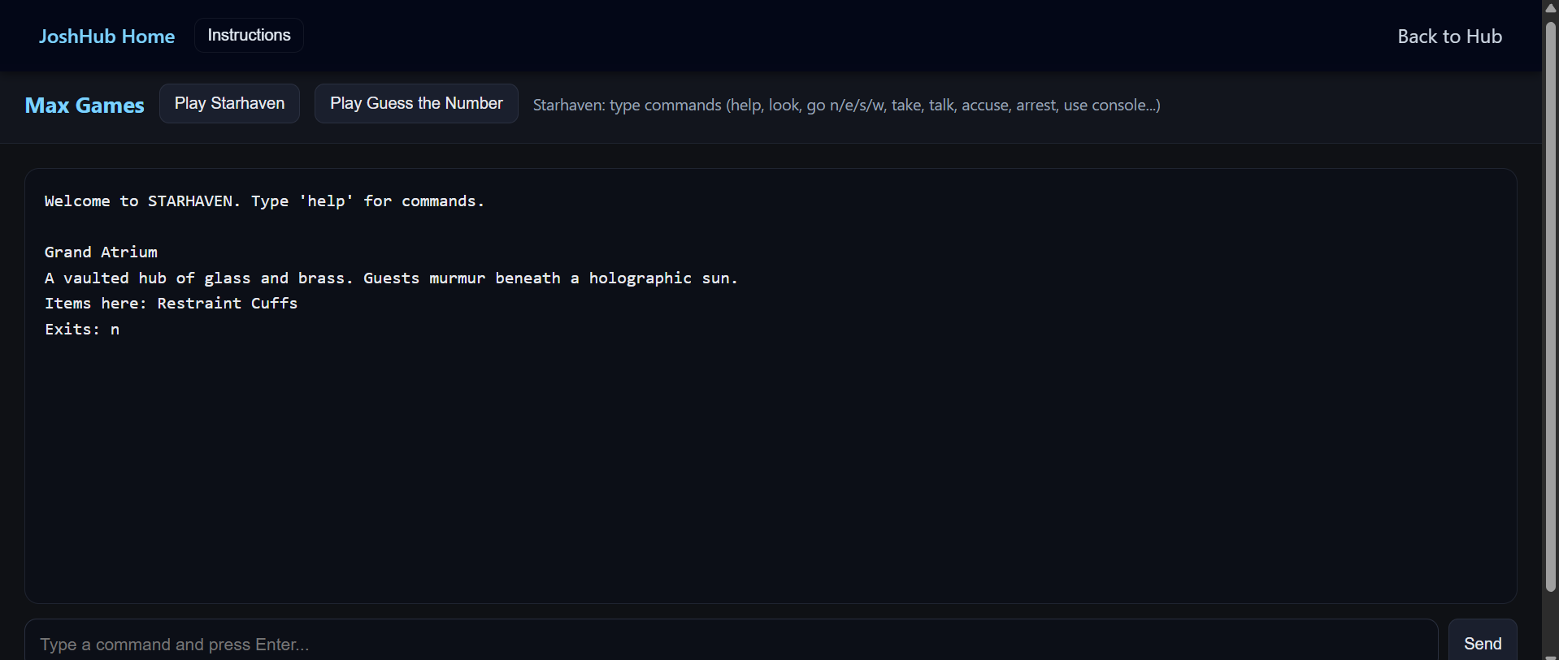
32. https://joshualparris.github.io/wastes-courier-roguelike/
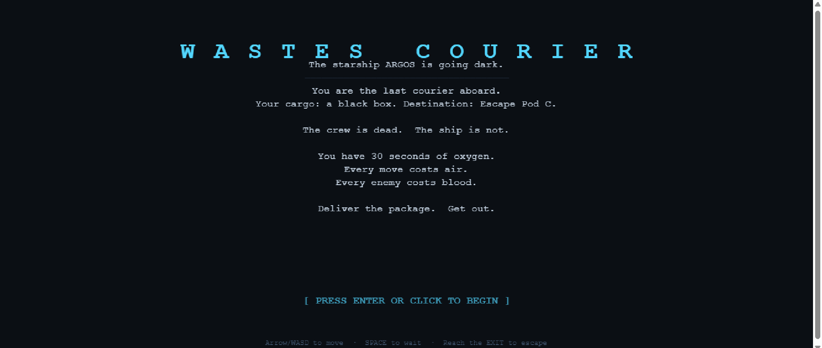

33. Different version of Whispering Wilds
https://joshuaparris-max.github.io/WhirringWilderness/
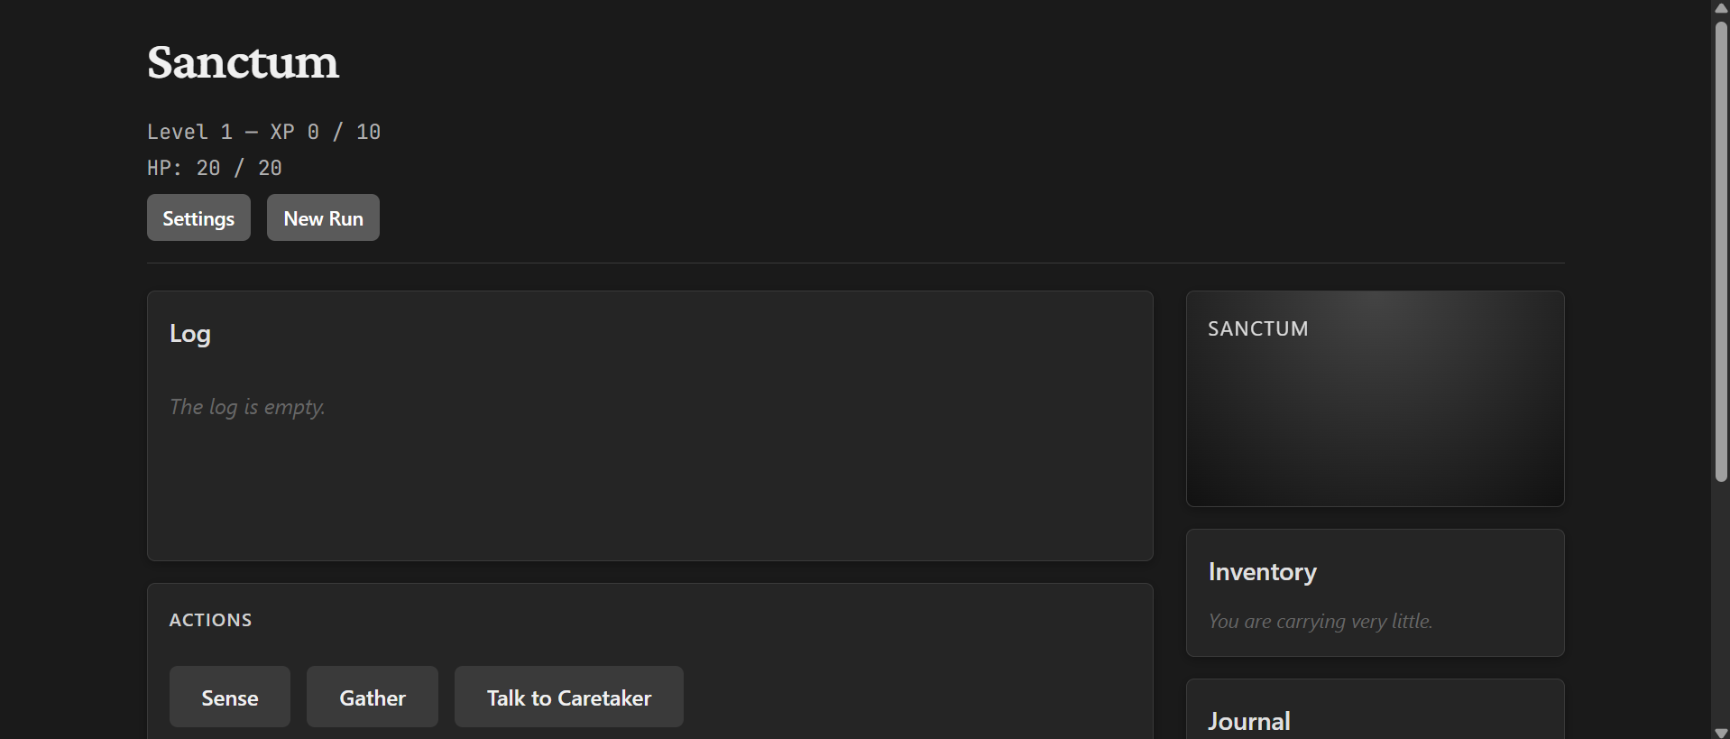
6. https://joshuaparrisdadlan-stack.github.io/whispering-wilds/
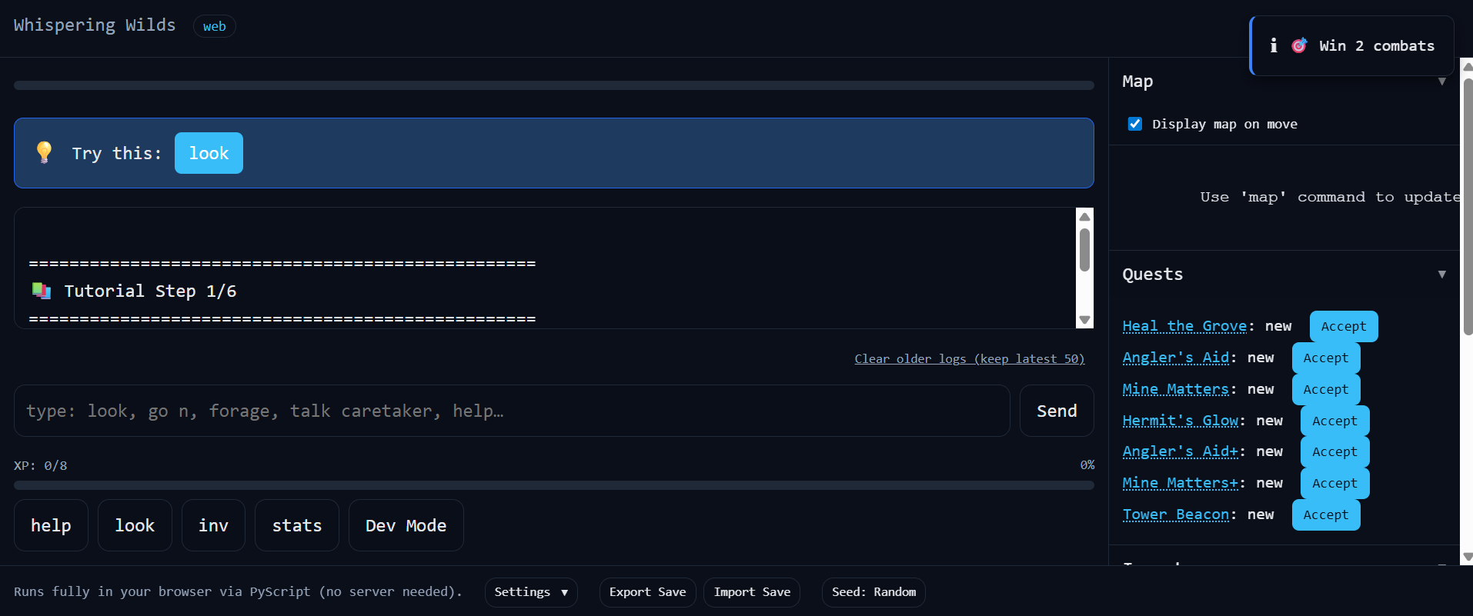
34. Boundary Road Panos
https://htmlpreview.github.io/?https://raw.githubusercontent.com/joshualparris/JoshHub/3de1a67/public/games/boundary-road/index.html


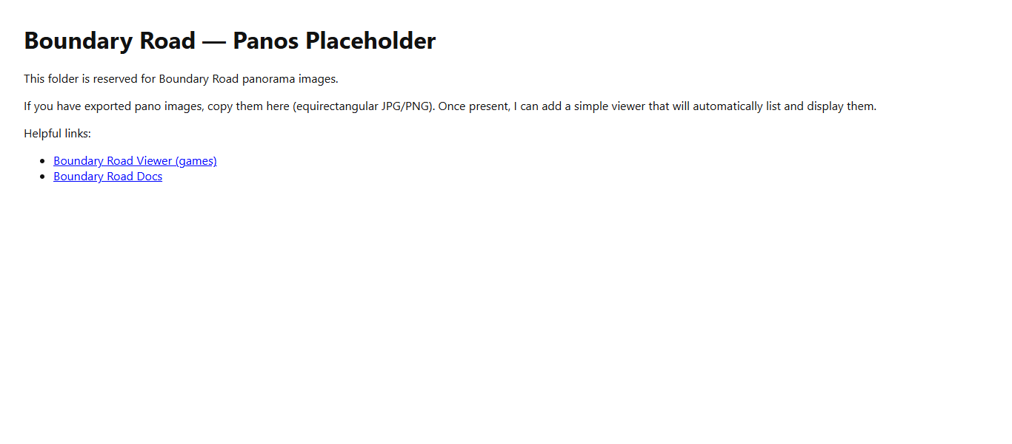
file:///C:/Users/joshu_w0zb8cp/OneDrive%20-%20Dubbo%20Christian%20School/Documents/03_Projects/JoshHub/JoshHub/public/panos/boundary-road/index.html

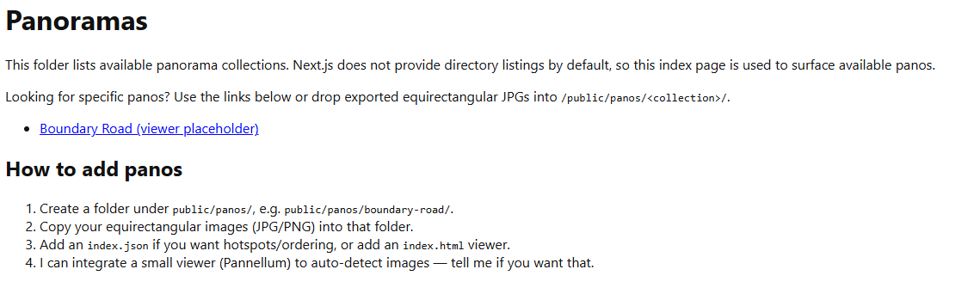
file:///C:/Users/joshu_w0zb8cp/OneDrive%20-%20Dubbo%20Christian%20School/Documents/03_Projects/JoshHub/JoshHub/public/panos/index.html
35. Neverwinter Tails v1
https://htmlpreview.github.io/?https://raw.githubusercontent.com/joshualparris/JoshHub/8d02ac4/public/games/neverwinter-tales/index.html
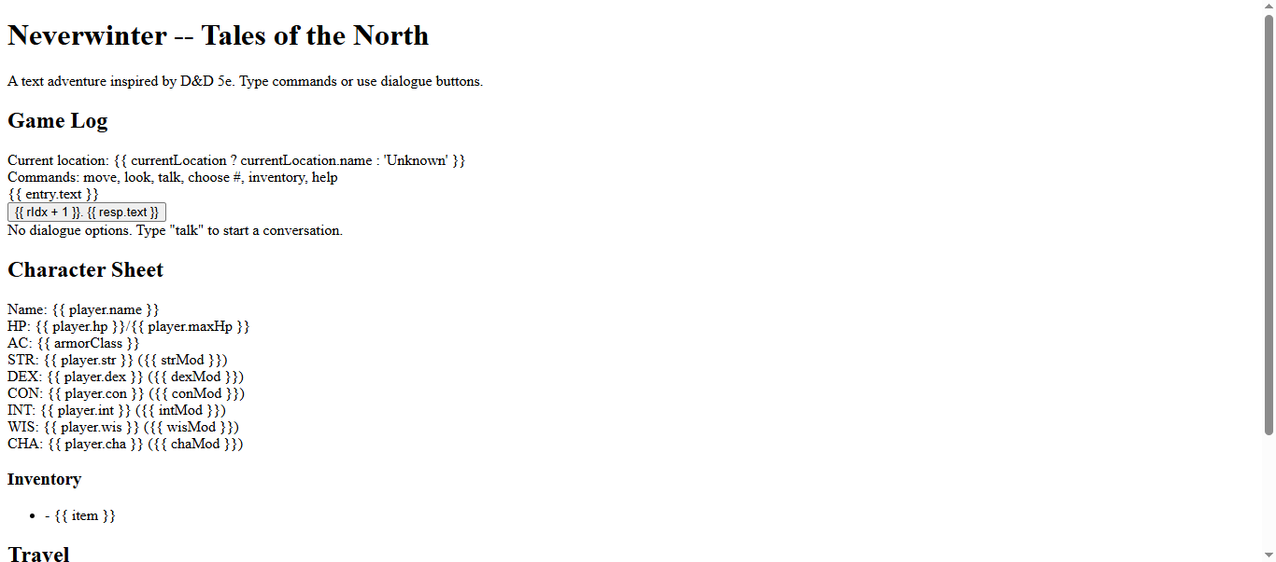

35. Neverwinter Tails v2
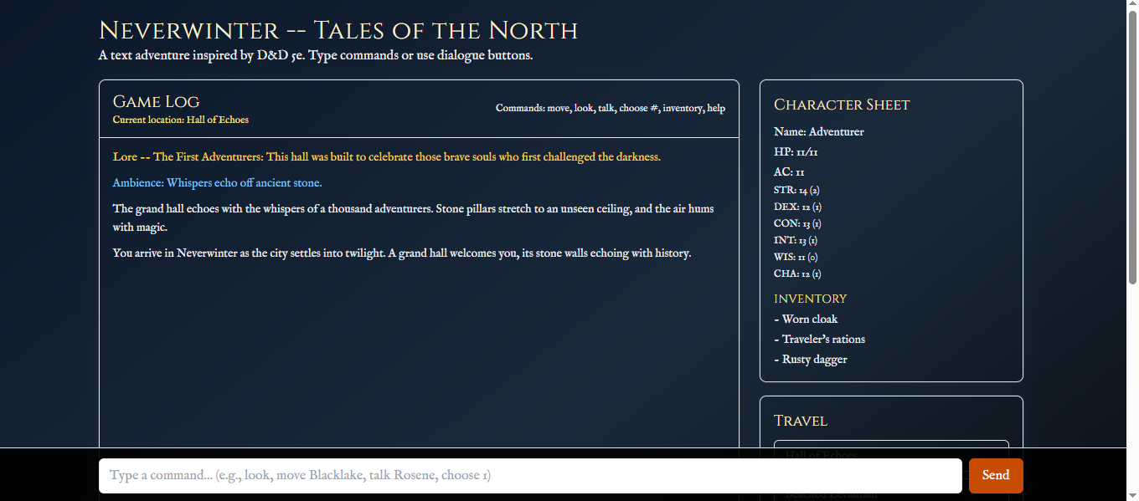
file:///C:/Users/joshu_w0zb8cp/OneDrive%20-%20Dubbo%20Christian%20School/Documents/03_Projects/JoshHub/public/games/neverwinter-tales/index.html
36. Sylvie Coregulation App - https://skill-deploy-a7nrkvc4gz.vercel.app/
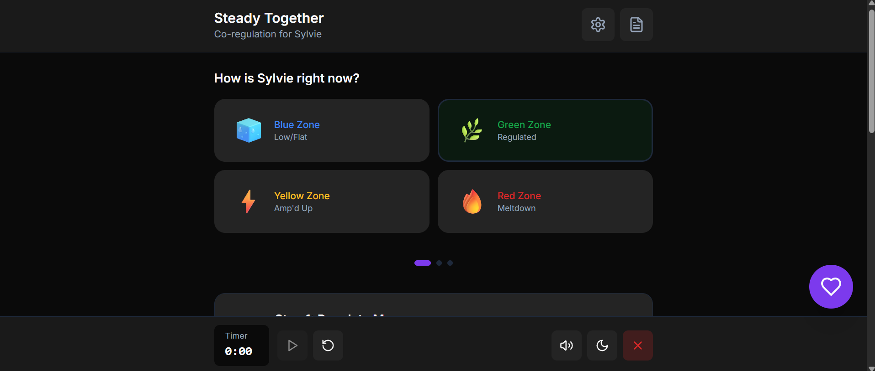
37. Wilds Sail West
https://htmlpreview.github.io/?https://raw.githubusercontent.com/joshualparris/JoshHub/41dfcef/public/games/wilds-sail-west/index.html

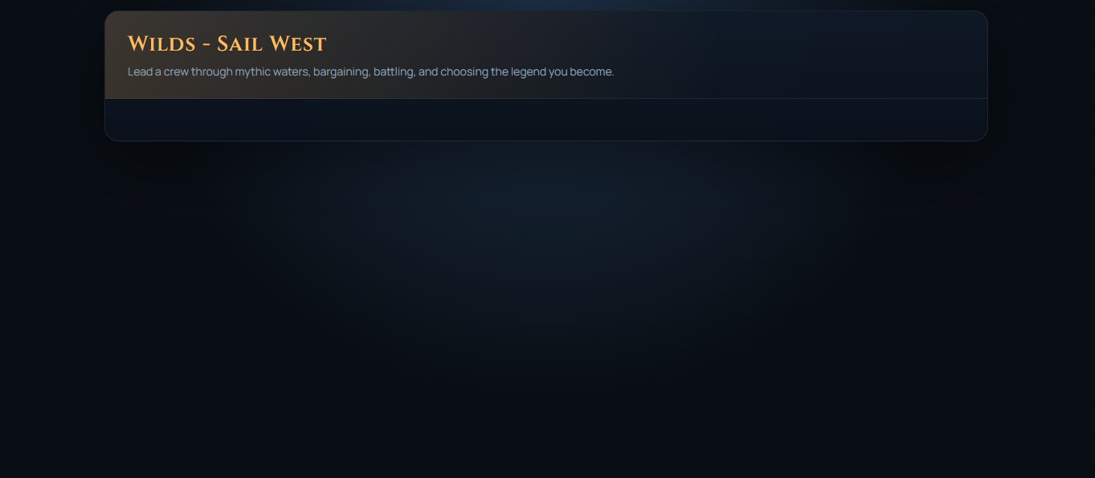

38 . Wilds Main
https://htmlpreview.github.io/?https://raw.githubusercontent.com/joshualparris/JoshHub/d7521ab/public/games/wilds-main/index.html

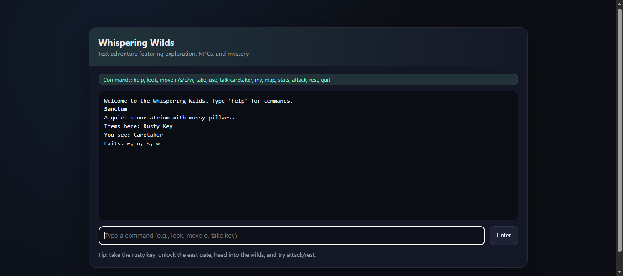
newfileqqqwertuhvgjkk.py
joshualparris/newfileqqqwertuhvgjkk.py

39. BucklandBlocks
39. joshualparris/BucklandBlocks

owner | name | visibility | category | status | size | notes
joshualparris | BucklandBlocks | public | game | active prototype | 3602 | Ambitious browser voxel sandbox.
joshualparris | BucklandBlocks1 | private | game | placeholder | 0 | Private placeholder or abandoned fork.
joshuaparrisdadlan-stack | BucklandGame | public | game | prototype | 14 | Small experiment.

1. JoshHub
1. joshualparris/JoshHub
6. Whispering-Wilds
6. joshualparris/Whispering-Wilds
22. HugCoach
22. joshualparris/HugCoach
40. energyquest
40. joshualparris/energyquest
3. DCSPrep
3. joshualparris/DCSPrep
39. BucklandBlocks1
39. joshualparris/BucklandBlocks1
26. ParrisTechApp
26. joshualparris/ParrisTechApp
27. ParrisTechServicesApp
27. joshualparris/ParrisTechServicesApp
24. LifeHub
24. joshualparris/LifeHub
23. ClearCore
23. joshualparris/ClearCore
41. JoshCoach
41. joshuaparris-max/JoshCoach
32. wastes-courier-roguelike
32. joshualparris/wastes-courier-roguelike
42. JoshTapApp
42. joshuaparrisdadlan-stack/JoshTapApp
42. JoshTapApp
42. joshualparris/JoshTapApp
See - JoshNFCAndroidApp
43. JoshNFCAudio
43. joshualparris/JoshNFCAudio
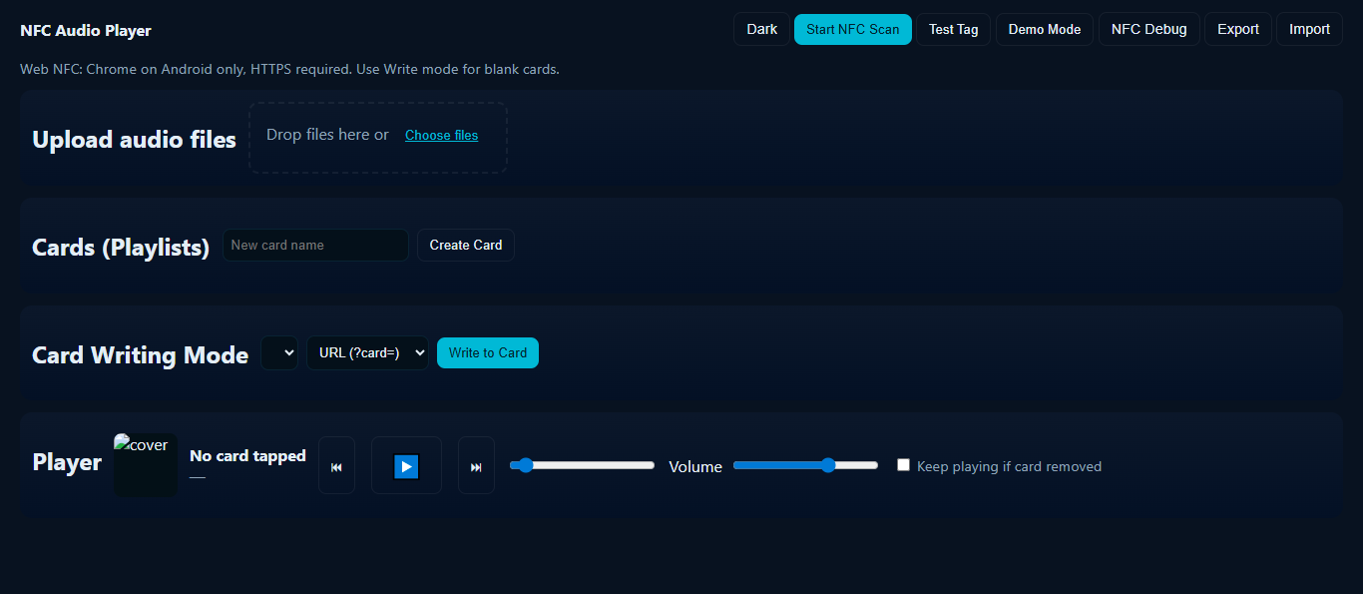
4. ParrisDubboMoverApp-Main
4. joshualparris/ParrisDubboMoverApp-Main

- JoshHub
1. joshualparris/JoshHub
6. WhirringWilderness
6. joshuaparris-max/WhirringWilderness
5. campaign-copilot
5. joshuaparris-max/campaign-copilot
23. ClearCore
23. joshualparris/ClearCore
4. ParrisDubboMoverApp
4. joshuaparris-max/ParrisDubboMoverApp

49. Max
49. joshuaparris-max/Max - Guess the Number
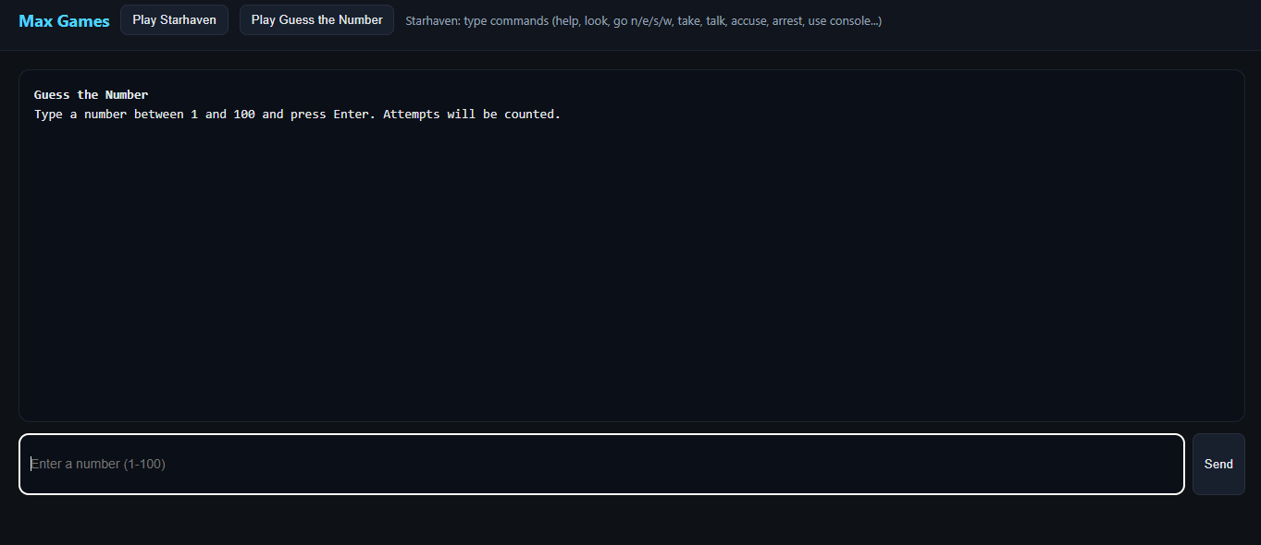
24. lifehubdashboard
24. joshuaparris-max/lifehubdashboard
41. JoshCoach
41. joshuaparris-max/JoshCoach
random-play
joshuaparris-max/random-play
26. ParrisTechApp
26. joshualparris/ParrisTechApp
25. ParrisPiano
25. joshuaparris-max/ParrisPiano
Wild2
joshuaparris-max/Wild2
exitbackup
joshuaparris-max/exitbackup
30. Midnight-Line
30. joshuaparris-max/Midnight-Line

44. StarHaven
44. joshuaparris-max/StarHaven
https://skill-deploy-kkckqq5c2j.vercel.app/
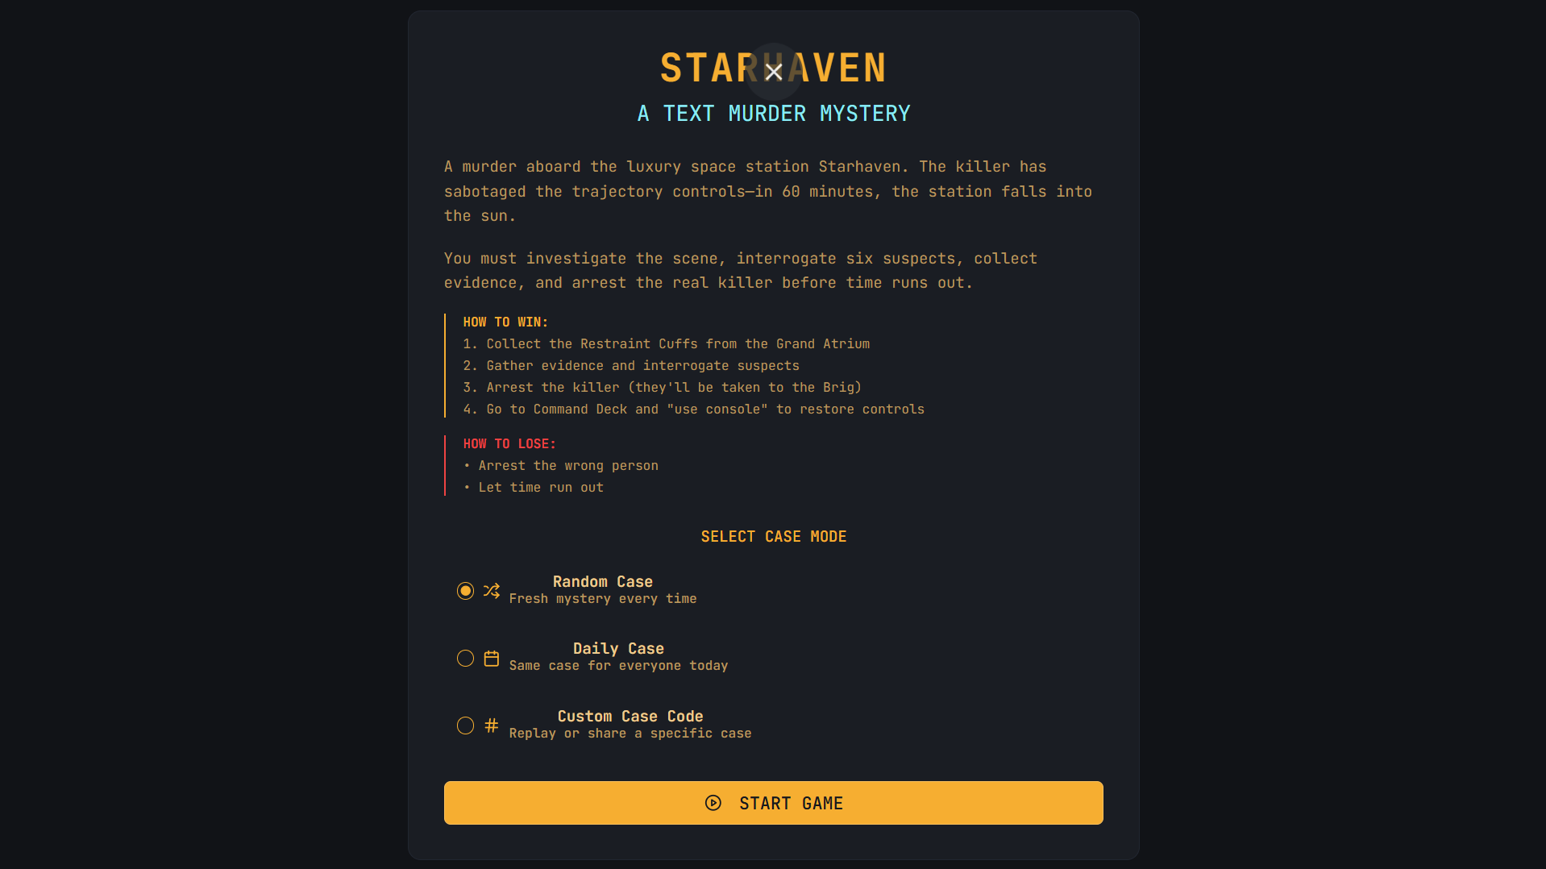
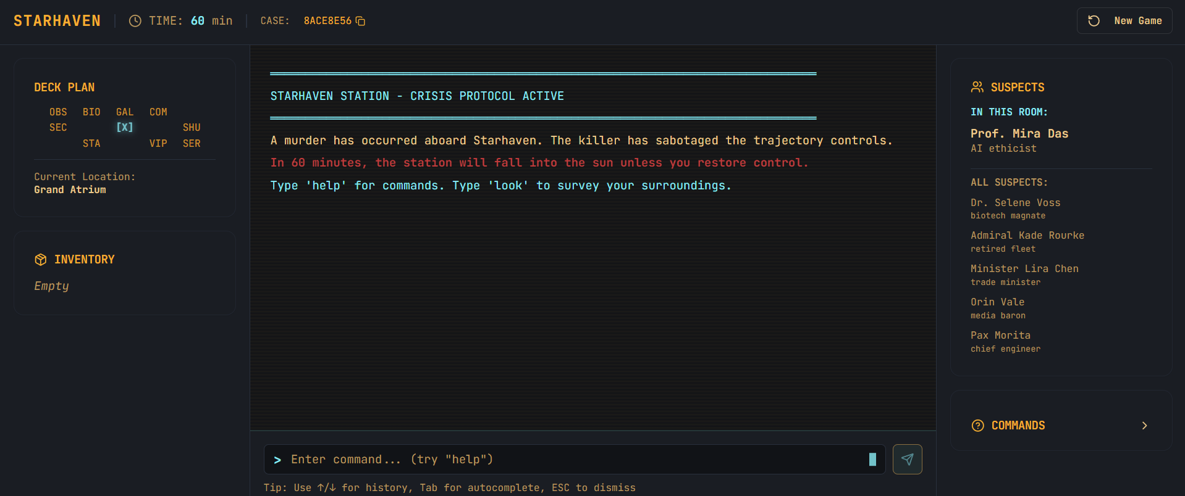
18. ParrisBudgetApp
18. joshuaparris-max/ParrisBudgetApp
10. ForbiddenQuests
10. joshuaparris-max/ForbiddenQuests
4. pdm-parris-dubbo-mover
4. joshuaparris-max/pdm-parris-dubbo-mover
- DCSCompanion
2. joshuaparris-max/DCSCompanion

45. Project Hub - Local Project Arcade
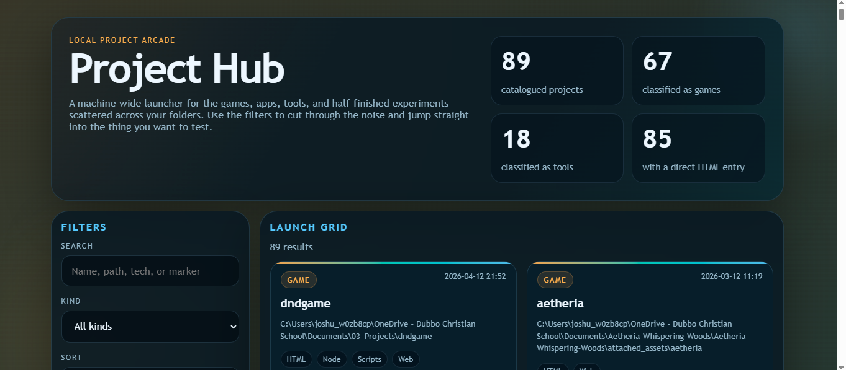

46. AA Game Adventure
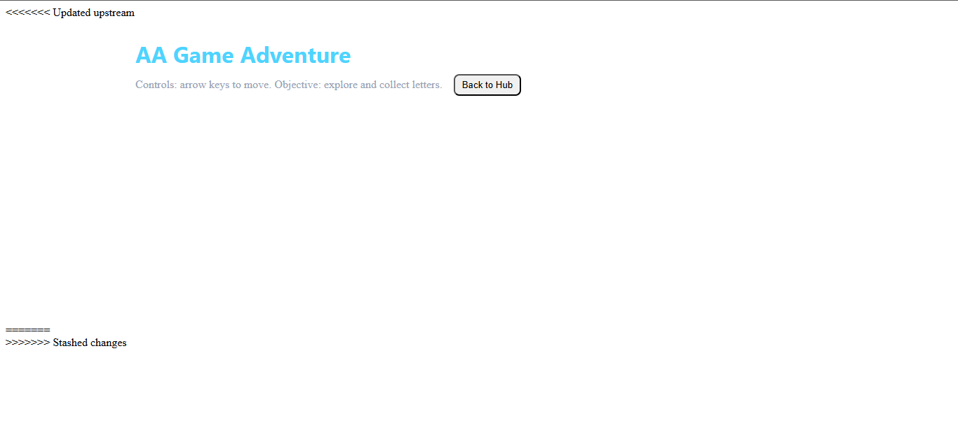
47. AA Module DND - Tile RPG
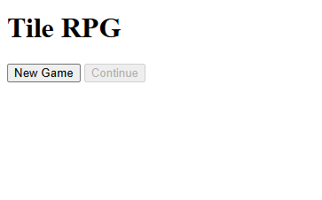
48. Buckland Street Game
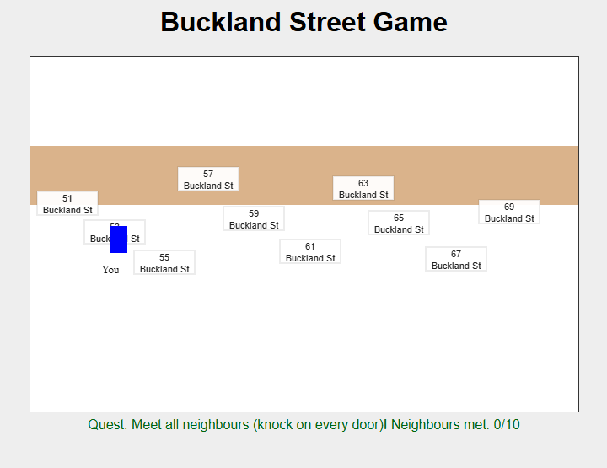
file:///C:/Users/joshu_w0zb8cp/OneDrive%20-%20Dubbo%20Christian%20School/Documents/03_Projects/JoshHub/JoshHub/public/games/buckland-v1/index.html
50. Neon Dash

file:///C:/Users/joshu_w0zb8cp/OneDrive%20-%20Dubbo%20Christian%20School/Documents/03_Projects/JoshHub/public/games/neon-dash/index.html

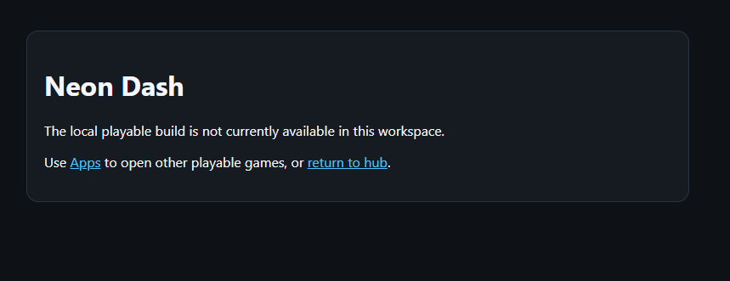

51. NebulaDice
https://joshualparris.github.io/NebulaDice-Browser/
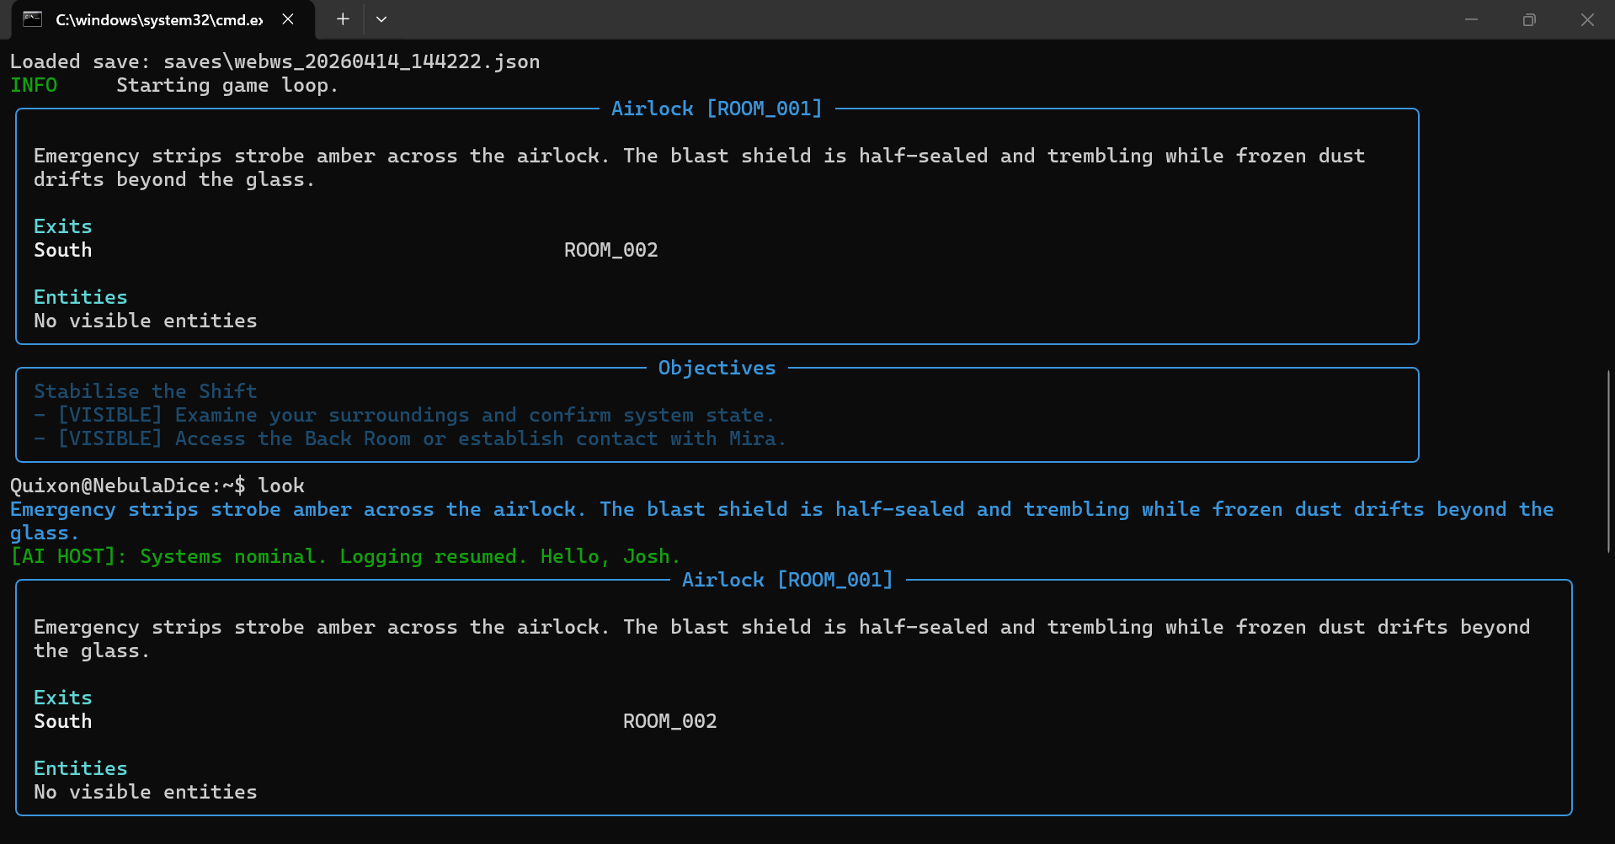
See: https://drive.google.com/drive/u/0/folders/1vPzC1DwbcepD4L7xtd0WGakhzivvwSVp
52. Josh App Hub
https://skill-deploy-rrs4sconcx.vercel.app/


53A. Parris Life Dashboard
https://joshualparris.github.io/Parris-Life-Dashboard/

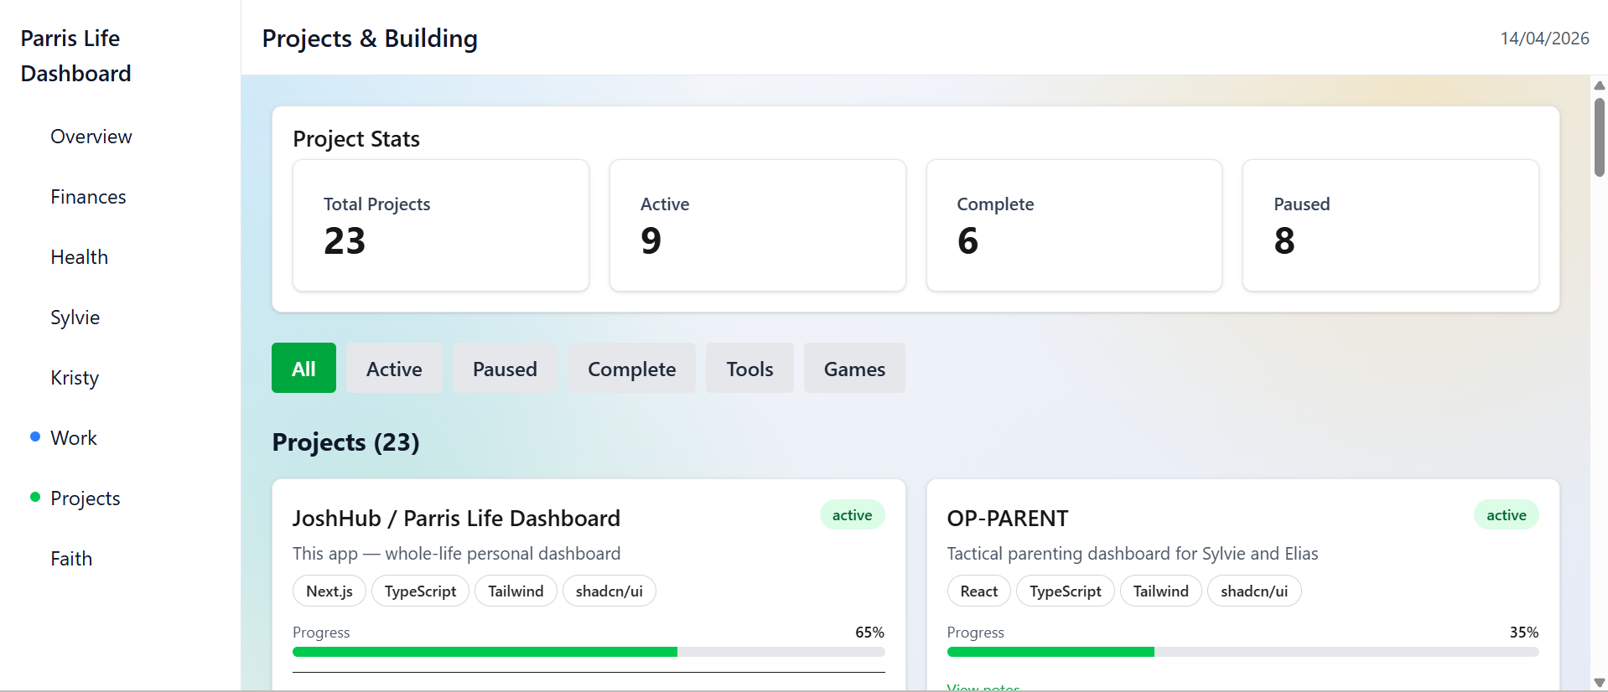

53B - https://joshualparris.github.io/Parris-Life-Dashboard/games/
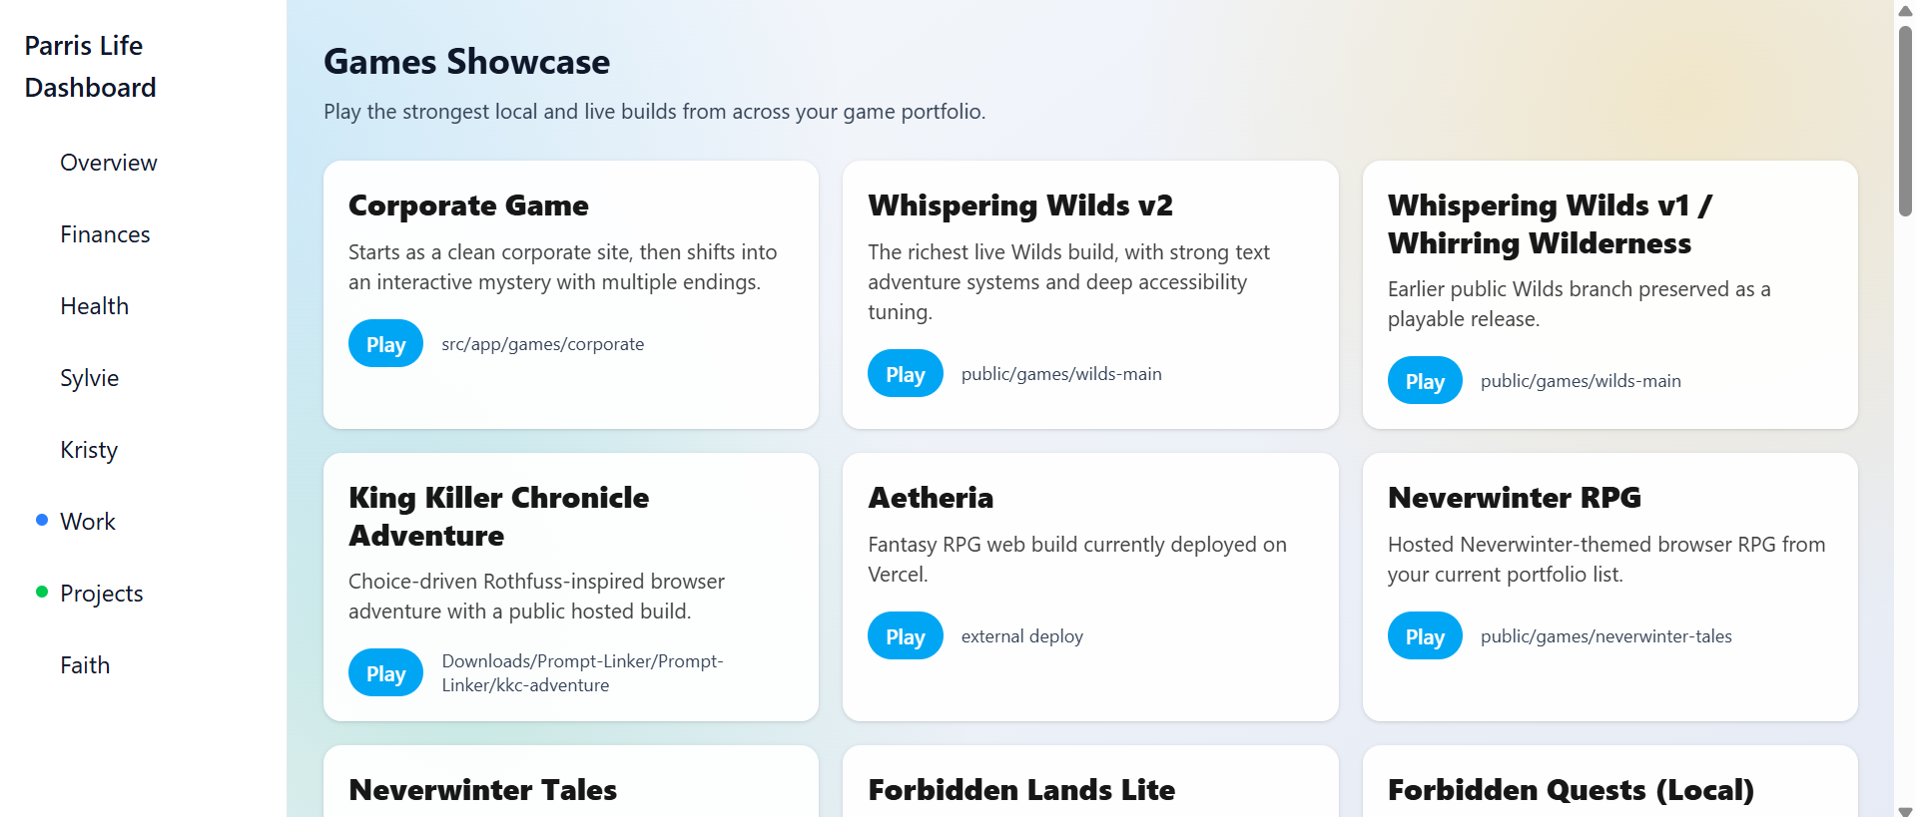
54 - Elodin Lore - https://joshualparris.github.io/ElodinDeepLore/
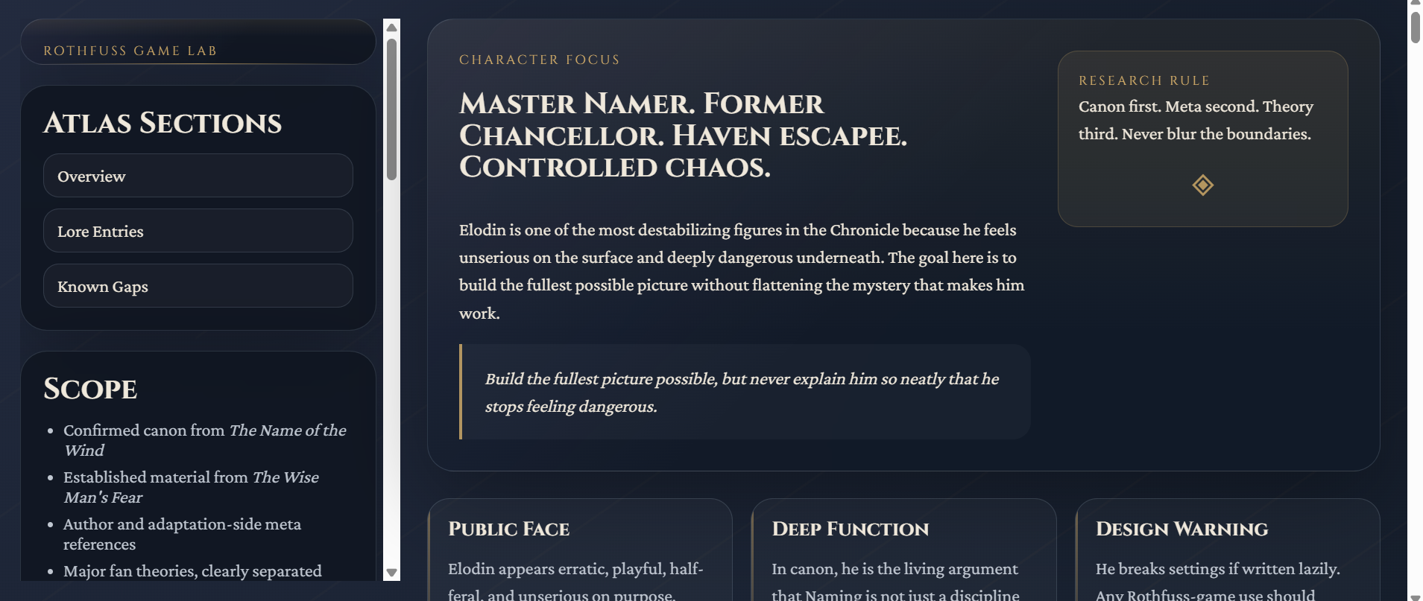
55 - Elodin Dossier
https://joshualparris.github.io/ElodinDeepLore/ElodinDeepLore.html
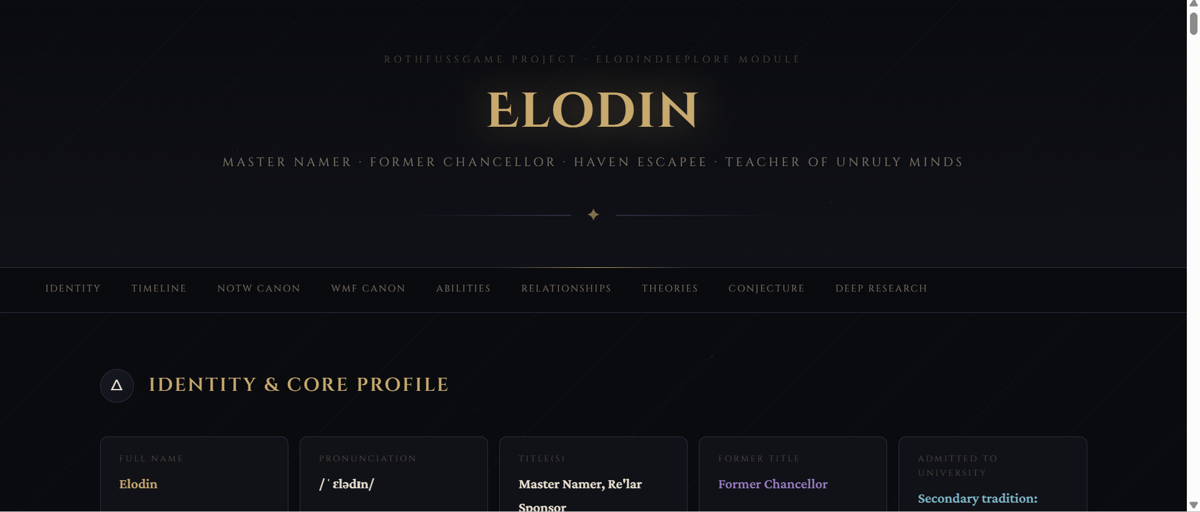
56 - Elodin Lore - https://joshualparris.github.io/elodin-deep-lore/
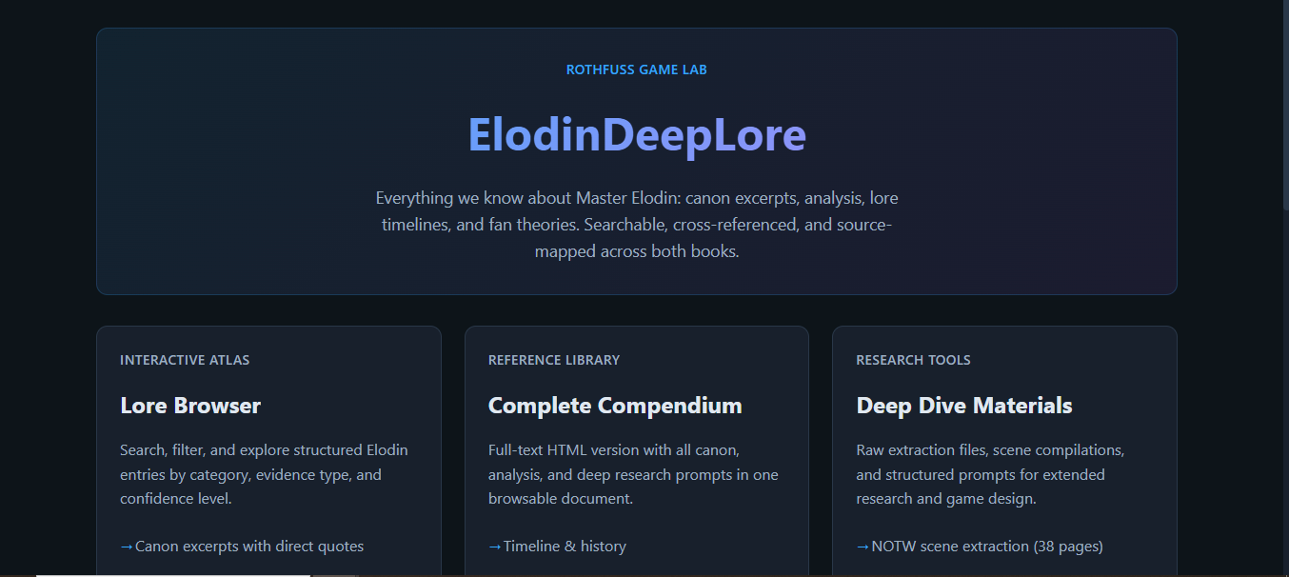
57 - Elodin Atlas - https://joshualparris.github.io/elodin-deep-lore/atlas.html
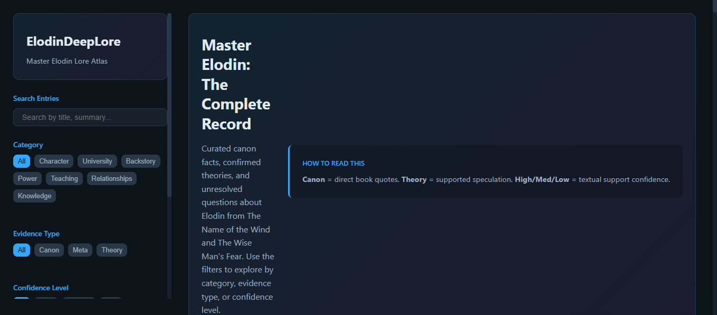
58 - Elodin Compendium - https://joshualparris.github.io/elodin-deep-lore/ElodinDeepLore.html
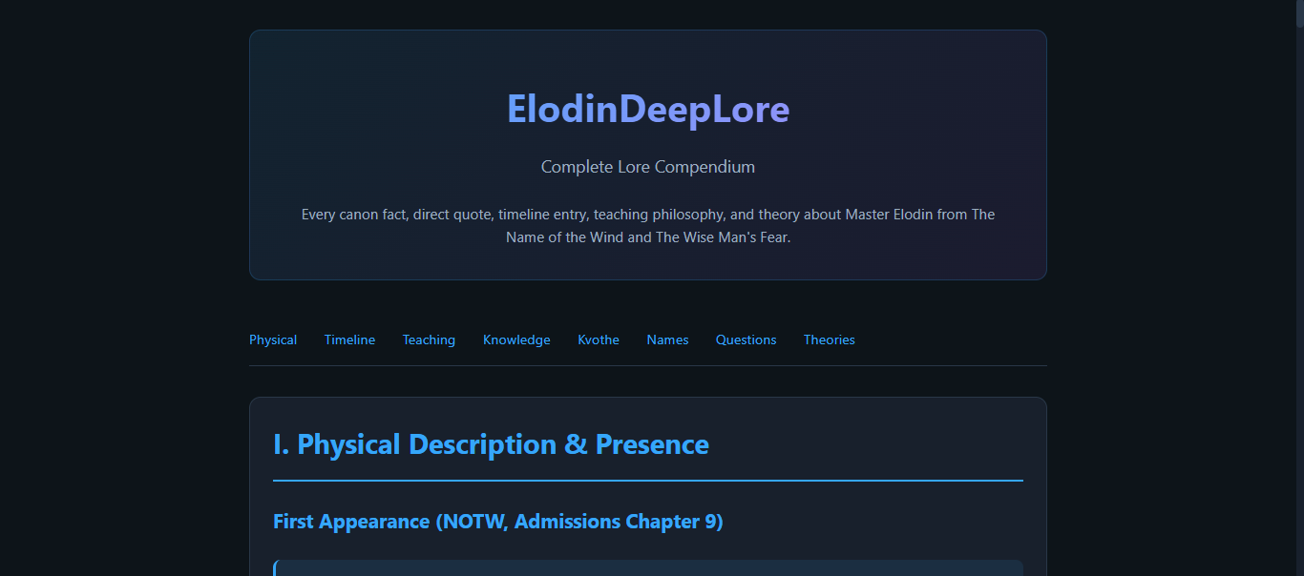

# Full App & Game Review — Parris Portfolio
## Ranked: Closest to AAA Indie → Prototype/Stub
Scoring dimensions: Polish, Features, Functionality, Fun/Engagement, Completeness, AAA Potential
---
## TIER S — AAA Indie Candidate
*Could ship on itch.io or Product Hunt today and hold its own*
---
### 1. WHISPERING WILDS v2 (PyScript)
**URL:** https://joshuaparrisdadlan-stack.github.io/whispering-wilds/
**Score: 9.2 / 10**
The standout of the entire portfolio. Feature density is exceptional for a solo browser game.
**Features:**
- Full text adventure engine running Python in-browser via PyScript
- 5 playstyle profiles (Storybook → Hardcore)
- 5 guidance levels (Off → Hand-in-Hand)
- Granular difficulty tuning: encounter rate, flee success, XP gain, drop luck, vendor prices, puzzle hints — each individually adjustable
- Safety options (no random attacks, can't be attacked, hide attack verbs)
- Read Aloud + Simplify Text accessibility features
- Multiple themes (Dark Forest, Light Meadow)
- Dyslexic font toggle
- Compact mode
- Sound + Music toggles
- Leaderboards
- Vendor/shop system
- Quest tracking panel
- Inventory panel
- Map panel with display-on-move
- XP progress bar
- Export/Import save
- Random seed system
- Dev mode
- Parental controls with PIN lock
- Tutorial bar
- Arrow key navigation
**What holds it back from 10:** No visual art/assets, no audio currently active, no story cinematics or title screen. The PyScript load time is a friction point.
**AAA path:** Add a title screen, ambient audio, a hand-drawn map image, and a few key art pieces. This is already a better-designed game than most itch.io paid titles.
---
### 2. PARRIS TECH SERVICES APP (Windows)
**URL:** https://parris-tech-services-app.vercel.app/
**Score: 9.0 / 10**
The most functionally complete app in the portfolio. A legitimate business tool.
**Features:**
- Full client management (add, edit, search, filter, find duplicates, CSV import/export)
- Full appointment system (recurring, status tracking, device checklist, follow-up reminders)
- Invoice creation with line items, time blocks, tax (GST), presets, payment URL, Zoho Books integration
- Reconciliation view with aging report, bulk mark paid, finance summary, CSV export
- Templates & assets with variable substitution (`{{name}}`, `{{datetime}}`)
- Quick actions with deep links (Calendly, JoshHub, ParrisTechApp)
- ICS calendar export
- Analytics dashboard
- Encrypted backup export/import with passphrase
- Dry-run import for safety
- Onboarding tips system
- Themed branding (Default, Irish, Aussie, Halloween, Christmas)
- Logo upload
- Keyboard shortcuts (Ctrl+1-4, Ctrl+S)
- Help & services section with FAQs, changelog, cleanup checklists
- Windows + Mac cleanup checklists
- Local storage persistence
- Print invoice view
- Demo data seeding (3 modes)
**What holds it back from 10:** localStorage only (no cloud sync), no mobile-optimised layout, no actual payment processing.
---
### 3. PARRIS TECH APP (Mac)
**URL:** https://parris-tech-app.vercel.app/
**Score: 8.5 / 10**
A polished guided tech support session tool — purpose-built and well-executed.
**Features:**
- Session timer with remaining time
- Client profile creation with devices, past issues, contact info
- Session length + location (onsite/remote) settings
- Timezone support
- Session templates (save, delete, apply)
- Dynamic checklist with undo last, collapse completed
- Progress tracking (N of N done)
- Invoice line items with subtotal, tax, total
- End-of-visit summary generation
- Print view + PDF invoice export
- JSON export (all sessions)
- Import sessions
- Rules editor — build custom modules with steps, questions, risk notes, timebox
- Client profiles manager
- Follow-ups & reminders with ICS export and email draft generation
- Session history with client filter
- Reports with time range filter + CSV export
- Metrics dashboard
- Themes (Dark, Light, Green, Blue)
- Offline detection
**What holds it back:** Overlaps significantly with ParrisTechServicesApp — feels like it should be merged or clearly differentiated. No cloud sync.
---
### 4. LIFEHUB DASHBOARD
**URL:** https://lifehubdashboard.vercel.app/
**Score: 8.3 / 10**
Staggeringly feature-rich. The most ambitious single-page app in the portfolio.
**Features:**
- Multi-panel dashboard with 20+ named sections
- Kiosk mode with custom rotation, panel dwell time, drag-to-reorder, presets
- Focus mode + Calm mode
- Multiple themes (Modern, Classic, High Contrast, Irish, Aussie, Halloween, Christmas, Easter)
- Compact spacing, readable font, no shadows, pixel mode
- Copilot natural language search (`/` shortcut)
- Wellbeing snapshot (Welltory CSV upload, stress/energy/focus/HRV)
- Calendar panel with .ics upload + agenda
- Activity timeline (events, reminders, files, downloads, automations, wellbeing, backups)
- Inbox triage board (drag-to-column)
- Downloads watcher + auto-triage heuristics
- Automation scheduler with queue, dry run, presets, JSON import/export
- System health freshness checks
- Resurface carousel (90-day untouched files)
- Achievement system with badges
- Weekly LifeHub routine checklist
- Resource spotlight
- Playable projects launcher
- Project scratchpad with promote-to-LifeHub, copy, download .md
- Backup integrity panel
- D&D tools: skill checks, saves, ability scores, magic item attunement
- Character creator (race, class, background, XP)
- Mini adventure (Clocktower Heist — choice-based)
- Encounter tracker (inbox dragon, downloads goblins — gamified tasks)
- Dice roller (d4–d20, encounter, loot)
- Tavern banter rotator
- Daily quest with reroll + streak
- Text game (PyScript Wilds engine, 3 save slots, autosave)
- Text game v2 (expanded sandbox build)
- Quick actions with custom add + drag/pin
- Daily realm event
- File area deep-links
- Keyboard shortcuts (I, W, F, P, H, A, ?, /)
- Visitor of the Day (fun randomiser)
**What holds it back:** It's almost too much — navigation friction is high, many panels are empty on first load, local-only with no sync. The gamification and work tools compete for attention rather than complement.
---
## TIER A — Polished, Shippable with Minor Work
---
### 5. JOSHHUB (josh-hub-two)
**URL:** https://josh-hub-two.vercel.app/dashboard
**Score: 7.8 / 10**
Clean, coherent personal OS with strong navigation and good information architecture.
**Features:**
- Dashboard with daily briefing, tasks, events, notes, health snapshot
- Quick launch (first 6 apps)
- Broken items panel (active friction tracking — smart)
- Health snapshot (sleep 7d avg, movement, nutrition, latest metric)
- Pinned areas
- Family rhythm section
- Recent activity
- Focus cues (short, faith-integrated)
- Full nav: Apps, Platform, Projects, Everything Map, Life, Care, Capture, Lifestyle Report, Notes, Tasks, Routines, Studio
- Global search (Ctrl+K)
- Theme toggle
- Keyboard shortcut system
**What holds it back:** Many panels empty on first load (no data), health/notes/tasks show zeroes. Feels like infrastructure waiting for content. The josh-hub-96no version is richer.
---
### 6. JOSHHUB APPS (josh-hub-96no)
**URL:** https://josh-hub-96no.vercel.app/apps
**Score: 7.6 / 10**
The catalogue/launcher version — extremely well-organised with tagging, filtering, and status tracking. Strong meta-app.
**Features:**
- Full searchable/filterable app catalogue (Category + Status filters)
- Tags per app
- Status system (OK / BROKEN / WIP / ARCHIVED)
- Multiple links per entry (Live, Repo, Docs, Drive, itch.io, Fables GG)
- Hosts local game builds at `/games/` paths
- Links to 80+ items across all life domains
---
### 7. NULL
**URL:** https://joshuaparrisdadlan-stack.github.io/Null/
**Score: 7.5 / 10**
The most conceptually distinctive game in the portfolio. Genuinely unusual design.
**Features:**
- Text adventure with command parser
- Rope/bead sensory mechanic ("Pings" system) — unique
- Bell/sensate tracker
- Known Routes map
- Inventory
- Logbook (event recording)
- Turn counter
- Save / Load / Restart
- Tactile design philosophy baked into UI (SVG bead assets)
- Accessibility-forward tone and content warnings
**What holds it back:** Content depth unknown without playing through. UI is minimal — intentionally so, but risks feeling sparse to a new player. Could use a short onboarding passage.
**AAA path:** The Pings mechanic is genuinely publishable as a concept. Expand the world, add ambient audio, and this is an art game that would get coverage.
---
### 8. ORGSCAPE / INFINITE OFFICE
**URL:** https://joshuaparrisdadlan-stack.github.io/OrgScape/ and https://josh-hub-96no.vercel.app/games/orgscape/index.html
**Score: 7.2 / 10**
Solid roguelike structure with strong thematic identity.
**Features:**
- Floor map
- Inventory
- Task system
- Org chart
- Faction reputation (multi-faction — significant design)
- Help command system
- Navigation (go north/south etc.)
- Missing Directive quest
- Dark/light mode toggle
- Command history
**What holds it back:** The UI panels are all empty on load — game world needs more content/rooms. Faction system promises depth that needs delivering.
---
### 9. MYSTERY DEPTHS
**URL:** https://joshuaparrisdadlan-stack.github.io/MysteriousDepths/
**Score: 7.0 / 10**
Well-presented text adventure with proper polish signals.
**Features:**
- Text adventure engine
- 3 themes (Deep Sea, Derelict, Stardrift)
- Sound toggle
- Animation toggle
- Save checkpoint / Load checkpoint
- Toggle log
- Settings panel
**What holds it back:** Content depth unclear from HTML alone — the settings system is polished but the game world needs investigation. Three themes is a genuine quality signal.
---
### 10. DCS PREP APP
**URL:** https://dcs-prep.vercel.app/
**Score: 7.0 / 10**
Professionally executed onboarding tool. Clean, purposeful, complete.
**Features:**
- 3 training modules with section counts (5, 10, 6 sections respectively)
- Progress tracking per module (% complete)
- Overall completion tracker (0/3 modules, 0%)
- Navigation (Home, Modules, Progress, Settings)
- Proper branding (DCS / Dubbo Christian School)
- Module deep-links
**What holds it back:** Only 3 modules, no gamification, no certificates, no quiz/assessment layer.
---
### 11. HUG COACH
**URL:** https://hug-coach.vercel.app/
**Score: 6.8 / 10**
Well-designed coaching/wellness app with proper RPG progression metaphor.
**Features:**
- Level/XP system (Level 1 Steady Starter, 100 XP to level 2)
- Sparks currency
- Streak tracking
- Spaced repetition review system ("Reviews due")
- Topics browser
- Rituals logging with daily count
- Momentum section
- Store
- Summary page
- Multi-section nav (Dashboard, Topics, Review, Rituals, Summary, Store)
**What holds it back:** No content loaded on first visit — topics/lessons/rituals all empty. The structure is excellent but the content layer needs populating.
---
## TIER B — Functional, Needs Content or Polish
---
### 12. DARK REALMS (NewGame)
**URL:** https://josh-hub-96no.vercel.app/games/newgame/index.html
**Score: 6.5 / 10**
Most mechanically complete combat RPG in the portfolio.
**Features:**
- Full character creation: 4 races with stat bonuses, 4 classes, 6 attributes (STR/DEX/CON/INT/WIS/CHA), point buy (27 pts), auto-assign, standard array
- WASD + arrow key movement
- Combat system (Attack, Defend, Flee)
- Merchant system
- NPC interaction panel
- Inventory
- Combat log
- Space to interact/talk
- E for inventory
- HP, Level, XP, Gold tracking
- Race-specific bonuses displayed in character creation
**What holds it back:** No story, no world depth, map content unclear. The systems are there but the world needs populating.
---
### 13. CLASSIC D&D TEXT ADVENTURE
**URL:** https://josh-hub-96no.vercel.app/games/classic-dnd-text/index.html
**Score: 6.3 / 10**
Good feature set — grid movement + character creation is a strong combo.
**Features:**
- D&D 5e character creator: 4 races, 4 classes, background, alignment
- 3 ability score methods: Standard Array, Roll 4d6 drop lowest, Point Buy (27)
- Grid movement with minimap
- Arrow key navigation
- HP/AC/Gold display
- Back to Hub link
- Randomise button
- Reset button
- Coordinates display
**What holds it back:** The game world behind character creation needs investigation — HTML was minimal on fetch. Likely more content than visible.
---
### 14. D&D RPG DUNGEON
**URL:** https://josh-hub-96no.vercel.app/games/dnd-rpg-dungeon/index.html
**Score: 6.2 / 10**
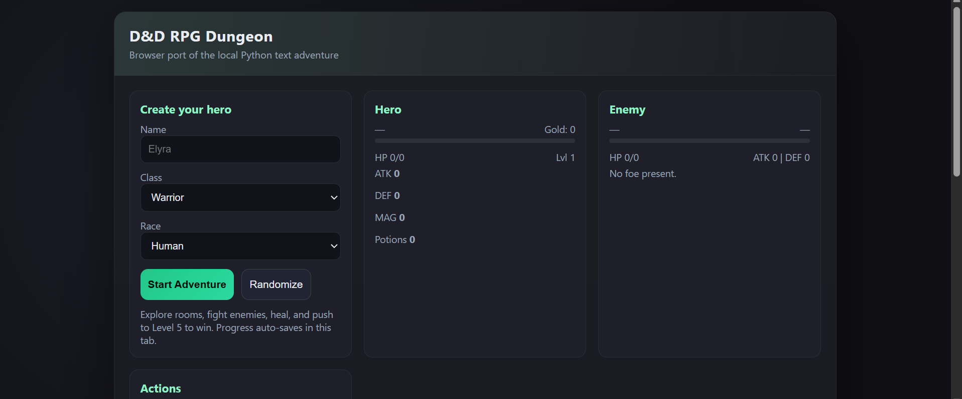
Clean combat dungeon crawler with clear win condition.
**Features:**
- Hero creation (name, class, race)
- Randomise button
- Combat: Attack, Magic, Heal (potion), Run, Explore/Continue
- Hero stats: HP, Level, ATK, DEF, MAG, Potions, Gold
- Enemy panel: HP, ATK, DEF
- Level 1–5 progression with win condition
- Auto-save (tab-level)
- Adventure log
- Reset run
- Tip system
**What holds it back:** Browser port of a Python script — feels like a conversion rather than a native design. Limited depth.
---
### 15. CAMPAIGN COPILOT
**URL:** https://joshuaparrisdadlan-stack.github.io/campaign-copilot/
**Score: 6.0 / 10**
Minimal content returned on fetch — D&D 5e session assistant. Title and branding present, full feature set not visible from HTML alone. From JoshHub catalogue: full Campaign Copilot UI seeded for specific campaigns (Spider Queen, Pets of the Spider Queen). Likely feature-rich in-session.
---
### 16. PARRIS BUDGET APP
**URL:** https://parris-budget-app.vercel.app/
**Score: 5.8 / 10**
Login-gated — "Josh & Kristy Budget Keeper." Cannot assess features without auth. From JoshHub description: live Vercel deployment for family budgeting. Likely solid given the other finance-adjacent tools in the portfolio.
---
### 17. PARRIS PIANO APP
**URL:** https://parris-piano.vercel.app/
**Score: 5.5 / 10**
Well-organised launcher/hub rather than a standalone app. Clever integration concept.
**Features:**
- Web MIDI input (Yamaha CVP-301 via USB)
- On-screen keyboard with live MIDI lighting
- Octave range selector (2–Full)
- BPM + metronome
- Loop points (A/B)
- Recording with download
- Live score (PERFECT/GOOD timing windows)
- Practice plan generator
- Fit Width / Expand Keyboard display options
- Settings (hide keyboard)
- Links to: Piano Marvel, Midiano, Synthesia, SeeMusic, MIDI Visualizer, MuseScore, Cakewalk, Waveform, FreePiano
- Google Drive sheet music folder link
**What holds it back:** The live MIDI features are genuinely impressive but require local USB connection. Most features are links to external tools rather than built functionality.
---
### 18. STARHAVEN / MAX
**URL:** https://josh-hub-96no.vercel.app/games/max/index.html
**Score: 5.5 / 10**
Text mystery with command interface. Two games in one launcher.
**Features:**
- Starhaven: text mystery with commands (help, look, go n/e/s/w, take, talk, accuse, arrest, use console)
- Guess the Number: secondary mini-game
- Shared command input
- Two-game launcher interface
**What holds it back:** Content depth of Starhaven unclear — mystery games live or die on world/puzzle design. The interface is minimal.
---
### 19. SIMPLE RPG / LetsPlayDnd
**URL:** https://joshuaparrisdadlan-stack.github.io/LetsPlayDnd/
**Score: 5.2 / 10**
Very minimal HTML returned — "Classic D&D 5e Text Adventure." Likely a full game engine underneath but surface presentation is bare. Content and features need in-session investigation.
---
### 20. WHIRRING WILDERNESS (Twine v1)
**URL:** https://joshuaparris-max.github.io/WhirringWilderness/
**Score: 5.0 / 10**
The original Whispering Wilds in Twine format. "Whispering Wilds" title present, minimal HTML on fetch. Twine export — all content is JS-rendered. Functionally this is the prototype that became the much richer v2. Worth preserving for history but v2 supersedes it comprehensively.
---
### 21. MIDNIGHT LINE
**URL:** https://josh-hub-96no.vercel.app/games/midnight-line/index.html
**Score: 4.8 / 10**
"The Midnight Line — Vertical Slice" — React/Vite build. "Vertical slice" in the title indicates an intentional prototype/demo slice rather than a complete game. Content not assessable from HTML alone.
**Potential:** The noir train aesthetic implied by the name has strong AAA indie potential. Needs content investment.
---
## TIER C — Stub, Broken, or Launcher-Only
---
### 22. DCS COMPANION
**URL:** https://joshuaparris-max.github.io/DCSCompanion
**Score: 3.5 / 10**
Title only returned ("DCS Companion"). Content not visible — likely a full app underneath but GitHub Pages may not be fully deployed or requires JS to render.
---
### 23. PARRIS DUBBO MOVER
**URL:** https://parris-dubbo-mover-app-main-client.vercel.app/
**Score: 2.0 / 10**
"PDM App" — title only. API/backend confirmed broken (noted in JoshHub). Client renders but is non-functional without the server.
---
### 24. CLEARCORE
**URL:** https://clearcore.vercel.app/
**Score: 1.0 / 10**
Blank page returned. No content visible. Not yet deployed or build broken.
---
### 25. FORBIDDEN QUESTS
**URL:** https://josh-hub-96no.vercel.app/games/forbidden-quests/index.html
**Score: 1.0 / 10**
Blank page returned. Static client build with server-side features stripped — likely missing bundled assets in JoshHub's public folder.
---
## OVERALL PORTFOLIO RANKING
| Rank | App/Game | Score | Tier |
|------|----------|-------|------|
| 1 | Whispering Wilds v2 (PyScript) | 9.2 | S |
| 2 | Parris Tech Services App | 9.0 | S |
| 3 | Parris Tech App (Mac) | 8.5 | S |
| 4 | LifeHub Dashboard | 8.3 | S |
| 5 | JoshHub (josh-hub-two) | 7.8 | A |
| 6 | JoshHub Apps (josh-hub-96no) | 7.6 | A |
| 7 | Null | 7.5 | A |
| 8 | OrgScape / Infinite Office | 7.2 | A |
| 9 | Mystery Depths | 7.0 | A |
| 10 | DCS Prep App | 7.0 | A |
| 11 | HugCoach | 6.8 | A |
| 12 | Dark Realms (NewGame) | 6.5 | B |
| 13 | Classic D&D Text Adventure | 6.3 | B |
| 14 | D&D RPG Dungeon | 6.2 | B |
| 15 | Campaign Copilot | 6.0 | B |
| 16 | Parris Budget App | 5.8 | B |
| 17 | Parris Piano App | 5.5 | B |
| 18 | Starhaven / Max | 5.5 | B |
| 19 | Simple RPG / LetsPlayDnd | 5.2 | B |
| 20 | Whirring Wilderness (Twine v1) | 5.0 | B |
| 21 | Midnight Line | 4.8 | B |
| 22 | DCS Companion | 3.5 | C |
| 23 | Parris Dubbo Mover | 2.0 | C |
| 24 | ClearCore | 1.0 | C |
| 25 | Forbidden Quests | 1.0 | C |
---
## Key Findings
**Strongest games for AAA polish investment (ranked):**
1. Whispering Wilds v2 — already near publishable, needs art + audio
2. Null — most original concept, art game potential
3. OrgScape — faction/floor systems need content but structure is right
4. Mystery Depths — three themes + save system is a strong base
5. Midnight Line — vertical slice framing suggests intentional future dev
**Strongest apps overall:**
1. Parris Tech Services App — legitimate business tool, could sell to other small IT operators
2. LifeHub Dashboard — most ambitious, needs UX consolidation
3. DCS Prep App — most professionally focused, needs more modules
**Biggest gaps between potential and current state:**
- Null (concept >> current content)
- Midnight Line (aesthetic potential >> current vertical slice)
- HugCoach (excellent structure, no content)
- Campaign Copilot (full UI exists, not visible on surface)
**Portfolio signature:** You build systems before content — the architecture and feature thinking is consistently strong, but many projects need content depth to match their structural ambition. The exception is Whispering Wilds v2, where both are present.

# GitHub Massive Audit
This audit is based on the three connected GitHub accounts and a repo-by-repo review of visible repository metadata, plus targeted inspection of representative files in the most important repos.
## Executive summary
- Total repos reviewed: **56**
- `joshualparris`: **17** repos
- `joshuaparris-max`: **18** repos
- `joshuaparrisdadlan-stack`: **21** repos
## What stands out most
- You have real product families, not random repos. The strongest families are JoshHub, ParrisDubboMover, Whispering/Whirring/Wild2, HugCoach, DCS tools, and campaign-copilot.
- Your biggest repo-level problem is duplication across accounts. Several projects exist in multiple places with slightly different names or maturity levels, which makes ownership and the 'current truth' hard to see.
- The dadlan-stack account looks like your game lab / alt-stack / content-and-prototype workshop.
- The max account looks like your polished-public creative/app account.
- The joshualparris account looks like the closest thing to your main product/account-of-record.
- A large chunk of the portfolio is promising-but-not-finished: strong names, real concepts, but many tiny or placeholder repos.
- You already have enough substance to curate a clean public portfolio. The issue is not lack of output. It is fragmentation.
## Strongest repos right now
1. **JoshHub (joshualparris)** — Best overall platform spine
2. **ParrisDubboMover (joshuaparrisdadlan-stack)** — Most substantial full-stack app family
3. **HugCoach (joshualparris)** — Most production-shaped coaching app
4. **DCSCompanion (joshuaparris-max)** — Strong focused school utility
5. **DCSPrep (joshualparris)** — Lean but real Next app
6. **ParrisBudgetApp (joshuaparris-max)** — Serious budget app foundation
7. **campaign-copilot (joshuaparris-max)** — Real tool/app architecture
8. **Midnight-Line (joshuaparris-max)** — Strongest game vertical slice
9. **ParrisPiano (joshuaparris-max)** — Most practical utility bundle
10. **BucklandBlocks (joshualparris)** — Most ambitious web sandbox concept
## Full inventory by account
### joshualparris
- **JoshHub** — hub/app — **flagship** — public — size 49103 — Primary all-in-one hub; strongest product spine.
- **HugCoach** — app — **flagship** — public — size 8299 — Modern coaching app with DB/test stack.
- **DCSPrep** — app — **active prototype** — public — size 242 — DCS-focused prep app; lean but real stack.
- **ParrisDubboMoverApp-Main** — app — **active prototype** — public — size 25656 — Earlier mover app branch/family; substantial code.
- **ParrisTechServicesApp** — app — **active prototype** — public — size 7598 — Windows-side tech services app; meaningful codebase.
- **BucklandBlocks** — game — **active prototype** — public — size 3602 — Ambitious browser voxel sandbox.
- **energyquest** — game — **prototype** — public — size 198929 — Large Unity repo, but README frames it as an early prototype.
- **ClearCore** — app — **prototype** — public — size 498 — Small but intentional app seed.
- **ParrisTechApp** — app — **prototype** — public — size 43 — Very small Mac-side counterpart; likely early or mirrored.
- **Whispering-Wilds** — game — **prototype** — public — size 65 — Whispering Wilds family repo on primary account; small.
- **wastes-courier-roguelike** — game — **prototype** — public — size 56 — Playable concept, but repo footprint is tiny.
- **JoshNFCAudio** — app — **prototype** — public — size 69 — NFC/audio concept seed.

- **SwordCoast** — game/tool — **prototype** — public — size 18 — Very small seed repo.
- **LifeHub** — hub/app — **placeholder** — public — size 0 — Name suggests larger ambition; repo currently looks empty/minimal.
- **JoshTapApp** — app — **placeholder** — public — size 0 — Likely superseded by the Android scaffold on dadlan-stack.
- **newfileqqqwertuhvgjkk.py** — misc — **scratch** — public — size 11 — Throwaway/scratch repo.
- **BucklandBlocks1** — game — **placeholder** — private — size 0 — Private placeholder or abandoned fork.
### joshuaparris-max
- **ParrisDubboMoverApp** — app — **flagship** — public — size 84070 — Large public mover app repo; likely main public presentation repo.
- **Midnight-Line** — game — **flagship vertical slice** — public — size 166724 — Most substantial game-style repo by footprint; clearly more than a toy.
- **ParrisPiano** — utility/app — **flagship utility** — public — size 39909 — Useful, documented piano/CVP toolkit with desktop utility angle.
- **WhirringWilderness** — game — **active prototype** — public — size 25141 — Strong Whispering Wilds family variant with meaningful substance.
- **pdm-parris-dubbo-mover** — app — **active prototype** — public — size 25613 — Another mover family repo; likely duplicate/transition lineage.
- **campaign-copilot** — app/tool — **active prototype** — public — size 312 — Real app stack despite modest repo size metric.
- **DCSCompanion** — app — **active prototype** — public — size 647 — Real deployed DCS helper app.
- **ParrisBudgetApp** — app — **active prototype** — public — size 1972 — Budgeting app with auth/DB stack.
- **lifehubdashboard** — hub/app — **prototype** — public — size 275 — LifeHub dashboard concept; lighter than JoshHub.
- **JoshCoach** — app — **prototype** — public — size 232 — Coach app seed / companion project.
- **JoshFireAwareness** — app — **prototype** — public — size 86 — Small targeted concept.
- **GoldFinder** — app/game — **prototype** — public — size 93 — Tiny concept repo.
- **Max** — game/misc — **prototype** — public — size 9 — Very small wrapper/experiment repo.
- **Wild2** — game — **placeholder** — public — size 0 — Name implies sequel path, but this account's repo currently looks empty.
- **random-play** — game/misc — **placeholder** — public — size 1 — Near-empty experiment.
- **exitbackup** — infra/misc — **placeholder** — public — size 0 — Backup/holding repo with no visible substance.
- **ForbiddenQuests** — game — **placeholder** — public — size 0 — Good title, but repo currently empty/minimal.
- **StarHaven** — game — **placeholder** — public — size 0 — Promising title, currently empty/minimal.
### joshuaparrisdadlan-stack
- **ParrisDubboMover** — app — **flagship** — public — size 101869 — Strongest mover-family repo; real client/server app.
- **JoshHub** — hub/app — **flagship** — public — size 48750 — Mirror/parallel JoshHub line with substantial code.
- **JoshTapApp** — app/mobile — **active scaffold** — public — size 54406 — Substantial Android scaffold with a clear next-step roadmap.
- **Docs** — docs/content — **active content repo** — public — size 185858 — One of the largest repos; likely writing/prompt/content heavy.
- **WhirringWilderness** — game — **active prototype** — public — size 24951 — Another strong Wilds-family branch.
- **whispering-wilds** — game — **active prototype** — public — size 2326 — Published Wilds branch.
- **Wild2** — game — **active prototype** — public — size 2583 — Sequel/variant line with more substance than the max account version.
- **campaign-copilot** — app/tool — **active prototype** — public — size 1165 — Earlier/smaller line of the same family.
- **Assets** — assets — **support repo** — public — size 8204 — Asset storage/support role.
- **Misc** — misc — **support repo** — public — size 16932 — General holding repo for assorted material.
- **HugCoach** — app — **duplicate/parallel line** — public — size 8300 — Near-duplicate family of the main-account version.
- **MysteriousDepths** — game — **prototype** — public — size 18 — Playable/static game family repo, but tiny footprint.
- **Null** — game — **prototype** — public — size 32 — Small but coherent static text-adventure repo.
- **OrgScape** — game — **prototype** — public — size 20 — Static browser roguelike repo; conceptually strong.
- **LetsPlayDnd** — game — **prototype** — public — size 11 — Simple RPG / text-adventure branch.
- **SimpleRPG** — game — **prototype** — public — size 14 — Small sibling repo to the D&D/text-RPG line.
- **BucklandGame** — game — **prototype** — public — size 14 — Small experiment.
- **whispering-wilds-test** — game — **test repo** — public — size 297 — Test harness/experimental branch.
- **Games** — misc — **placeholder** — public — size 0 — Umbrella name, currently empty/minimal.
- **DCSCompanion** — app — **placeholder** — public — size 0 — Probably a mirror placeholder rather than the live main repo.
- **WhisperingWildsReloaded** — game — **placeholder** — public — size 0 — Strong concept title, currently empty/minimal.
## Cleanup priorities
1. Pick one canonical home for each major product family.
2. Mark mirrors / experiments clearly (`-archive`, `-prototype`, `-spike`, `-legacy`).
3. Create one public portfolio README that links only the best current repo in each family.
4. Archive or hide empty placeholder repos that are not helping your story.
5. For the top 6 projects, add clean READMEs, screenshots, and live links.
6. Standardise branch naming (`main` vs `master`) and deployment ownership.
## Best next move
If you want the highest return, the next pass should not be 'more repos'. It should be a **portfolio consolidation pass** where we crown a single source-of-truth repo for each major project family and sort the rest into active, archived, or experimental.
See google keep doc here - https://keep.google.com/#NOTE/1JodjgHlXIETW07Z8ULkZk6t5u7bimZZRGmdPiE4J6RaxALULw27QeuKaPaGj6w

7 Games by Claude
Game | URL | Status
StarHaven (Star Wars) | https://joshuaparris-max.github.io/StarHaven/ | ✅ Working
ForbiddenQuests (D&D) | https://joshuaparris-max.github.io/ForbiddenQuests/ | ✅ Fixed
LifeHub (LotR) | https://joshualparris.github.io/LifeHub/ | ✅ Rebuilt
Wild2 (Skyrim) | https://joshuaparris-max.github.io/Wild2/ | ✅ Working
WhisperingWildsReloaded (Witcher) | https://joshuaparrisdadlan-stack.github.io/WhisperingWildsReloaded/ | ✅ Working
exitbackup (Hitchhiker's) | https://joshuaparris-max.github.io/exitbackup/ | ✅ Working
Games (GoT) | https://joshuaparrisdadlan-stack.github.io/Games/ | ✅ Working

Ashes of the Hollow Crown
http://127.0.0.1:5500/epic-rpg/index.html
http://localhost:8080/
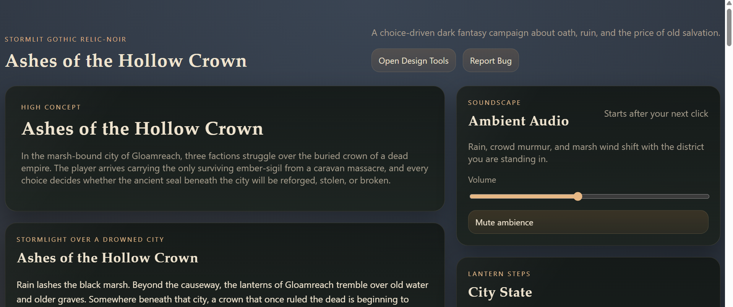

Games in the Parris-Life-Dashboard Repository
Your cloned repo at Parris-Life-Dashboard contains a public/games/ folder with numerous local game builds. These appear to be mostly complete (with index.html files), but some may be prototypes or works-in-progress. The games include:
- aa-game-adventure
- amodule-dnd
- boundary-road
- buckland-blocks
- buckland-v1
- buckland-v2
- classic-dnd-text
- dinner-decider
- dnd-rpg-dungeon
- forbidden-quests
- infinite-office
- josh-nfc-audio
- max
- midnight-line
- mysterious-depths
- neon-dash
- neverwinter-tales
- newfileqqqwertuhvgjkk (seems like a test/placeholder)
- newgame
- nexus-descent
- orgscape
- random-play
- simple-rpg-gh
- starhaven
- tile-game
- wilds-2
- wilds-main
- wilds-sail-west
Many of these are listed in your gamesShowcase.ts data, but some (like newfileqqqwertuhvgjkk or dinner-decider) might be unfinished or experimental.

Other Projects in Documents
- Project-Hub (Project-Hub): Contains an index.html, scripts, and a RothfussGame/ subfolder. This looks like a project hub/dashboard with an embedded unfinished game.
- RothfussGame (inside Project-Hub): Appears to be a King Killer Chronicle-inspired game project, with files suggesting it's in development.

Zipped Projects in Downloads
Your Downloads folder has several archived projects that may be unfinished:
- RothfussGame.zip and RothfussGame-20260413T030826Z-3-001.zip: Likely backups or exports of the Rothfuss-inspired game.
- Prompt-Linker.zip: Seems related to prompt management or AI tools.
- Game-Fixer.zip: Possibly a utility or game-related tool.
- Prompts1to180-20260413T054759Z-3-001.zip: A collection of prompts, potentially for AI or game development.
- Aetheria-Lore-Deep/: An extracted folder for what appears to be a fantasy RPG lore project.

Additional Notes
- The repo's scripts/ folder might contain build or utility scripts for unfinished features.
- Some folders (like experimental/, Game-Fixer/, Serenity-Keep-Flying/) are mentioned in your next.config.ts as ignored, suggesting they exist but are excluded from builds—possibly unfinished side projects.
- If you have specific criteria for "unfinished" (e.g., no index.html, missing features, or not deployed), I can dive deeper into any of these folders or search for patterns like incomplete code or TODOs.
Yes — there are other likely unfinished projects/games
From your current filesystem, these stand out as active/unfinished development folders:
epic-rpg
Contains src/, assets/, docs/, tests/, and progress.md
Looks like a game project in active development
JoshHub
A larger code repo with:
Game-Fixer/
Wilds - Sail West/
projects/, src/, package.json, tasks.md
Definitely another active software/game workspace
NebulaDice
Your current game project
dnd-file-explorer
Contains a JoshHub subfolder, so likely another project/repo
Also present are related Nebula Dice package/output folders like:
NebulaDice-Browser-publish - c:\Users\joshua.parris\NebulaDice.zip

Confirmed active source projects
- NebulaDice
- corporate-game
- Prompt-Linker
- JoshHub
- Parris-Life-Dashboard-clean-publish
- Parris-Life-Dashboard-publish
- Parris-Life-Dashboard-web-deploy
- NebulaDice-Browser-publish

Additional projects found under OneDrive
Under C:\Users\joshua.parris\OneDrive - Dubbo Christian School\Documents\03_Projects I found more active project folders:
- Dinner-Decider
- dnd-file-explorer
- ForbiddenQuests
- Game-Booster
- Game-Fixer
- Health-Data-Manager
- Hub-Improvement
- Josh-Guardian
- Josh-Platform
- Whispering\WhirringWilderness
- StarhavenMystery\StarhavenMystery

Other notable roots
- JoshHub
- Serenity-Keep-Flying
- Serenity-Keep-Flying

Notes
- dnd-file-explorer itself is not a standalone project root; it just contains a JoshHub folder.
- The OneDrive folder contains many more nested project copies and archives, including several Prompt-Linker and JoshSim related paths.

3 Layers Alfie DND
https://3layers-puce.vercel.app/
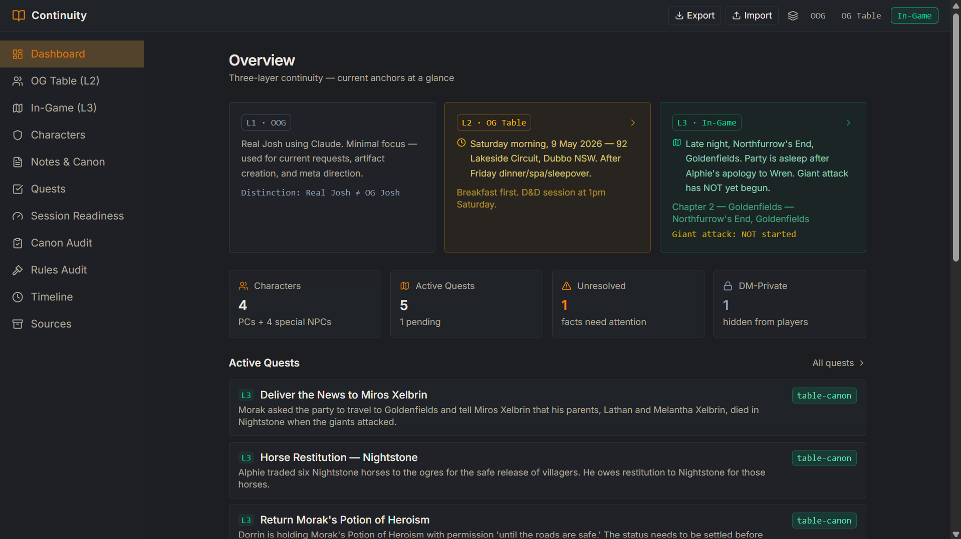

Josh Hub - https://josh-hub-two.vercel.app/dashboard
(All in One - Josh App)

Realms Atlas -
v1
https://realms-atlas-readable-map-patch.vercel.app/
https://joshuaparris-max.github.io/realms-atlas/

Game that has all my links and apps in it
v2
https://joshualparris.github.io/realms-atlas/

See App Links Doc here - https://docs.google.com/document/d/1rYeeXqK6QBZx1upwHdtzzoXSwxNLHz7_omcooqhUKIM/edit?tab=t.0

JoshDashboard
v1 https://joshdashboard2-3d63fzekflg2wlakjmrakz.streamlit.app/
v2 josh-dashboard-black.vercel.app/app/dashboard.html

Research Atlas
https://research-atlas-phi.vercel.app/

Research Gems
https://joshualparris.github.io/ResearchGems/

Waypoint - https://waypoint-azure.vercel.app/

Upskill App - https://upskillapp.vercel.app/

WorkApp - https://work-app-pearl.vercel.app/

Dubbo / DCS Apps / Games

DCSPD App - https://dcspd.vercel.app/

DCSProfessionalDevelopment - https://dcs-professional-development.vercel.app/

DCS Companion - https://joshuaparris-max.github.io/DCSCompanion

DCS Prep App - https://dcs-prep.vercel.app/

Avance PD - https://avance-professional-development.vercel.app/
And https://avance-pd.vercel.app/

ParrisDubboMover - https://parris-dubbo-mover-app-main-client.vercel.app/
(Note API / Backend Server is not working for this one)

AI Dungeon Master - https://ai-dungeon-master-azure.vercel.app/

Campaign Copilot - https://joshuaparrisdadlan-stack.github.io/campaign-copilot/

Field Notes
https://field-notes-two.vercel.app/

Sylvie Sleepytime
https://joshualparris.github.io/Sleepy/

Sylvie phonics app
https://joshualparris.github.io/SylviePhonetics/

App Factory
https://appfactory-inky.vercel.app/
https://app-factory-gamma.vercel.app/
https://app-factory-77522izch-joshualparris-projects.vercel.app
https://joshuaparris-max.github.io/AppFactory/

3 Layers DND - Alfie
https://3layers-puce.vercel.app/

Games

Whispering Wilds - 3 Versions
https://joshuaparris-max.github.io/WhirringWilderness/
https://joshuaparrisdadlan-stack.github.io/whispering-wilds/
https://joshualparris.itch.io/whisperingwilds

King Killer Chronicle Adventure
https://joshualparris.github.io/kkc-adventure/
https://rothfuss-kkc-adventure-production.up.railway.app/

PowerApp
https://github.com/joshuaparris-max/PowerApp
https://power-app-delta.vercel.app/
https://joshuaparris-max.github.io/PowerApp/

PartyAI Dungeon Master
https://party-ai-mu.vercel.app/play

EliasApp
https://elias-app2.vercel.app/

Rothfuss - University Maps
https://joshualparris.github.io/RothfussMaps/university-atlas/

Aetheria
https://skill-deploy-fs1ircxjkn.vercel.app/

Neverwinter RPG
https://skill-deploy-dwxq7kw5pa.vercel.app/
https://skill-deploy-wbzruert4j-codex-agent-deploys.vercel.app

Forbidden Lands Lite
https://skill-deploy-7tfaq44eli-codex-agent-deploys.vercel.app

Serenity - Firefly RPG
http://skill-deploy-ubokv1ax71.vercel.app/

Mystery Depths
https://joshualparris.itch.io/mysterydepths
https://joshuaparrisdadlan-stack.github.io/MysteriousDepths/

Grey Realms
https://a7d7c8d4-f588-4e1a-a1eb-23f46fa50d0b-00-2qe90krr96xo5.janeway.replit.dev/ - need to push to GitHub from download of Dnd-Path-Creator

Grey March
https://joshualparris.github.io/Marsh/

Ashfaller
https://joshualparris.github.io/ashfaller/
https://joshualparris.github.io/AshFallen/

44. joshuaparris-max/StarHaven
https://skill-deploy-kkckqq5c2j.vercel.app/

Simple RPG
https://joshualparris.itch.io/simplerpg
https://joshuaparrisdadlan-stack.github.io/LetsPlayDnd/

Infinite Office
https://joshualparris.itch.io/infiniteoffice
https://joshuaparrisdadlan-stack.github.io/OrgScape/

Null
https://joshualparris.itch.io/null-html-game
https://joshuaparrisdadlan-stack.github.io/Null/

Chronicles of Sword Coast
https://htmlpreview.github.io/?https://raw.githubusercontent.com/joshualparris/JoshHub/3de1a67/public/games/dndgame/index.html

Wilds - Sail West
https://htmlpreview.github.io/?https://raw.githubusercontent.com/joshualparris/JoshHub/41dfcef/public/games/wilds-sail-west/index.html

Wilds Main
https://htmlpreview.github.io/?https://raw.githubusercontent.com/joshualparris/JoshHub/d7521ab/public/games/wilds-main/index.html

Delve
https://joshualparris.github.io/delve/

Breach Command
https://joshualparris.github.io/breach-command/

Echo Vault
https://joshualparris.github.io/Echo/

Vercel apps
Takeaway tonight
https://skill-deploy-gzaqtty7hb-codex-agent-deploys.vercel.app

JoshSim - Life Simulator
https://skill-deploy-wn74y0trpc-codex-agent-deploys.vercel.app

https://parris-budget-app.vercel.app/

JoshHealthHub
https://skill-deploy-ibq7zs9hn6-codex-agent-deploys.vercel.app

DrunkJoshGuardian
https://skill-deploy-oww33mfjrh-codex-agent-deploys.vercel.app

https://josh-hub-96no.vercel.app/apps

https://hug-coach.vercel.app/

https://clearcore.vercel.app/

https://lifehubdashboard.vercel.app/

https://parris-piano.vercel.app/

https://parris-tech-app.vercel.app/ (mac one)

https://parris-tech-services-app.vercel.app/ (windows one)

Boundary Road Panos
https://htmlpreview.github.io/?https://raw.githubusercontent.com/joshualparris/JoshHub/3de1a67/public/games/boundary-road/index.html

Neverwinter tales
https://htmlpreview.github.io/?https://raw.githubusercontent.com/joshualparris/JoshHub/8d02ac4/public/games/neverwinter-tales/index.html

54 - Elodin Lore - https://joshualparris.github.io/ElodinDeepLore/
55 - Elodin Dossier
https://joshualparris.github.io/ElodinDeepLore/ElodinDeepLore.html
56 - Elodin Lore - https://joshualparris.github.io/elodin-deep-lore/
57 - Elodin Atlas - https://joshualparris.github.io/elodin-deep-lore/atlas.html
58 - Elodin Compendium - https://joshualparris.github.io/elodin-deep-lore/ElodinDeepLore.html

Find a repository…
newfileqqqwertuhvgjkk.py
joshualparris/newfileqqqwertuhvgjkk.py
BucklandBlocks
joshualparris/BucklandBlocks
JoshHub
joshualparris/JoshHub
Whispering-Wilds
joshualparris/Whispering-Wilds
HugCoach
joshualparris/HugCoach
energyquest
joshualparris/energyquest
DCSPrep
joshualparris/DCSPrep
BucklandBlocks1
joshualparris/BucklandBlocks1
ParrisTechApp
joshualparris/ParrisTechApp
ParrisTechServicesApp
joshualparris/ParrisTechServicesApp
LifeHub
joshualparris/LifeHub
ClearCore
joshualparris/ClearCore
JoshCoach
joshuaparris-max/JoshCoach
wastes-courier-roguelike
joshualparris/wastes-courier-roguelike
JoshTapApp
joshuaparrisdadlan-stack/JoshTapApp
JoshTapApp
joshualparris/JoshTapApp
JoshNFCAudio
joshualparris/JoshNFCAudio
ParrisDubboMoverApp-Main
joshualparris/ParrisDubboMoverApp-Main
Dashboard
Home

Top repositories
Find a repository…
JoshHub
joshualparris/JoshHub
WhirringWilderness
joshuaparris-max/WhirringWilderness
campaign-copilot
joshuaparris-max/campaign-copilot
ClearCore
joshualparris/ClearCore
ParrisDubboMoverApp
joshuaparris-max/ParrisDubboMoverApp
Max
joshuaparris-max/Max
lifehubdashboard
joshuaparris-max/lifehubdashboard
JoshCoach
joshuaparris-max/JoshCoach
random-play
joshuaparris-max/random-play
ParrisTechApp
joshualparris/ParrisTechApp
ParrisPiano
joshuaparris-max/ParrisPiano
Wild2
joshuaparris-max/Wild2
exitbackup
joshuaparris-max/exitbackup
Midnight-Line
joshuaparris-max/Midnight-Line
StarHaven
joshuaparris-max/StarHaven
ParrisBudgetApp
joshuaparris-max/ParrisBudgetApp
ForbiddenQuests
joshuaparris-max/ForbiddenQuests
pdm-parris-dubbo-mover
joshuaparris-max/pdm-parris-dubbo-mover
DCSCompanion
joshuaparris-max/DCSCompanion
Dashboard
Home

https://joshuaparrisdadlan-stack.github.io/whispering-wilds/

https://josh-hub-96no.vercel.app/games/classic-dnd-text/index.html

https://josh-hub-96no.vercel.app/games/dnd-rpg-dungeon/index.html

https://josh-hub-96no.vercel.app/games/forbidden-quests/index.html

https://josh-hub-96no.vercel.app/games/infinite-office/index.html

https://josh-hub-96no.vercel.app/games/max/index.html

https://josh-hub-96no.vercel.app/games/midnight-line/index.html

https://joshuaparrisdadlan-stack.github.io/MysteriousDepths/

https://josh-hub-96no.vercel.app/games/newgame/index.html

https://joshuaparrisdadlan-stack.github.io/Null/

https://josh-hub-96no.vercel.app/games/orgscape/index.html

https://joshuaparrisdadlan-stack.github.io/OrgScape/

https://joshuaparrisdadlan-stack.github.io/LetsPlayDnd/

https://josh-hub-96no.vercel.app/

https://josh-hub-96no.vercel.app/games/max/index.html

https://joshualparris.github.io/wastes-courier-roguelike/

https://joshuaparris-max.github.io/WhirringWilderness/

https://joshuaparrisdadlan-stack.github.io/whispering-wilds/

https://health-lens-rust.vercel.app/ - joshualparris

https://github.com/joshualparris/HealthLens - joshualparris

https://josh-health-cyan.vercel.app/ - joshuaparris-max

https://github.com/joshuaparris-max/JoshHealth - joshuaparris-max

1 https://parris-tech-app.vercel.app/

2 https://avance-professional-development.vercel.app/

3 https://avance-pd.vercel.app/

4 https://waypoint-azure.vercel.app/

5 https://josh-hub-two.vercel.app/dashboard

6 https://field-notes-two.vercel.app/

7 https://parris-tech-services-app.vercel.app/

8 DCSPD App - https://dcspd.vercel.app/

9 DCSProfessionalDevelopment - https://dcs-professional-development.vercel.app/

10 DCS Companion - https://joshuaparris-max.github.io/DCSCompanion

11 DCS Prep App - https://dcs-prep.vercel.app/

